Standards WG (PD1)/N51

PROPOSED DOCUMENT
International Medical Device Regulators Forum

Title: Optimizing Standards for Regulatory Use

Authoring Group: IMDRF Standards Working Group

Date: 26 March 2018

Table of Contents
1.0 Introduction 4
2.0 Scope 5
3.0 References 7
4.0 Definitions 7
5.0 General Principles 9
6.0 Recommendations for Standards Development 11
7.0 Enhancing Stakeholder Participation in Standards Development 16
8.0 IMDRF and Standards Development 19
Appendices Error! Bookmark not defined.
Appendix A: Problems in Standards for Regulatory Purposes Error! Bookmark not defined.
Appendix B: How to Contact a National Body/Committee of a Country Error! Bookmark not defined.

Preface

The document herein was produced by the International Medical Device Regulators Forum (IMDRF), a voluntary group of medical device regulators from around the world. The document has been subject to consultation throughout its development.

There are no restrictions on the reproduction, distribution or use of this document; however, incorporation of this document, in part or in whole, into any other document, or its translation into languages other than English, does not convey or represent an endorsement of any kind by the International Medical Device Regulators Forum.

Introduction

Background
Standards play a significant role in the design, manufacture and regulation of medical devices. Important tools for conformance assessment, standards facilitate and support innovation and help ensure that devices are safe and perform as expected.As medical devices grow in complexity and international markets expand, standards offer a means to streamline and harmonize regulatory processes around the world.

Moreover, standards tend to be used and cited by many sectors and organizations across economic systems, from product developers to associations, testing facilities and governments. Standards are especially valuable as they ‘… generally reflect the best experience of industry, researchers, consumers and regulators worldwide, and cover common needs in a variety of countries.’

As standards have grown in prominence in recent decades, evidence of their utility compels industry, Regulatory Authorities (RAs), clinicians and public health experts to dedicate resources to the development and promulgation of standards. However, standards are frequently written in ways that diminish their utility in regulatory processes. For example, some standards do not sufficiently contemplate conformity assessment testing needs. Other standards are too flexible or unclear in expectations, or do not meet a specific need, either for the market or regulators. These and other shortcomings highlight the importance of considering how medical devices are regulated when building a standard, sothat a firm’s declaration of conformance with it will inspire reviewers’ confidence and streamline the approval process. See Annex A for more information.

In preparing this guidance, IMDRF learned that while all its member regions use standards for regulatory purposes, they differ in how they apply and/or recognize them. In addition, IMDRF found that active participation in the standards development processes of the International Organization for Standardization (ISO), the International Electrotechnical Commission (IEC) and their corresponding national/mirror committees across RAs is uneven, and resource constraints, particularly time and people, hinder RA representation.

IMDRF’s conclusions – that standards can be improved by increasing and enhancing RA participation in standards developing processes and through better cooperation and coordination within the IMDRF network – led to the creation of this guidance. Itoffers clear recommendations to RAs, Standards Developing Organizations (SDOs)and other stakeholders for improving standards for use in medical device regulatory activities.

Role of Standards in Regulatory Processes
Although regulatory processes among IMDRF regions differ, RAs share the common objectives to ensure medical device safety and performance and to protect public health. International consensus standards are based upon science, technology and experience and generally reflect the best experience of industry, researchers, consumers, regulators and other experts worldwide.IMDRF members affirm their collective belief that reliance upon consensus standards is a key element of a robust regulatory framework that will promote efficiencies and innovation while facilitating an appropriate assessment of device safety and performance.

Consensus standards contribute to regulatory quality because consensus-based SDOs must demonstrate adherence to ‘transparency, openness, impartiality, effectiveness and relevance, coherence, due process and technical assistance,’ among other principles. The rigor conferred by the consensus process ensures that many interests are considered and that no single party wields disproportionate influence. Note: In this guidance, we refer to ‘standards’ without additional modifiers indicating if it is a consensus or international consensus standard. IMDRF believes that globally accepted consensus standards are preferred; however, regional, national and consortia standards may be equally useful, especially in emerging technologies in which these SDOs may be able to react quickly to changes in the state of the art.

Benefits of Optimizing Standards for Regulatory Use
Standards offer important technical tools to assess medical devices. Good standards can streamline the device review process, improve the efficiency of regulations and establish productive dialogue among RAs, manufacturers, clinicians and the public.

With the greater use of commonly accepted standards among regulators comes harmonization, which supports IMDRF’s mission: ‘…to strategically accelerate international medical device regulatory convergence to promote an efficient and effective regulatory model for medical devices that is responsive to emerging challenges in the sector while protecting and maximizing public health and safety.’

IMDRF believes that RAs’ adoption of the recommendations in this guidance will lead to advances in global regulatory harmonization.For manufacturers, harmonization will help speed products to market, and promote international trade and market integration. Patients will benefit from improved access to life-saving and life-enhancing treatments and SDOs will enjoy greater success as standards grow in relevance and utilization.

Scope
This IMDRF guidance serves as an educational tool and resource for regulators, SDOs and other stakeholders involved in standards writing to ensure that standards are useful for the regulatory oversight of medical devices. It suggests improvements inthe standards writing process andrecommends best practices for effective RA participation in standards development that will advance their use for regulatory purposes and ultimately promote the harmonization of regulatory schemes globally. While we refer specifically to ISO and IEC in this document, most consensus-based SDOs follow similar procedures and rules, though terminologies may differ.
Note:
This document does not establish competency or training requirements for experts/liaisons appointed to standards development activities nor does it offer direction on how regulators should implement the use of standards, though it is anticipated that RAs’ use of standards will be enhanced when standards are written with greater attention to regulatory utility. This guidance applies to all medical devices, including in vitro diagnostic devices.

References

IMDRF Essential Principles of Safety and Performance of Medical Devices and IVD Medical Devices: 2018 (IMDRF GRRP WG(PD1)/N47 forthcoming)

ISO Conformity Assessment tools to support public policy https://www.iso.org/sites/cascoregulators/02_casco_toolbox.html

ISO/IEC Directives Parts 1 (Ed. 13, 2017) and 2 (Ed. 7, 2016)

ISO/IEC Guide 59, Code of good practice for standardization 1994

ISO/IEC 17007:2009, Conformity assessment – Guidance for drafting normative documents suitable for use for conformity assessment

ISO/IEC 17050-1:2004 Conformity Assessment – Supplier’s Declaration of Conformity – Part 1: General Requirements

ISO/IEC 17050-2:2004 Conformity Assessment – Supplier’s Declaration of Conformity – Part 2: Supplemental Information

ISO 14971:2007 Medical devices – Application of risk management to medical devices

World Health Organization WHO Global Model Regulatory Framework for Medical Devices including in vitro diagnostic medical devices 2017

World Trade Organization Agreement on Technical Barriers to Trade 1994

Definitions

Consensus Standards: ‘are standards developed through the cooperation of all parties who have an interested in participating in the development and/or use of the standard. Consensus requires that all views and objections be considered, and that an effort be made toward their resolution. Consensus implies more than the concept of a simple majority but not necessarily unanimity.’ (The Society for Standards Professionals: http://www.ses-standards.org/?58)

Essential Principles/Essential Principles of safety and performance: fundamental high-level requirements that when complied with ensure a medical device is safe and performs as intended (ISO 16142-2:2017)

Manufacturer:“Manufacturer” means any natural or legal person with responsibility for design and/or manufacture of a medical device with the intention of making the medical device available for use, under his name; whether or not such a medical device is designed and/or manufactured by that person himself or on his behalf by another person(s). (GHTF/SG1/N055:2009)

Medical Device: Any instrument, apparatus, implement, machine, appliance, implant, reagent for in vitro use, software, material or other similar or related article, intended bythe manufacturer to be used, alone or in combination, for human beings, for one or more of the specific medical purpose(s) of:
- diagnosis, prevention, monitoring, treatment or alleviation of disease,
- diagnosis, monitoring, treatment, alleviation of, or compensation for, an injury,
- investigation, replacement, modification, or support of the anatomy, or of a physiological process,
- supporting or sustaining life,
- control of conception,
- disinfection of medical devices,
- providing information by means of in vitro examination of specimens derived from the human body; and does not achieve its primary intended action by pharmacological,immunological, or metabolic means, in or on the human body, but which may be assisted in its intended function by such means.

Note 1: Products which may be considered to be medical devices in some jurisdictions but not in others include:
- disinfection substances,
- aids for persons with disabilities,
- devices incorporating animal and/or human tissues,
- devices for in-vitro fertilization or assisted reproduction technologies.
(GHTF/SG1/N071:2012)

Note 2: For clarification purposes, in certain regulatory jurisdictions, devices for cosmetic/aesthetic purposes are also considered medical devices.

Performance: The ability of a medical device to achieve its intended purpose as stated by the manufacturer. Performance may include both clinical and technical aspects. (IMDRF GRRP WG(PD1)/N47 forthcoming)

Recognized Standards: Standards deemed to offer the presumption of conformity to specific essential principles of safety and performance. (GHTF/SG1/N78:2012)

Regulatory Authority (RA): A government body or other entity that exercises a legal right to control the use or sale of medical devices within its jurisdiction, and that may takeenforcement action to ensure that medical products marketed within its jurisdiction comply with legal requirements. (GHTF/SG1/N078:2012)

State of the Art: Developed stage of technical capability at a given time as regards products, processes and services, based on the relevant consolidated findings of science, technology and experience. (ISO/IEC Guide 2:2004)

General Principles
Standards help facilitate the assessment of the safetyand performance of medical devices.They represent the consensus of a variety of experts and interested entities, and a commitment to their use presents an opportunity to promote the global harmonization of regulatory processes. RAs and all interested stakeholders should support and contribute to standards development to encourage the publication of standards that are useful in the regulation of medical devices and can streamline review processes.Outlined below are three key expectations for the development and promulgation of regulatory-ready standards: a commitment to IMDRF’s Essential Principles of Safety and Performance of Medical Devices and IVD Medical Devices, an emphasis on performance over design stipulations in writing standards, and the importance of a consensus approach.

IMDRF Essential Principles of Safety and Performance of Medical Devices and IVD Medical Devices (IMDRF EPs)
IMDRF’s Essential Principlesidentify the high-level criteria that, when met, indicate that a medical device is safe and performs as expected. Standards that are written with regulatory needs in mind will address one or more of the IMDRF EPs, and should reflect:
- a close relationship of the scope of the standard to one or more of the IMDRF EPs,
- the clarity and completeness of the requirements contained in the standard as it relates to a specificEP,
- the existence of test methods for determining compliance with each of the requirements in the standard, and the definition of clear acceptance criteria for determining that each technical requirement is met.

Performance versus Design Stipulations
There is broad agreement among SDOs and others that it is much preferred to express a standard’s requirements with references to performance, rather than to specific device features. As noted in the ISO/IEC Directives Part 2, this approach fosters innovation and healthy marketplace dynamics.
An example from the Directives illustrates this principle:
‘Different approaches are possible in the specification of requirements concerning a table:
Design requirements: The table shall have four wooden legs.
Performance requirements: The table shall be constructed such that [the table top remains level and at its original height] when subjected to … [stability and strength criteria].’

Consensus Approach
IMDRF believes that for regulatory purposesinternational, regional, national, consortia and industry standardsshould be developedby organizations using consensus principles. Standards should also demonstrate the following characteristics:

- Fairness: the needs of all stakeholders, including regulators, are considered in standards development.
- Compatibility: standards are compatible with the internationally accepted principles of safety and performance of medical devices.
- State of the art: standards represent the state of art in a technological field.
- Efficiency: they should also promote economic benefits, e.g., reducing redundant reporting requirements, streamlining regulatory activities and harmonizing expectations across different countries and regions.
- Completeness: within its scope, a standard address all predictable elements related to Essential Principles of device safety and/or performance.
- Verifiability: requirements include verifiable objective measurements.
- Repeatability: testing methods in standards will yield consistent results across different certified test houses.
- Consistency: terms and symbols across standards are as consistent as possible.
- Clarity: standards are clear, unambiguous, and easily understood.
- Accessibility: standards and associated documents should be reasonably available to relevant stakeholders.

The remaining sections of this guidance outline recommendations for standards development and participation that are based upon these general principles, and which will foster the development of standards that are optimized for regulatory use.

Recommendations for Standards Development
This section offers specific suggestions for improving standards for regulatory useand for achieving harmonization.

Optimizing Standards Content
Standards should be crafted in such a way that conformity to them can reduce the burden of regulatory review and demonstrate conformance toIMDRF’s EPs. To achieve this, standards’ content must contain objective and specific requirements that clearly indicate how conformance can be achieved and conveyed. Adherence to the following will improve standards’ content and suitability for regulatory purposes:

- Standards should include a rationale explaining the general requirements in the standard that may assist in interpreting the meaning and/or purpose of the standard. The rationale should identify test methods and/or other means of demonstrating compliance. In addition, the rationale should demonstrate how conformance to the standard achieves its goal of satisfying the associated EPs.

- To better indicate the breadth of experts involved within the development activity, standards should provide a summary of the type of stakeholder groups involved in the drafting and editing of the standard. This should apply to both SDOs and national-level mirror committee activities.

- When a reasonably foreseeable risk, hazard or a hazardous situation is identified without a specific requirement for its mitigation, the standard should clearly identify this hazard and provide direction on how to address the residual risk as appropriate (e.g., conduct a Risk Analysis).

- The standard’s scope should be clear in terms of how it achieves the EPs of safety and performance addressed in the standard.

- Standards should include terms and definitions that have been established and accepted in other standards (see ISO/IEC Directives Part 2).

- If the scope of a standard includes clinical performance as part of the normative requirements, the standard should include acceptance criteria required to demonstrate compliance with the standard. Where these criteria cannot be adequately established, but are still addressed in the standard, it should indicate that additional clinical evaluation may be required.

- When possible, standards should contain clear and quantitative acceptance criteria that can adequately support IMDRF EPs.

- Where provisions permit not meeting an acceptance criterion or a requirement while still allowing a claim of conformance, justification should be providedas to why the acceptance criteria are not mandatoryand how to demonstrate conformance to the standard (see ISO/IEC17050-2:2004 – Supplier’s Declaration of Conformity - Part 2 Supplemental Information).

- Where a requirement is included without specific acceptance criteria, it should be clearly identified as to how conformance can be met.

- Whenever alternative solutions are offered in a document and preferences for different alternatives provided, the reasons for the preferences should be explained in the introduction to the standard (see ISO/IEC Directives Part 2:2016 for more information).

- Acceptance criteria should be validated as relevant for meeting safety and performance requirements and a rationale supporting the validation methods should be included.

- Test methods should be verified as reliable to ensure that tests can be successfully conducted and consistent results obtained.When technical requirements are stipulated, associated test methods should usewell accepted approaches. New or unfamiliar test methods should likewise be verified as reliable.

- When a standard is undergoing revision, it should highlight thechanges from the previous version(e.g., show a red-line version of the standard).

- Standards should contain, as an annex, a table that cross references, or maps, the standard’s clauses to the Essential Principles.

Best Practices for Standard Development Procedures
Standards should be developed using consensus principles and support the values articulated by the World Trade Organization, the World Health Organization and others: accessibility, transparency, broad representation and consideration of interests in consultations.Applying consensus requirements to standards confers credibility to the future published standard and enhances the probability of its adoption and promulgation.

At every stage of the standards development process, careful thought should be given to how a standard can be used by RAs.In the preliminary and proposal stages, the effect on regulatory practices and industry should be evaluated. The justification forthe need for the standard should clearly identify the purpose in its scope and specify how it will achieve that purpose (e.g., meeting an EP, addressing new technologies, or mitigating a public health concern or a known deficiency from post market reports).

When crafting the business plan, standards developers should carefully and comprehensively study objective market, regulatory and/or safety needs. A robust analysis of need during the business plan stage will preclude the drafting of standards that are unnecessary, duplicative, or of little regulatory use.In addition, before drafting begins, standards writers should investigate whether existing standards already address the issue under consideration. Avoiding duplication of and conflicts between existing standards and new proposals – at national, regional and international SDO levels - will save time and resources.

Once drafting is underway, working groups solicit and deliberate stakeholders’ commentsto the draft standard.At this stage, the RA comments both from national committees/bodies or from IMDRF can be particularly helpful, as they offer insights into theglobal regulatory usefulness of the standard. In the enquiry stage, it is also useful to include additional comment information on the comment form. In addition to general, technical and editorial categories, the form should also include two additional comment categories: regulatory and clinical. The awareness of a comment’s regulatory or clinical origins will add valuable perspective to the standards developing process.

Because some standards address not only performance but also broader public health issues, IMDRF encourages SDOs to make information about these standards used for regulatory purposes more accessible throughout the development process, thereby assuring adequate input from the larger medical and public health communities, including RAs.

SDO committees should strengthen tracking and evaluation on the post-market performance of the applicable technology from the published standard.SDOs should also encourage the application ofa rapid-response procedure to revise standards when issues related to product safety arise.

Finally, in order to deepen awareness of and expertise in the regulatory fitness of standards and to encourage participation in their work, SDOs should regularly organize and offer training on standards and standards development procedures to all interested entities. Equally importantly, SDOs should actively collaborate with IMDRF to train the technical committees and working groups on regulatory requirements of medical devices, and to encourage member countries to carry out similar training in their own agencies.

Use of Standards in Meeting IMDRF Essential Principles
Standards that contain detailed requirements may be used to demonstrate conformance with some or all of the IMDRF EPs.These principles provide a framework for regulatory expectations and represent a consensus on fundamental design and manufacturing requirements that, when met, indicate that a medical device is safe and performs as intended. Essential Principles of safety and performance provide broad, high-level, criteria for design, production, and postproduction (including post-market surveillance) throughout the life-cycle of all medical devices.

Standards that conform to the relevant EPs provide a greater level of detail and specificity than can be expressed in the EPs. Thus, when writing standards it is helpful to test the standard against the relevant EP(s). Mapping a standard to its EP will serve to ensure that standards developers are giving adequate consideration to the regulatory ramifications of the standard and its applications, and ultimately build confidence among RAs that a standard is fit for use in conformity assessment. This approach has the added benefit of promoting harmonization among jurisdictions.Note: the use of specific standards depends on the requirements of the RAs having jurisdiction. In addition, some RAs may have additional requirements outside these EPs.

Figure 1 belowuses examples to delineate howstandards, when aligned with the relevant EPs, contribute to the assessment of a device’s performance. The first example is for technical performanceand the second is for clinical performance.

Example of Essential Principle:
5.1.1 Medical devices and IVD medical devices should achieve the performance intended by their manufacturer…

Technical performance:
Standards conformance demonstrates the ability of a medical device under test to achieve technical goals that are needed to support its intended use.

Clinical performance:
Standards conformance demonstrates the ability of a medical device to provide clinical outcome(s) in its intended use as claimed by the manufacturer. (GHTF/SG5/N1R8:2007, modified)

Performance:
The ability of a medical device to achieve its intended purpose as stated by the manufacturer. Performance may include both clinical and technical aspects.
General Standards Example: IEC 60601-1/61010-1
Example of Essential Principle:
5.2.1Where appropriate and depending on jurisdictional requirements, a clinical evaluation may be required. A clinical evaluation should assess clinical data to establish that a favorable benefit-risk determination…
Example of Essential Principle:
6.2.1 Medical devices emitting ionizing radiation intended for diagnostic radiology should be designed and manufactured in such a way as to achieve ……

Standards Example:
IEC 60601-1:2005 3rd Ed - Clause 10
Other examples of standards:
IEC 60601-series (General requirements for Basic Safety and Essential Performance
-1-x (collateral general requirement(s)
-2-x (product specific)

Note: the use of device standards that reference the general standard addressing an EPs may provide additional requirements specific to the device under test.

General standard example:
ISO 14155:2011 Clinical investigation of medical devices for human subjects -- Good clinical practice.
Product specific example:
ISO 80601-2-61:2017 Medical electrical equipment - Part 2-61: Particular requirements for basic safety and essential performance of pulse oximeter equipment – Clause 201.12.1.101.2/Annex EE

Figure 1: Example of standards addressing Safetyand Performance of the IMDRF Essential Principles

Enhancing Stakeholder Participation in Standards Development
Standards’ role in international commerce and their impact on competitiveness and other priorities confer a special significance to contributions from RAs. RAs’ engagement promotes the development of standards that facilitate and shape innovation in ways that benefit global public health, as well as the medical device marketplace. When actively contributing to standards development, RAs interact with a wide range of stakeholders at the domestic and international levels and contribute substantively to technical and policy solutions with industry experts, international counterparts, other regulators and policymakers, andpublic health organizations.

RAs’ engagement is enhanced by organizational support from their respective agencies. IMDRF recommends that, for those who use standards for regulatory, procurement, or other mission related activities, a formal standards function be established, e.g., appointment of a designated standards executive and/or a department responsible for the RA’s standards activities.

International, regional and national level participation: joining the conversation
Standards development takes place at the international, regional and national levels. Internationally, consensus SDOs draft, publish and sell standards in the global market. While some SDOs establish membership and participation by individual experts (e.g., ASTM International), membership in IEC and ISO committees (including technical committees, subcommittees, working groups and maintenance teams) is by country only. ‘Participating’ member countries send a limited, prescribed number of delegates to meetings around the world in which standards are written, reviewed, revised or rescinded. They also conduct other committee tasks such as writing guidance, technical reports and business plans. This work is formal and governed by strict protocols and rules designed to ensure that consensus status is maintained.

Countries, as the members of ISO and IEC, work on a national level toformulate their positions on the various SDO priorities. ISO and IEC member countries designate an organization to act as ‘Member Body’ (in ISO terminology) or “National Committee” (in IEC terminology); per the ISO/IEC Directives Part 1, this document will use the term ‘national body’ to refer to them. The national body is responsible for relevant activities of ISO and IEC within their respective countries, including audits and registration of international experts to participate in IEC/ISO working group, review of new standard proposals, guidance and supervision of commenting and voting, and hosting ISO and IEC conferences.

The national body manages various national or mirror committees (called Technical Advisory Groups, or TAGs in the US; this document will hereafter use the term ‘mirror committees’) whose work parallels that of ISO and IEC committees and working groups at the international level. Individuals in these groups also constitute the pool of nominees from which the national body draws for official delegates to the ISO and IEC meetings.

The objectives of these national-level mirror committees are to develop consensus on the many issues about which ISO and IEC will write standards and reports, and their decisions will form the basis of their countries’ official positions. These groups are ordinarily accredited by the national bodies; mirror committees also surveil the environment for needs and opportunities that the SDO should consider, and propose new work items to address those needs.

To increase utilization of standards for regulatory applications, RAs should participate in standards development at both the national and international levels. At the international level, RA engagement is welcomed in the various committees within IEC and ISO and regulators are strongly encouraged to serve as experts through their official country delegations.

Equally important is participation in the mirror committees. As noted above, the national bodies develop consensus on their countries’ positions and votes; their nominating function to ISO and IEC delegations makes national level engagement even more important for RAs. This accessibility at the national level supports consensus principles and is an important feature that facilitates participation in standards development without requiring the membership and resources necessary for ISO and IEC membership.

Joining the ISO and IEC national bodies and mirror committees is a key first step for RAs. It is not always clear how one joins a mirror committee. Most countries’ national bodies encourage participation and direct their mirror committees to offer membership to all interested stakeholders, though they may be administered by private organizations who may charge dues or membership fees. RAs often have membership status through their agency or government and that membership may entitle them to join mirror committees. Understanding and identifying relevant committees may require investigation; Annex B offers specific steps for identifying committees of interest and you should not hesitate to contact the many individuals listed on the SDOs’ websites for clarification.

Recommendations for participation: submitting effective comments
Standards are written according to an established and orderly procedure, from the proposal stage through draft iterations and finally a vote and publication. RAs should enter the process as early in the standard’s life cycle as possible. If regulators contribute expertise early, particularly at the New Work Item Proposal (NWIP) stage, the opportunity to shape its direction and enhance regulatory utility is maximized. Figure 2 below depicts the stages in the standards development process over time, from left to right. The further along the standard moves in the process, the less opportunity there is for substantive changes.

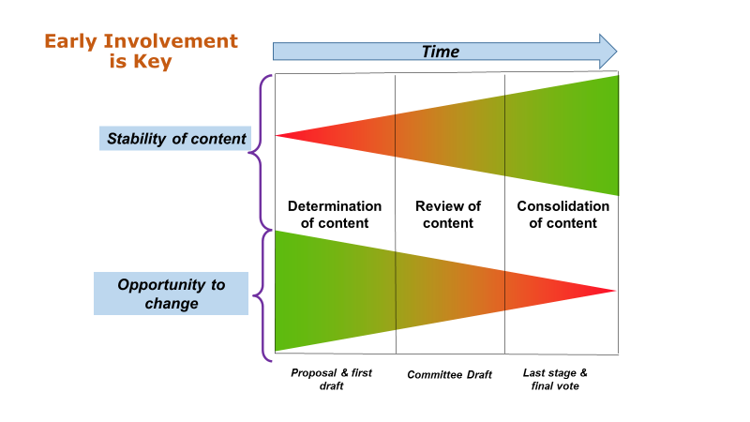
Figure 2: Stages of ISO standards development

On their Web sites, ISO and IEC publish comprehensive information about where each standard currently resides in the development process. Interested stakeholders may search by the Technical Committee or Sub-Committee working on a standard or the standard itself; the stages are coded for easy identification (see https://www.iso.org/files/live/sites/isoorg/files/developing_standards/docs/en/stage_codes.pdf) and http://www.iec.ch/standardsdev/resources/processes/stage_codes.htm).

Once engaged, it is incumbent upon participants to have a clear understanding of the standard’s substance and purpose, to pay attention to others’ thoughts and to carefully analyze any challenges or problems that the draft document presents. They should solicit input from their regulatory colleagues (both in their own country and among their peers, as well as other experts who may be interested in the topic), and give consideration to implications that elements of the standard will have on the regulatory activities, such as the review processes for conformity assessment, testing methods and audit requirements.

The next step is to articulate one’s position clearly and timely and in the format specified by the national body. Protocols for submitting comments are clear and straightforward; they encourage not only an explanation of the commenter’s suggested improvements, but also the submission of specific language that can replace text that one disagrees with. Effective comments are clear, concise and germane to the issue.For more information on how to provide effective comments, please see the ISO/IEC Directives Part 2 (http://www.iec.ch/members_experts/refdocs/iec/isoiecdir-2%7Bed7.0%7Den.pdf).

RAs should take advantage of every opportunity to submit comments. The entire standards development system is predicated upon stakeholder input and having RAs’ insights during the entire process means that regulatory use will be considered in time for it to make a difference.

RAs should not only join but should also seek leadership positions within SDO committees and national bodies. Serving in a leadership role is important for several reasons. First, having regulators in leadership positions will result in more useful standards for regulatory purposes.Second, those who hold an office will be able to contribute substantively to the overall good of the standards development process. Finally, it will benefit both the participant and his organization professionally.

IMDRF and Standards Development
Representing medical device regulatory authorities from several major jurisdictions, IMDRF enjoys a unique position and authority in the international community. As such, it capitalizes on its collective expertise and relationships with SDOs that advance our shared goal of expanding the use of standards to streamline regulatory requirements. While IMDRF engagement with SDOs in no way diminishes the importance of regulators’ participation (e.g., in both their national bodies and at the international SDO levels), agreements to collaborate with ISO and IEC provide mutual benefit to IMDRF, SDOs, and RAs. The more these entities interact, the greater the impact regulators will have on the standards development process.
In its role as partner to the SDOs and advocate for member RAs, IMDRF acts as a resource to both, and serves as a hub for communicating needs and priorities in both directions: from the SDOs to regulators and vice versa. In addition to facilitating communications, IMDRF offers oversight and assistance to RAs in their contributions to standards development, particularly in commenting support, both through their national bodies and through IMDRF.
For their part, through these interactions (including joint meetings and training sessions), SDOs enhance RAs’ confidence in their standards by committing to consensus principles, particularly balanced participation in its working groups, transparency at all levels of the standards development process, and the production of effective impact assessments that explicitly consider regulatory applications in new work items. Additionally, SDOs’ support for the IMDRF EPs and other priorities such as risk management and quality management programs fosters regulatory-ready standards and their ultimate adoption and promulgation.

This close cooperation further ensures that other advances in standards harmonization will be possible, e.g., procedures to identify, correct and inform standards’ users about possible shortcomings that might lead to unsafe devices, increased transparency on the authorship of SDO output and comments (regulator, clinician, industry, etc.), and evaluation of the implementation of published standards.

IMDRF is the voice of its members, thereby advancing progress toward IMDRF’s key strategic goal of ‘…improving the suitability of standards for regulatory authorities and effective regulatory authority involvement at each stage in standards development.’

Appendices
Appendix A: Problems in Standards for Regulatory Purposes

IMDRF identified key shortcomings in the way standards are currently written. Problems with representation, decision-making and processes, and a lack of understanding in ISO and IEC about what RAs need are all important issues. Discussions with ISO and IEC leadership lead us to conclude that, while challenging, these problems can be resolved with appropriate intervention and collaboration among RAs and SDOs.

Note: it is acknowledged that various RAs may use standards differently. For some RAs, regulatory authorizations or approvals may be based entirely on compliance to consensus standards as a mandatory approach to obtaining authorization to market a medical device. For some RAs, standards may be an optional element that can be used to complement and augment other documentation, test reports, and objective evidence used to demonstrate safety and effectiveness. The approaches used by RAs might also differ based on the risk classification of the medical device.

Representation and Expertise of Standards Committees
- Poor participation by RAs, due to financial and human costs of engagement, precludes substance and language that are useful for regulatory purposes from appearing in final standards. If regulators are not present at the drafting and commenting stages at a minimum, the standards will not reflect requirements conducive to product review processes.

- A profusion of work items (and duplication across SDOs)stresses resources. Most regulatory authorities characterize themselves as understaffed; those who work on standards often do so on an extra-curricular basis and must carefully prioritize those standards most important to their areas of expertise. Frequently, RAs are unable to contribute manpower to all pertinent standards.

- Unbalanced representation in drafting and voting can result in some groups’ disproportionate voice in and impact on standards development. The ramifications of a standards committee having, for example, an industry-heavy composition can be significant if clinical, public health and/or safety experts are under-represented.

- ‘Turf battles’ among TCs and SCs sometimes stymie progress. It is sometimes unclear which TCs and SCs should have jurisdiction in a technical area, which can slow progress as ownership is worked out.

Transparent processes and decision-making
- Working document accessibility is often unpredictable, making analysis, commenting and future promulgation difficult. When regulators have easy and reliable access to the drafts, they are more likely to contribute substantively on behalf of the review process.

- Lack of transparency on authorship of proposals, comments and positions hinder an understanding of other positions and their origins. Knowing which individual or stakeholder submitted specific input can help regulators understand and effectively balance the overall direction of the standard.

- Adherence to deadlines is often poor; business plans need to clearly specify due dates, and TCs should demonstrate better accountability to timelines, especially for emergent and urgent standards. Missing deadlines and extending work items make it even more difficult for RAs to be able to contribute where they are most needed.

Usefulness for regulatory purposes
- Inadequate RA input into design of key standardsoften leads to out-of-scope substantive content. ‘Scope creep’ for example can result in standards that do more than is needed, reducing their utility and adoption.

- Insufficient attention is paid to evaluating need in developing NWIPs. IMDRF members note that standards teams should spend more time determining a market, safety or regulatory need before the standard is actually drafted (this may be aided by developing a set of design specifications for regulatory purposes). This will prevent unnecessary standards from being developed, while redirecting participants to pursue a more appropriate outcome, e.g., a technical report or other option.

- Impact assessments need outside review to assure a standard is ‘fit for purpose.’ For example, gaining insights from testing laboratories will ensure that conformance assessment is doable and reasonable.

- Mixed standards can be difficult to use in product reviews. Standards that combine, for example, product and process requirements present challenges for recognition programs and for the review process.

- Conformance considerations (e.g., validation) and clarity of expectations need to be built into standards. Since conformance assessment, testing and declarations are among standards’ most important functions it is important to always keep these practical, applied aspects of standards in mind when developing them.

- Content of standards can be too flexible. Technological changes encourage the allowance of more flexibility to accommodate the rapid rate of advances. That flexibility can render standards less useful as they may not adequately identify minimum requirements for quality, safety and/or effectiveness/performance.
Appendix B: How to Contact a National Body/Committee of a Country
Source: Global Medical Technology Association

To effectively participate in standards developed by national voting (e.g., ISO/IEC), it is important to know that your participation is authorized through your country’s National Body/Committee. This annex provides information on how to reach your National Body/Committee.

For an IEC committee
Go to the IEC website link at this link: http://www.iec.ch/dyn/www/f?p=103:6:0##ref=menu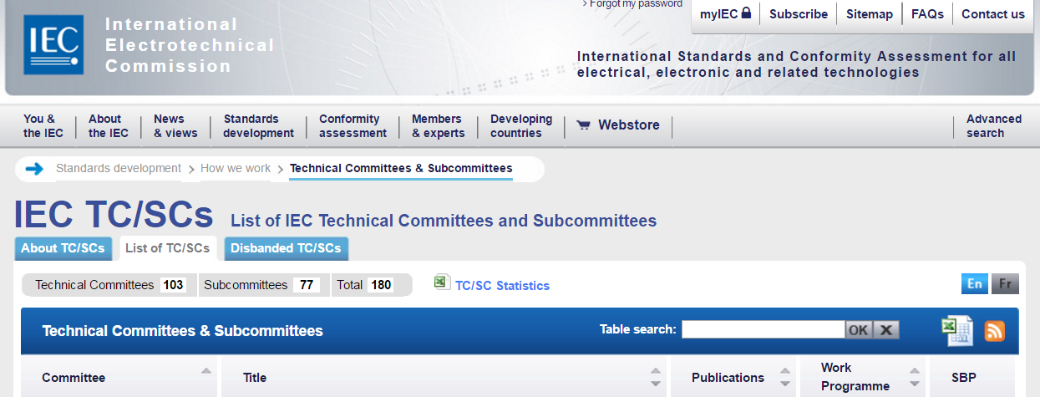

Scroll down and click on the TC or SC you want

Click on the tab marked Structure 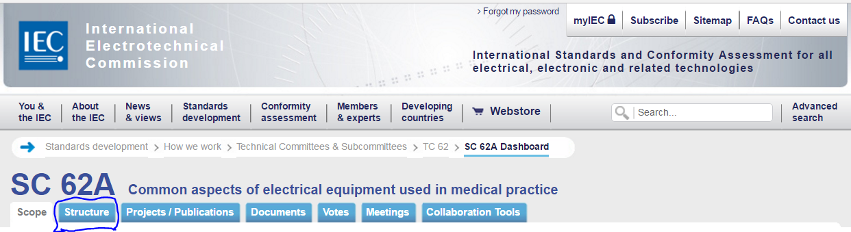

Click on the country for which you want the National Committee information.
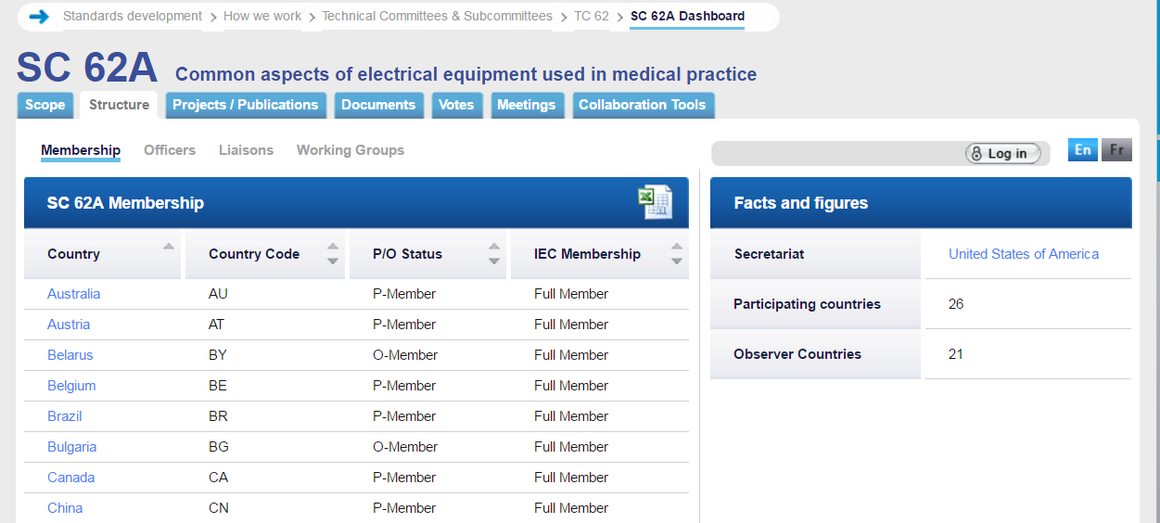

For example, if you selected Canada, the contact information will appear. There is a link (circled) to e-mail the national committee.

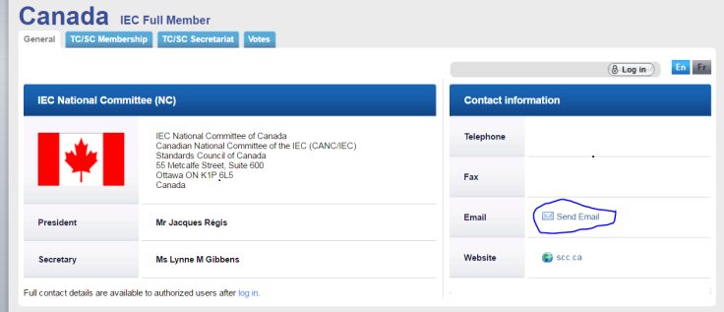

For an ISO committee
Go to the ISO website at this link: http://www.iso.org/iso/home/standards_development/list_of_iso_technical_committees.htm

At the bottom of the page is a list of Technical Committees (TCs).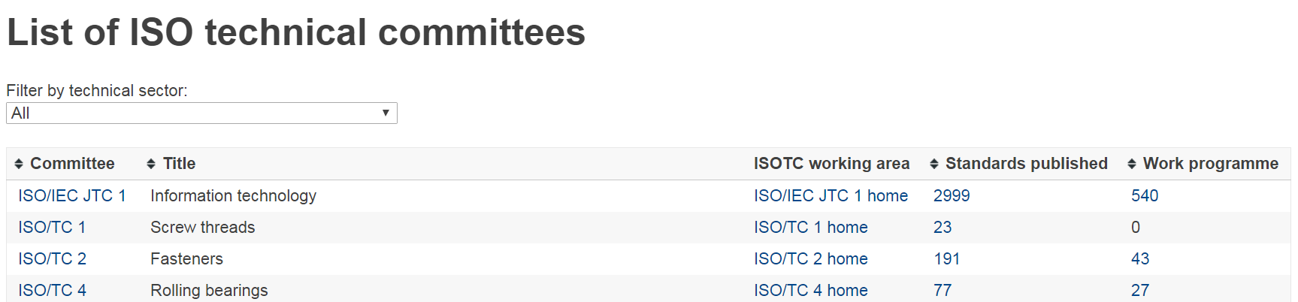

Scroll down and click on the TC you are interested in, for example TC 210

At the bottom of the page you will find information on how many countries participate in that TC. The number is a link. Click on it.
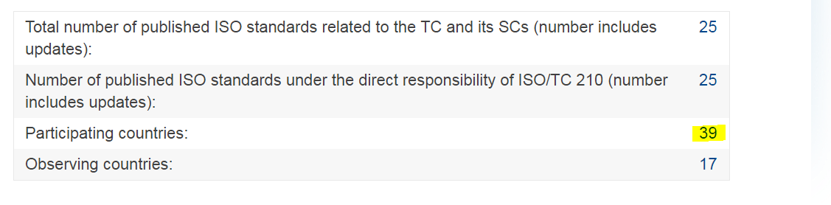
Scroll down and click on the country for which you desire National Committee information (in this example, Australia). The e-mail to contact will be available.

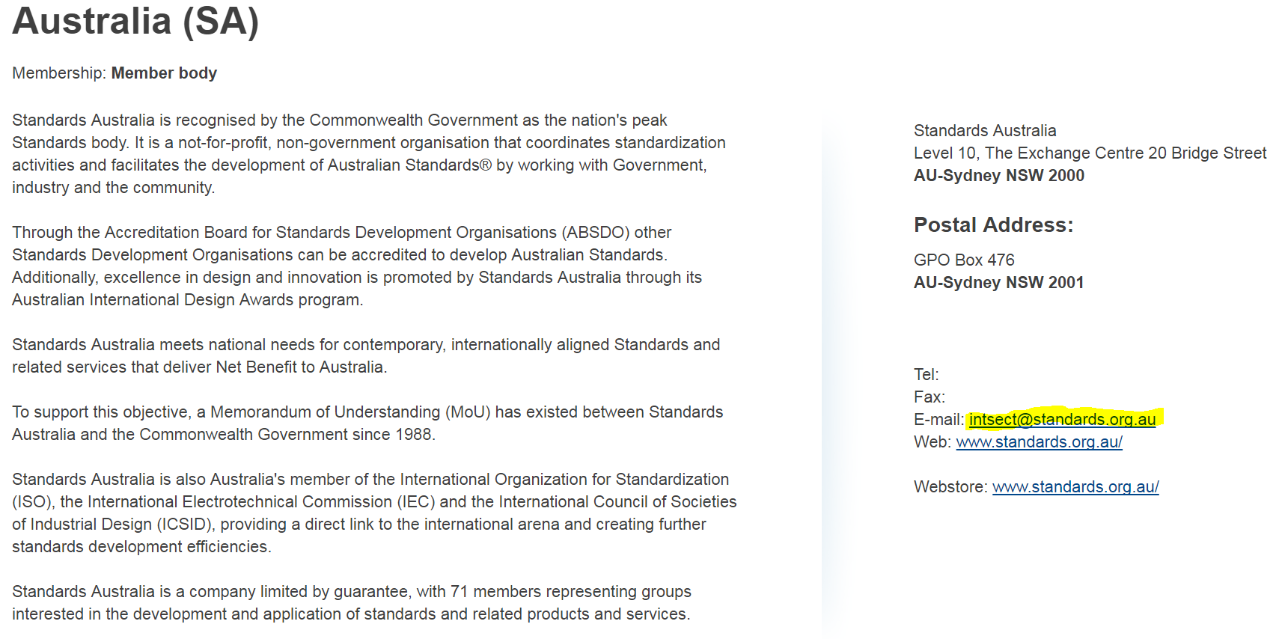

http://www.iec.ch/about/activities/standards.htm?ref=home
https://share.ansi.org/shared%20documents/Standards%20Activities/NSSC/USSS_Third_edition/ANSI_USSS_201.pdf and ISO/IEC Guide 2:2004 Standardization and related activities – General vocabulary accessed at https://www.iso.org/standard/39976.html
IMDRF Strategic Plan 2010, accessed at http://imdrf.org/docs/imdrf/final/procedural/imdrf-proc-151002-strategic-plan-2020.pdf
The term “person” that appears here and in the other definitions of this document, includes legal entities such as a corporation, a partnership or an association.
See ISO/IEC Directives Part 2, accessed at http://www.iec.ch/members_experts/refdocs/iec/isoiecdir-2%7Bed7.0%7Den.pdf
See Annex 3 of the World Trade Organization’s Agreement on Technical Barriers to Trade, accessed at https://www.wto.org/english/docs_e/legal_e/17-tbt_e.htm and the World Health Organization’s Medical Device Regulations: Global Overview and Guiding Principles, accessed at http://www.who.int/medical_devices/publications/en/MD_Regulations.pdf
IMDRF Strategic Plan 2020, accessed at http://imdrf.org/docs/imdrf/final/procedural/imdrf-proc-151002-strategic-plan-2020.pdf

