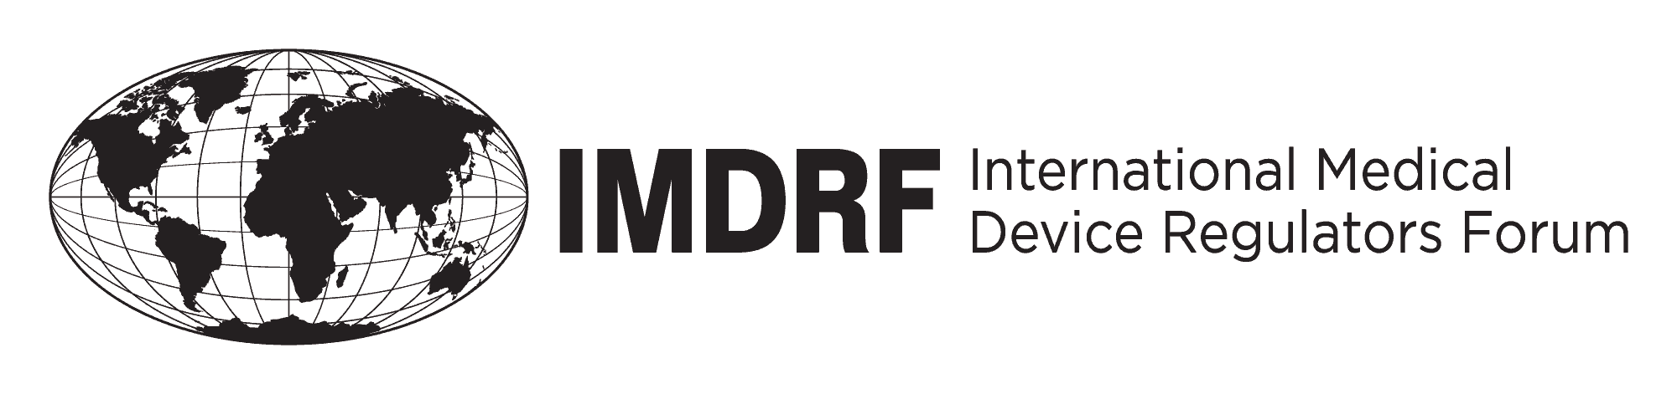

Comments template – for submitting comments on proposed IMDRF documents.
Once completed, please forward to bakul.patel@fda.hhs.gov
Interested parties should respond by close of business Tuesday 13 December 2016.
Document number: SaMD WG (PD1)/N41R3 Title: Software as a Medical Device (SaMD): Clinical Evaluation
Submitted by (name): Affiliated to: On:__________
High level feedback | Yes/No | Comment and rationale and proposed recommendations
Does the document address the intention captured in the introduction/scope or vice-a versa?
Does the document appropriately translate and apply current clinical vocabulary for SaMD?
Are there other types of SaMD beyond those intended for non-diagnostic, diagnostic and therapeutic purposes that should be highlighted/considered in the document?
Does the document adequately address the relevant clinical evaluation methods and processes for SaMD to generate clinical evidence?
Are there other appropriate methods for generating clinical evaluation evidence that are relevant for SaMD beyond those described in the document?
Are the recommendation identified in section 7.2 related to the” importance of clinical evaluation evidence” appropriate as outlined for the different SaMD categories ?
Are the recommendation identified in section 7.3 related to the” importance of independent review ” appropriate as outlined for the different SaMD categories ?
Given the uniqueness of SaMD and the proposed framework -- is there any impact on currently regulated devices or any possible adverse consequences?

Detailed Feedback
Comment Number | Page / Section / Line | Editorial or Technical | Comment and rationale | Proposed revised text | IMDRF Decision  (& date)
1.
2.
3.
4.
5.
6.
7.
8.
9.
10.
11.
12.
13.
14.

