UDI WG(PD1)/N54

PROPOSED DOCUMENT
International Medical Device Regulators Forum

Title: Recording Unique Device Identifiers in Electronic Health Sources

Authoring Group: IMDRF UDI WG

Date: 12 July 2018

Table of Contents

1.0 Background 4
2.0 Definitions 5
3.0 General System Requirements for Recording the UDI 5
4.0 Examples of Forms using UDI 6
4.1 Use Case 1 – Adverse Event Reporting: US FDA Medical Product Safety Network (MedSun) 6
4.2 Use Case 2 – Vigilance Reporting: European Union 7
4.3 Use Case 3 – Medical Device Registry: Society for Vascular Surgery Vascular Quality Initiative (VQI) 8
Preface

The document herein was produced by the International Medical Device Regulators Forum (IMDRF), a voluntary group of medical device regulators from around the world. The document has been subject to consultation throughout its development.

There are no restrictions on the reproduction, distribution or use of this document; however, incorporation of this document, in part or in whole, into any other document, or its translation into languages other than English, does not convey or represent an endorsement of any kind by the International Medical Device Regulators Forum.

1.0 Background

The fundamental elements of a UDI system can be summarized as follows:

- Development of a standardized system of Unique Device Identifiers (UDIs)

- Placement of UDI in human readable and Auto Identification Data Capture (AIDC) formats/forms on package labels and in some cases, on the device itself

- Submission of core UDI data elements to a Unique Device Identification Database (UDID)

- Setting of appropriate transitional and implementation arrangements to ensure a smooth UDI implementation.

Benefits of UDI strongly rely on effective integration of the UDI to support various regulatory activities during the lifecycle of medical devices and uptake of UDI across the whole healthcare sector.

Figure 1. Learning UDI System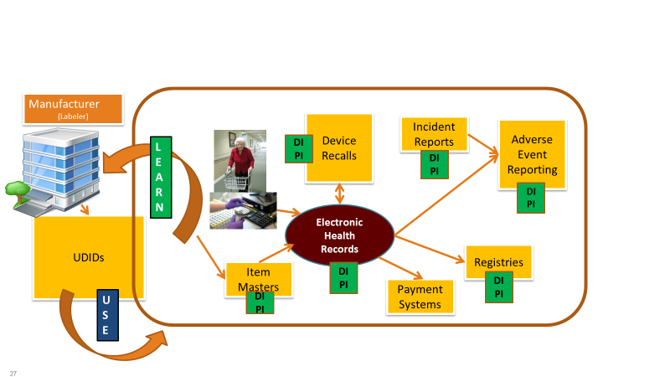

Those benefits are more likely be achieved when the UDI is recorded in real world electronic health systems (e.g. electronic health records (EHRs), device registries, material management systems, and reimbursement data) and used as part of real world evidence to improve clinical and regulatory decision making.

The purpose of this document is to provide a common set of best practices that can be generalized for use by all data sources wishing to scan the UDI and use data extracted from the UDIDs as a source for auto-populating information into forms/electronic information.

2.0 Definitions
See Section 3.0 of the IMDRF UDI Application Guide (UDI WG(PD1)/N48).

3.0 General System Requirements for Recording the UDI

The UDI Carrier (Automated Identification for Data Capture (AIDC) and human readable interpretation (HRI) representation of the UDI) shall be on the label or on the device itself and on all higher levels of device packaging. The following are recommended general system requirements to record the UDI available at the point of care and transmit the UDI across health systems:
- The system should be able to capture the data in the UDI Carrier. The system should be able to parse the UDI into its device identifier (UDI-DI) and production identifiers (UDI-PIs) (i.e., lot or batch, serial number, expiration date, manufacturing date, distinct identification code) to identify a device as part of device use. If the level of device identification detail required is limited to the model/version of the device and not the specific product, then only the UDI-DI should be recorded.
- The system should be able to capture all formats of the UDI as established by accredited issuing agencies/entities. See issuing agency/entity format descriptions (see Appendix A in UDI Application Guide Document)
- The system should be able to capture and save the UDI, the UDI-DI and all the UDI-PIs in distinct fields. This requirement is applicable to both electronic capture and exchange as well as for paper forms collecting device data.
- The system should be able use the UDI-DI as a real-time look-up to the appropriate UDID, verifying that the UDI-DI exists in the local UDID and/or in the UDIDs of other jurisdictions.
  - If the AIDC portion is available, the expectation is that the UDI be recorded by scanning the machine-readable portion of the UDI.
  - If the UDI is received from an external system, then both the full UDI and UDI components should be populated into designated UDI, UDI-DI and separate UDI-PI fields, as available.
  - If the UDI cannot be scanned electronically, then the data as viewed on label (e.g. (01), (10), +/ etc.) should be manually recorded into the system
- If the system captures the full UDI, it should be able to parse out the following identifiers from the UDI:
  - UDI-DI
  - The following identifiers that compose the UDI-PI, if applicable:
    - The lot or batch within which a device was manufactured;
    - The serial number of a specific device;
    - The expiration date of a specific device;
    - The date a specific device was manufactured; and
    - Others, if defined by respective regulations
- Tools should be provided to assist in parsing the UDI and using the UDI-DI to pull data from a UDID
- The system should be able to:
  - store the UDI-DI and UDI-PI excluding the data delimiters (e.g., (01), +, =/, etc.)
  - pull and auto-populate relevant UDID attributes in the UDID record based upon the purpose and field requirements of the source database.
  - map between regulatory requirements related to risk classification.
display and report the UDI-DI, the relevant UDI-PI, and other data pulled from UDID.

4.0 Examples of Forms using UDI
The goal of the UDI system is to replace recording of unstructured device identification information with the recording of the UDI parsed components (UDI-DI and elements of UDI-PI) and the pulling of standard data from UDID. The following forms provide examples of current or envisioned recording of UDI in structured forms/registries. The method used for recording UDI is similar across form types.

4.1 Use Case 1 – Adverse Event Reporting: US FDA Medical Product Safety Network (MedSun)
The MedSun program provides a web interface for member hospital to member hospitals to report adverse events. The following lists the high level programming steps used to support users complete the structured form.

- Record and parse the UDI
  - Scan or manually record UDI found on label of device
  - Use a tool to parse the UDI into UDI-DI + UDI-PIs, and use the UDI-DI as a key to the UDID record. Use the data in the UDID record to automatically populate the corresponding MedSun fields
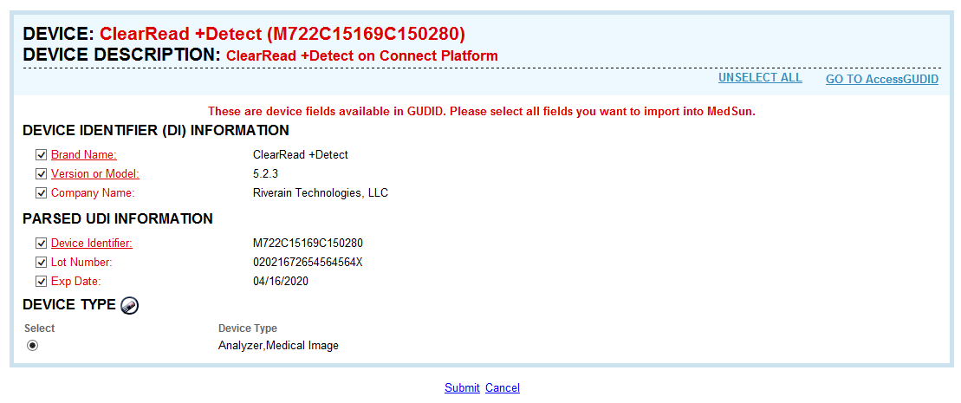
NOTE: MedSun does not display all elements avaliable inUS FDA’s GUDID record. MedSun only extracts the elements from GUDID that are captured in MedSun.

4.2 Use Case 2 – Vigilance Reporting: European Union
An example of how information about the device (including UDIs) could be presented in the forms is given below (taken from the draft EU Manufacturers Incident Report form). As in the MedSun example, the UDI would be parsed into UDI-DI and UDI-PI, and the UDI-DI used to autopopulate parts of this medical device information with the corresponding UDI-DI record data already submitted to the EUDAMED UDI database.

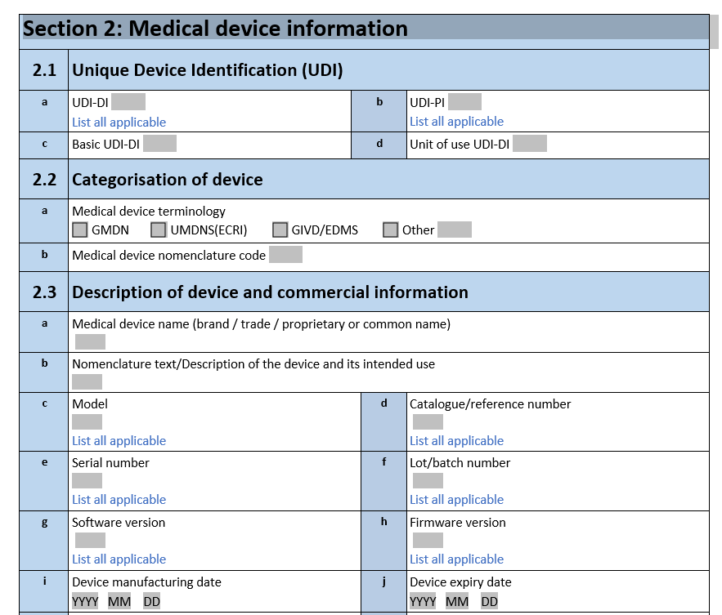
Use UDI-DI to extract, auto-populate and display data from UDID

4.3 Use Case 3 – Medical Device Registry: Society for Vascular Surgery Vascular Quality Initiative (VQI)
VQI offers three ways to enter stents/stent graft data:
- Product number or Catalog Number
- Manufacturer
- UDI-DI

VQI uses the UDI-DI as a means to identify products at the model/company level. A user can enter the initial letters of a product number and see the relationship between the product number and the UDI-DI as listed below.
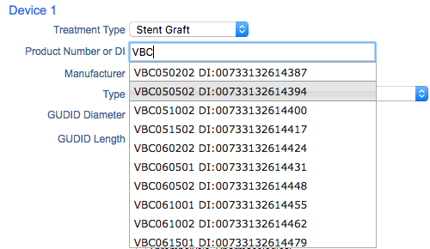

The VQI auto-populates data from GUDID into appropriate fields (manufacturer, type, size) by using the UDI-DI to return data from accessGUDID.
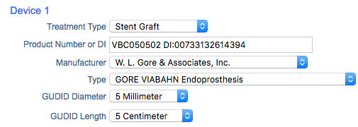

VQI also offers options for selecting from a list of available devices based upon data in GUDID. VQI’s use case demonstrates that there is value to linking the UDI-DI to existing catalog numbers during the current transition period. Users may use existing methods of device identification (such as catalog number) rather than exclusive use of UDI.

IMDRF COMMON DATA ELEMENTS DOCUMENT (pag.9)
Example of a parser that pulls data from a UDID is available at: https://accessgudid.nlm.nih.gov/resources/developers/device_lookup_api
Please note that the final Manufacturers Incident Report form, including UDIs, is to be fully implemented under the new EU Regulations on medical devices which will be applicable as from 26 May 2020 (and 26 May 2022 for in-vitro diagnostic medical devices). The form and the information therein listed might be subject to change.
The Basic UDI-DI is an EU-specific UDI data element. For more information on Basic UDI-DI, please see the IMDRF information document (the document is under preparation).

