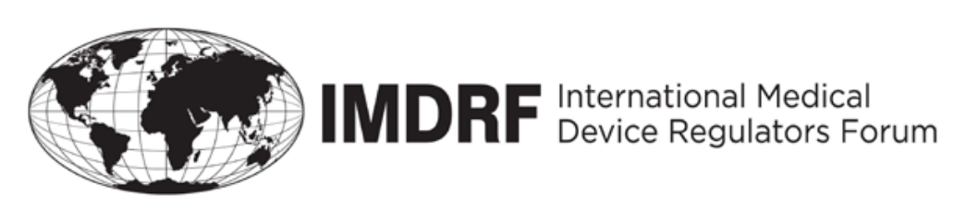

OUTCOME STATEMENT

of the IMDRF-16 MANAGEMENT COMMITTEE
16 to 19 September 2019
The sixteenth meeting of the Management Committee (MC) of the International Medical Device Regulators Forum (IMDRF) took place in Yekaterinburg, Russia, from 16 to 19 September 2019. The meeting was chaired by Russia. The MC consists of regulators from Australia, Brazil, Canada, China, the European Union (EU), Japan, Russia, Singapore, South Korea and the United States of America (USA). The USA participated via WebEx. Representatives of the World Health Organization (WHO) participated as Official Observers and the Asian Harmonization Working Party (AHWP), Pan American Health Organization (PAHO) and Asia-Pacific Economic Cooperation Life Sciences Innovation Forum Regulatory Harmonization Steering Committee (APEC LSIF RHSC) participated as Regional Harmonization Initiatives (RHIs).
On Monday, 16 September, the IMDRF/DITTA Joint Workshop “AI in Healthcare” was attended by 200 participants. Industry representatives, healthcare professionals and regulators presented their views on the development and emerging use of Artificial Intelligence, its application in healthcare, and regulatory approaches to AI-based medical devices.
On the first day of the Management Committee (MC) meeting, September 17th, an Open Stakeholder Forum was held. The Forum had 270 participants representing regulators, industry, and the research community.
In the morning session, participants had an opportunity to hear regulatory updates from Australia, Brazil, Canada, China, EU, Japan, Russia, Singapore, and South Korea and update reports on IMDRF’s eight current working groups. A Questions & Answers session was held after each presentation.
The IMDRF’s current working groups are:
- Regulated Product Submission – Canada
- Medical Device Adverse Event Terminology – Japan
- Good Regulatory Review Practices – USA
- Standards – USA
- Personalized Medical Devices – Australia
- Medical Device Clinical Evaluation – China
- Medical Device Cybersecurity – Canada/USA
- Principles of IVD Medical Devices Classification – Russia
In the afternoon, there was a Stakeholder session including Official Observers, Regional Harmonization Initiatives (RHIs) and Invited Observers. Brief updates were provided by:
- Russian Ministry of Industry and Trade
- Official Observers
  - WHO
- RHIs
- APEC LSIF RHSC
- AHWP represented by Saudi Food and Drug Authority
- PAHO
- Industry
  - DITTA
  - GMTA
  - International association of developers, producers and users of medical technique
  - IMEDA
Day 1 concluded with remarks from the IMDRF chair.
Day 2 started with an open session of regulatory reviews and updates on the progress achieved by Invited Observers:
  - Argentina
  - Republic of Belarus
  - Colombia via WebEx
  - Eurasian Economic Commission
  - Kyrgyz Republic
  - Saudi Arabia
  - Cuba
  - Republic of Kazakhstan
The following session was dedicated to discussions with DITTA and GMTA.
        - DITTA presented results of the discussion from the IMDRF/DITTA Joint Workshop on Artificial Intelligence in Healthcare via WebEx and suggested potential topics for the Workshop in March 2020.
b. GMTA presented on Regulatory convergence for IVDs.
At the end of the open session of the Day 2, WHO presented on standardized international nomenclature of medical devices. The session was concluded by overall discussion of the morning session.
In the afternoon Closed session of Day 2, MC members discussed the Open Stakeholder Forum and the morning session with invited observers and industry.
On the third day, the MC discussed and made decisions regarding the documents submitted by current working groups, New Work Item Extensions proposed by MC members, as well as some procedural issues (See Annex).

ANNEX

DECISIONS BY THE IMDRF MANAGEMENT COMMITTEE
In summary:
- The MC agreed that PAHO could translate IMDRF documents into Spanish and Portuguese. The members discussed the translation of IMDRF documents in general and agreed for the translation of any IMDRF documents by outside organisations, as long as it is clear that the original English version is the official version and link to the original documents on the IMDRF website.
- The MC accepted the final report at IMDRF Analysis of Standards` Recognition and Use Report and IMDRF SWG Standards Checklist.
- The MC discussed the IMDRF SWG’s draft procedures for interactions between IMDRF and Standards Developing Organizations.
- The MC approved the proposed document, N60 “Principles and Practices for Medical Device Cybersecurity”, for a two months’ public consultation period.
- China announced their intention to join the NCAR program.
- The MC continued their discussions on the preparation of a document outlining the implementation status of IMDRF documents by member jurisdiction.
- The MC discussed the proposed changes to the SOP, which includes the New Work Item Proposal and New Work Item Extension adoption process; development, implementation and publication of IMDRF documents; and review procedures and the responsibilities of WG Chairs, the Secretariat and Webmaster.
- The MC approved the NWIE: Post-Market Clinical Follow-Up Studies (update of GHTF/SG5/N4).
- The MC approved three final documents from the Medical Device Clinical Evaluation Working Group: N55: Clinical Evidence – Key Definitions and Concepts, N56: Clinical Evaluation, and N57: Clinical Investigation.
Yekaterinburg, Russia
September 19, 2019

