PROPOSED DOCUMENT
International Medical Device Regulators Forum

Title: Clinical investigation

Authoring Group: Medical Device Clinical Evaluation Working Group

Date: 5 April 2019

This document was produced by the International Medical Device Regulators Forum. There are no restrictions on the reproduction or use of this document; however, incorporation of this document, in part or in whole, into another document, or its translation into languages other than English, does not convey or represent an endorsement of any kind by the International Medical Device Regulators Forum.

Copyright © 2014 by the International Medical Device Regulators Forum

CONTENTS

Preface 3
1 Introduction 4
2 Scope 4
3 References 5
4 Definitions 6
5 General Principles When Considering the Need for a Clinical Investigation 7
6 General Principles of Clinical Investigation Design 9
7 Ethical Considerations for Clinical Investigations 12

Preface
The document herein was produced by the International Medical Device Regulators Forum (IMDRF), a voluntary group of medical device regulators from around the world.

There are no restrictions on the reproduction, distribution or use of this document; however, incorporation of this document, in part or in whole, into any other document, or its translation into languages other than English, does not convey or represent an endorsement of any kind by the International Medical Device Regulators Forum.

Introduction
What is clinical investigation?

A clinical investigation is defined as “any systematic investigation or study in or on one or more human subjects, undertaken to assess the safety, clinical performance, and/or effectiveness of a medical device”. (ISO 14155:2011)

The undertaking of a clinical investigation is a scientific process that represents one method of generating clinical data.

What is the objective of a clinical investigation?

The objective of a clinical investigation is to assess the safety, clinical performance and/or effectiveness of a medical device for a particular indication or intended use.

How is a clinical investigation conducted?

ISO 14155: 2011 Clinical Investigation of Medical Devices for Human Subjects — Good clinical practice details the requirements for the conduct of clinical investigations. Clinical investigations must take into account scientific principles underlying the collection of clinical data along with accepted ethical standards surrounding the use of human subjects.

This document supersedes an earlier version produced under the Global Harmonization Task Force (GHTF) with the same title in May, 2007 (GHTF/SG5/N3:2010).

Scope
The primary purpose of this document is to provide guidance in relation to:

- when a clinical investigation should be undertaken for a medical device to demonstrate compliance with the relevant Essential Principles (see IMDRF/GRRP WG/N47 FINAL:2018 “Essential Principles of Safety and Performance of Medical Devices and IVD Medical Devices”); and
- the general principles of clinical investigation involving medical devices.

Given the wide diversity of medical devices and their associated risks, this document is not intended to provide comprehensive guidance for clinical investigations of specific medical devices.

The guidance contained within this document is intended to apply to medical devices generally and combination products regulated as medical devices. It is not intended to cover in vitro diagnostic medical devices. Additionally, this document was drafted primarily to address the use of Clinical Investigations to support a marketing authorization application. Some aspects of this document may apply to studies conducted following commercial release of a device. Future GHTF documents will specifically address post-market clinical follow-up studies.

References
IMDRF/GHTF final documents

GHTF SG1/N011:2008 Summary Technical Documentation for Demonstrating Conformity to the Essential Principles of Safety and Performance of Medical Devices (STED)

GHTF SG1/N029:2005 Information Document Concerning the Definition of the Term “Medical Device”

IMDRF GRRP WG/N47 FINAL: 2018 Essential Principles of Safety and Performance of Medical Devices and IVD Medical Device

GHTF SG1/ N78:2012 Principles of Conformity Assessment for Medical Devices

GHTF SG1/N43:2005 Labelling for Medical Devices

IMDRF MDCE WG (PD1)/Nx Clinical Evidence – Key definitions and Concepts

IMDRF MDCE WG (PD1)/Nx Clinical Evaluation

International standards

ISO 14155 2011 Clinical investigation of medical devices for human subjects — Good clinical practice

ISO 14971: 2007 Medical devices -Application of risk management to medical devices

Other References

World Medical Association – Declaration of Helsinki - Ethical principles for medical research involving human subjects

Definitions
Clinical Data: Safety, clinical performance, and/or effectiveness information that is generated from the clinical use of a medical device.

Clinical Evaluation: A set of ongoing activities that use scientifically sound methods for the assessment and analysis of clinical data to verify the safety, clinical performance, and/or effectiveness of the device when used as intended by the manufacturer.

Clinical Evidence: The clinical data and the clinical evaluation report pertaining to a medical device.

Clinical Investigation: Any systematic investigation or study in or on one or more human subjects, undertaken to assess the safety, clinical performance, and/or effectiveness of a medical device.

Clinical Investigation Plan: Document that states the rationale, objectives, design and pre-specified analysis, methodology, monitoring, conduct and record-keeping of the clinical investigation.

Clinical Performance: The ability of a medical device to achieve its intended purpose as claimed by the manufacturer.

Effectiveness: The ability of a medical device to achieve clinical outcome(s) in its intended use as claimed by the manufacturer.

Safety: Acceptable risks as weighed against benefits, when using the device according to the manufacturer’s Instructions for Use.

Conformity Assessment: The systematic examination of evidence generated and procedures undertaken by the manufacturer, under requirements established by the Regulatory Authority, to determine that a medical device is safe and performs as intended by the manufacturer and, therefore, conforms to the Essential Principles of Safety and Performance for Medical Devices and IVD Medical Device (IMDRF GRRP WG/N47 FINAL:2018) .

Endpoint: An indicator used for providing the evidence for safety, clinical performance, and/or effectiveness in a clinical investigation (ISO 14155:2011, modified).

Multi-Regional Clinical Investigation: A clinical investigation conducted in more than one region under a single protocol.

Region: A geographical region, country or regulatory region.

Regulatory Region: A region comprised of countries for which a common set of regulatory requirements applies for medical device approval (e.g., EU).

Residual Risk: Risk remaining after risk control measures have been taken (ISO 14971:2007).

Risk Management: Systematic application of management policies, procedures and practices to the tasks of analysing, evaluating, controlling and monitoring risk (ISO 14971).

General Principles When Considering the Need for a Clinical Investigation

When should a clinical investigation be undertaken?

Clinical investigations are necessary to provide data not available through other sources (such as literature or preclinical testing) required to demonstrate compliance with the relevant Essential Principles (including safety, clinical performance and acceptability of benefit/risk associated with its use). When a clinical investigation is conducted, the data obtained is used in the clinical evaluation process and is part of the clinical evidence for the device (see IMDRF/MDCE WG(PD1)/Nx– “Clinical Evaluation”).

When considering the need for a clinical investigation, one should consider whether there are new questions of safety, clinical performance and/or effectiveness for the particular device and intended use that need to be addressed in a clinical investigation. Generally, such questions are more likely to be generated for high risk and/or novel devices.
For long established technologies, the clinical investigation data that might be required for novel technologies may not be necessary. The available clinical data in the form of, for example, published literature, reports of clinical experience, post-market reports and adverse event data may, in principle, be adequate to establish the safety, clinical performance, and/or effectiveness of the device, provided that new risks have not been identified, and that the intended use(s)/purpose(s) has/have not changed.

What are the key considerations in clarifying the need for clinical investigations?

- Identifying relevant clinical Essential Principles (for example, specifics of safety, clinical performance, acceptability of benefit/risk) for the device and its intended use/purpose(s) (see IMDRF/GRRP WG/N47 FINAL:2018 Essential Principles of Safety and Performance of Medical Devices and IVD Medical Device);

- Performing risk management (ISO 14971:2007) activities such as a risk analysis will help in identifying the clinical data necessary to address residual risks and aspects of clinical performance not completely resolved by available information (e.g. design solutions, preclinical and material/technical evaluation, conformity with relevant standards, labelling).

Risk control measures include inherent safety by design, protective measures in the medical device itself or in the manufacturing process, and information for safety. The decision to use a medical device in the context of a clinical procedure requires the residual risk to be balanced against the anticipated benefits of the procedure. A clinical investigation may be required to further elucidate the benefit/risk in a defined patient population;

- Conducting a proper clinical evaluation will demonstrate which clinical data are necessary, and can be adequately contributed to by sources such as literature searching, prior clinical investigations (including clinical data generated in other jurisdictions), clinical experience, or clinical data available from comparable devices, and which clinical data should be generated from clinical investigation(s) when data are unavailable or insufficient to demonstrate conformity to the Essential Principles. Available clinical data from comparable devices should be carefully examined for comparability and adequacy (see IMDRF/MDCE WG (PD1)/Nx Clinical Evaluation).

Key considerations for clarifying the need for clinical investigations are illustrated by the flowchart in Figure 1.

Where uncertainty exists as to whether current data are sufficient to demonstrate conformity with the Essential Principles, discussion with the relevant regulatory authorities or conformity assessment bodies may be appropriate.

Note: This exercise is applicable for the introduction of a new device as well as for planned changes of a device, its intended use and/or claims.

6 General Principles of Clinical Investigation Design

Any clinical investigation must:

- be based on the results of the clinical evaluation process;
- follow a proper risk management procedure to avoid undue risks;
- be compliant with all relevant legal and regulatory requirements;
- be appropriately planned, conducted, analysed and reported;
- follow appropriate ethical principles (see Section 7).
The design of the clinical investigation, including the study objectives and statistical considerations, should provide the clinical data necessary to address the residual risks, including
aspects of clinical performance. Some factors that may influence the extent of data requirements include, but are not limited to, the following:
- type of device and/or regulatory classification;
- novel technology/relevant previous experience;
- clinical application/indications;
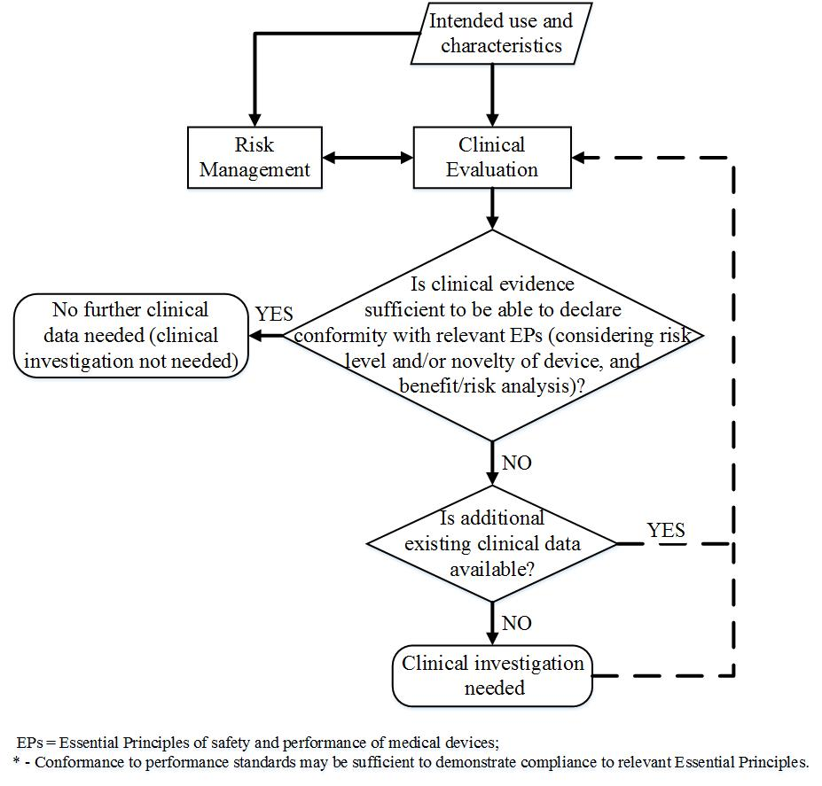
Figure 1 Key considerations for clarifying the need for clinical investigations

- nature of exposure to the product, e.g.: surface contact, implantation, ingestion;
- risks inherent in the use of the product, e.g.: risk associated with the procedure;
- performance claims made in the device labeling (including instructions for use) and/or promotional materials;
- component materials or substances;
- disease process (including severity) and patient population being treated;
- demographic, geographic and cultural considerations (e.g.: age, ethnicity, gender, etc.);
- potential impact of device failure;
- period of exposure to the device;
- expected lifetime of the device;
- availability of alternative treatments and current standard of care; and
- ethical considerations.
Considerations for Device Study Protocols
Factors needing consideration in study protocols include:
- clear statement of objectives
- primary and secondary endpoints, or composite endpoints if applicable
- appropriate subject population(s)
- minimization of bias (e.g., randomization, blinding/masking, concealment of allocation)
- identification of confounding factors (e.g., concurrent medications, co-morbidities)
- choice of appropriate controls (e.g., active control, sham, historical), where necessary
- design configuration (e.g., parallel, crossover, cohort study, single arm)
- type of comparison (e.g., superiority, non-inferiority, equivalence)
- follow-up duration and monitoring, where necessary
In designing the study, statistical considerations should be prospectively specified and be based on sound scientific principles and methodology. Care must be taken in developing a statistical plan that includes consideration of, for example, the following:
  - clinically relevant endpoints
  - analysis population (e.g. intention-to-treat, per-protocol)
  - statistical significance levels, power
  - sample size calculation and justification
  - analysis methodology (including sensitivity analyses)
  - accounting for learning curve or run-in issues
  - the provision for an interim analysis, where applicable
  - management of potential confounding factors (e.g. adjustment, stratification or stratified randomization)
  - describe procedures for multiplicity control and adjustment of error probabilities, if applicable
  - the specification of subgroups for analysis, if applicable
  - the handling of missing, unused or spurious data, including drop-outs
  - procedures for reporting any deviation(s) from the original statistical analysis plan
The design should ensure that the statistical evaluation derived from the investigation reflects a meaningful, clinically significant outcome.
Multi-regional clinical investigation designs may be considered to facilitate more efficient medical device development, thus providing earlier access to new medical devices worldwide. For multi-regional clinical investigation designs, the potential differences between two or more regions that might affect study results should be carefully considered.
Discussion with the relevant regulatory authorities or conformity assessment bodies may be appropriate when there is uncertainty as to whether the proposed clinical investigational plan is sufficient.

Conduct of Clinical Investigations
A properly conducted clinical investigation, including compliance to the clinical investigation plan and local laws and regulations, ensures the protection of human subjects, the integrity of the data and that the data obtained is acceptable for the purpose of demonstrating conformity to the Essential Principles. ISO 14155 outlines good clinical practice for clinical investigations of medical devices.

Final Study Report
The outcome of a clinical investigation should be documented in a final study report. This then forms part of the clinical data that is included in the clinical evaluation process and ultimately becomes integrated into the clinical evaluation report (see IMDRF/MDCE WG(PD1)/Nx Clinical Evaluation) for the purposes of conformity assessment.

7 Ethical Considerations for Clinical Investigations

As a general principle, “the rights, safety and wellbeing of clinical investigation subjects shall be protected consistent with the ethical principles laid down in the Declaration of Helsinki” and the applicable regulatory requirements or other relevant standards (ISO 14155:2011).

It is ethically important in deciding to conduct a clinical investigation that it should generate new data and answer specific safety, clinical performance, and/or effectiveness questions that remain unanswered by the current body of knowledge. The desire to protect human subjects from unnecessary or inappropriate experimentation must be balanced with the need to protect public health through the use of clinical investigations where they are indicated. In all cases, however, care must be taken to ensure that the necessary data are obtained through a scientific and ethical investigational process that does not expose subjects to undue risks or discomfort. The rights, safety and well-being of subjects are paramount, and appropriate trial design and conduct is essential to generate meaningful data.

