**AE WG(PD1)/N43R1**

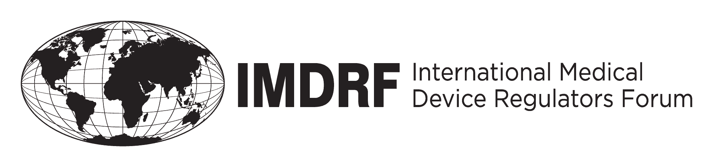

**PROPOSED DOCUMENT**

**International Medical Device Regulators Forum**

**Title: IMDRF terminologies for categorized Adverse Event Reporting**

**(AER): terms, terminology structure and codes**

**Authoring Group: IMDRF Adverse Event Terminology Working Group**

**Date: 22 July 2016**

**Table of Contents**

The table of contents should be created on this page. See “IMDRF Document Format & Style

1. Introduction 4

2. Scope 5

2.1 Use of the adverse event reporting terminology 5

2.2 Intended end-users of the adverse event reporting terminology 5

3. Definitions 5

4. References 6

5. Adverse event terminology 6

5.1 Adverse event terminology used in adverse event reporting 6

5.2 Basic considerations regarding terms, codes and hierarchical coding structure 10

5.3 The four terminologies comprising the complete adverse event reporting terminology 11

6. Maintenance of adverse event terminology 15

6.1 Work streams for modifications / adaptations 15

6.2 Decision making on modifications / adaptations 15

6.3 Publication of adapted terminology 16

Annexes 17

Annex A: Medical Device Problem Terms and Codes 18

#### Preface

This guidance document was produced by the International Medical Device Regulators Forum (IMDRF), a voluntary group of medical device regulators from around the world. The document has been subject to consultation throughout its development.

There are no restrictions on the reproduction, distribution or use of this document; however, incorporation of this document, in part or in whole, into any other document, or its translation into languages other than English, does not convey or represent an endorsement of any kind by the International Medical Device Regulators Forum.

# 1. Introduction

This document has been prepared by the IMDRF Adverse Event Working Group, charged with developing a harmonized terminology for reporting adverse events that are known or suspectedto be linked to the use of medical technology (medical devices and in vitro diagnostic medical devices).

Widespread use of a single, appropriate adverse event terminology and coding system will improve signal detection by adverse event management systems enabling a faster response by both the industry and the regulatory agencies.

Use of a defined **terminology** as well as associated **codes** to describe problems encountered with medical devices provides several benefits:

it improves the accuracy of capturing and reporting of medical device problems,

it reduces ambiguity and hence increases effectiveness of the evaluation process and

it is readily usable, in contrast to narrative text, for more sophisticated approaches to signal detection (i.e. the identification of novel risks) and trending analysis by incident management systems including advanced querying functions and data visualization, enabling a faster response by both, regulatory agencies and device manufacturers.

A globally harmonized terminology and associated codes has the following benefits:

* **For manufacturers:** it provides **consistency for manufacturers** reporting to multiple jurisdictions, reducing the burden of managing multiple coding systems when preparing medical device adverse event reports for multiple jurisdictions. It protects business interests by deflecting potential damages.
* **For regulatory authorities:** by providing common terms and definitions, it supports analysis of safety, quality and performance information in a manner that can readily be shared globally: common terms will increase accuracy and reliability about medical device adverse events between regulatory agencies.
* **For patients:** it protects patients by **enabling faster local and international response** to adverse events due to problems with medical devices including medical device malfunctions/deteriorations.
* **For healthcare providers:** it provides suitable terms and definitions which may be used for User Report regarding the adverse events to be submitted to the authorities as well as for intra-organizational reporting: use of common terms with manufacturers and regulators may enhance accuracy and reliability of the report.

# 2. Scope

## 2.1 Use of the adverse event reporting terminology

This document provides the preferred terms and IMDRF numerical codes to be used for coding device problems in medical device Adverse Event (AE) reporting systems (including in vitro diagnostics).

Notably, the precise criteria for reporting adverse events are defined by each regulatory jurisdiction and are not subject to this guidance document. Reference is made to the relevant guidance documents of each jurisdiction and the GHTF document on Post Market Surveillance: Global Guidance for Adverse Event Reporting for Medical Devices (GHTF, 2005).

## 2.2 Intended end-users of the adverse event reporting terminology

The set of terminologies outlined in this document are intended for use by

1. *reporters* of adverse events which are obligated to be reported to the authorities in accordance with the relevant regulations of each jurisdiction;
2. *regulatory authorities*, collecting and processing such information and related data in databases and other electronic systems for purposes of effective monitoring and analysis of adverse events in view of protection of patients and public health. Regulatory authorities may be national competent authorities (NCAs) or supranational bodies charged with these tasks.

# 3. Definitions

**Adverse Event reporting System**

Reporting system for adverse event and regulatory obligate to make report about the fact to the regulatory authorities. Reporting obligation details may different in each jurisdiction. ***GHTF/SG2 /N54R8:2006***

**Adverse Event**

Event associated with a medical device that led to death or serious injury of a patient, user or other person, or that might lead to death or serious injury of a patient, user or other person if the event recurs.

NOTE: This definition is consistent with guidance in GHTF/SG2/N54R8:2006

**Incidents**

Malfunctions or deterioration in the safety, quality or performance of a device made available on the market, any inadequacy in the information supplied by the manufacturer and undesirable side-effects.

**Medical Device Malfunction**

A failure of a device to perform in accordance with its intended purpose when used in accordance with the manufacturer’s instructions for use.

***GHTF/SG2/N54R8:2006***

**User**

The person, either professional or lay, who uses a medical device. The patient may be the user.

***GHTF/SG1/N70:2011***

# 4. References

The following documents were used in the development of this document.

* ISO /TS 19218-1 Medical device- Hierarchical coding structure for adverse event – Part 1 Event –type codes
* GHTF/SG1/N70:2011 Label and Instructions for Use for Medical Devices
* GHTF/SG2/N54R8:2006 Post Market Surveillance: Global Guidance for Adverse Event Reporting for Medical Devices
* GHTF/SG2/N87:2012 Medical Devices: Post Market Surveillance:  An XML Schema for the electronic transfer of adverse event data between manufacturers, authorized representatives and National Competent Authorities
* Event Problem Codes of US FDA, which is available at; <http://www.fda.gov/MedicalDevices/DeviceRegulationandGuidance/PostmarketRequirements/ReportingAdverseEvents/EventProblemCodes/default.htm>

# 5. Adverse event terminology

## Adverse event terminology used in adverse event reporting

The adverse event terminology is intended to serve as a tool for addressing reporting needs identified in previous guidance (e.g. GHTF/SG2/N54R8:2006) and relating to the occurring of adverse events in the post-market period. Due to the requirement for clinical evidence to be generated in the pre-market period, the devices will be used on patients before regulatory approval, therefore the terminology for adverse events may also be used for event and incidents occurring during the pre-market period (e.g. during clinical trials).

The adverse event terminology outlined here consists of four sets of specific terminologies (see section 1.4 for more details) and is intended to facilitate the reporting of

1. **observations** at the level of the ***medical device***
2. and its constituting ***components*** including accessories,
3. **observations** at the level of the ***patient*** (i.e. the actual "adverse event" concerning patient or user health)
4. **investigations** into possible ***causes*** relating to malfunctioning of the device as well as ***causal links*** between use of the device (independent whether malfunctioning or not) and adverse event (i.e. clinical observation).

This is graphically summarized in ***Figure 1***.



***Figure 1:*** *Purpose of adverse event reporting terminology. The key objective of adverse event reporting is to understand whether there is a causal link between use of a device and adversity at patient or user level (adverse event).*

As for other hazard and risk analysis frameworks conducted in the interest of protection of patients, end-users or public health, the central question that both industry and regulators need to address in the context of adverse event reporting of medical devices is whether there is a *causal link* between adversity at patient/user level and use of devices. This allows for appropriate corrective and preventive action to be taken.

Adversity happens at the level of patients, users or other persons, and relates primarily to observations of *physiological/clinical/diagnostic adverse events*. The term adverse event hence relates to any undesired and negative effects on the health of patients, ranging from misdiagnosis, discomfort, pain, complications to serious injury or death.

Importantly, adversity may, but need not be, triggered by malfunctioning, failure or errors of instructions of use only. Adverse effects on health may also be due to intrinsic properties of devices that appear to function as intended. Reporting of adversity at patient level that may be linked in a hitherto unknown manner to use of the device is key during clinical investigations but also important in the post-market period: it allows for detection of a correlation between use of a device and adversity that may be indicative of causal links. Consequently, relevant guidance (GHTF/SG2/N54:2006) has outlined previously, that

*"The act of reporting an event … is not to be construed as an admission of manufacturer, user, or patient liability for the event and its consequences. […] It is also* ***not a conclusion that the******device******caused or contributed to the******adverse event****."*

Reporting adverse events that are not linked to an obvious malfunction of the device is key for detecting novel risks or hazards that were not yet known or observed.

In principle, the observation of problems can start either from observations of device-related problems (incidents) or from observations of problems at the level of the patient, user or any other person using, applying or otherwise being exposed to the device (adverse events). See Figure 2 – the definition of "adverse event" in fact relates to observations of clinical signs or otherwise in the context of clinical investigations including screening and diagnostic purposes, despite the fact that the term adverse event reporting is generally used for post-market surveillance purposes (see GHTF/SG2/N54:2006).

Independent of the starting point of the observation (device or patient), it is not always clear whether there is a causal link between the two types of phenomena. In particular, it not always immediately clear when observing adverse events in patients whether these are indeed causally linked to use of a device, especially in cases where the device does not show any malfunction, failure or any other issue. In such cases it is important to give consideration to conceivable causes of the observed adverse event and, once other possibly confounding factors (e.g. existing diseases, conditions, side-effects of medication, use error) have been ruled out, to report such adverse events. This is particular relevant for devices that are implanted into the body, inserted into body orifices and/or used for long periods of time (consider issues linked to chronic exposure to materials used in the device).

Considering the above, the terminologies outlined here can serve to report the totality of observed or possible events:

* **Adverse events**
* **Incidents**

Both, incidents at device level may, but need not to be, accompanied by manifested adverse health effects: reporting needs to cover cases in which possible effects may have happened in the past or may happen in the future, in particular, if the incident / event at device level were to reoccur.

Equally, adverse events may be observable without, at the time of reporting, a clear established and evidence-based link to use of the device. This is schematically summarized in ***Figure 2***.

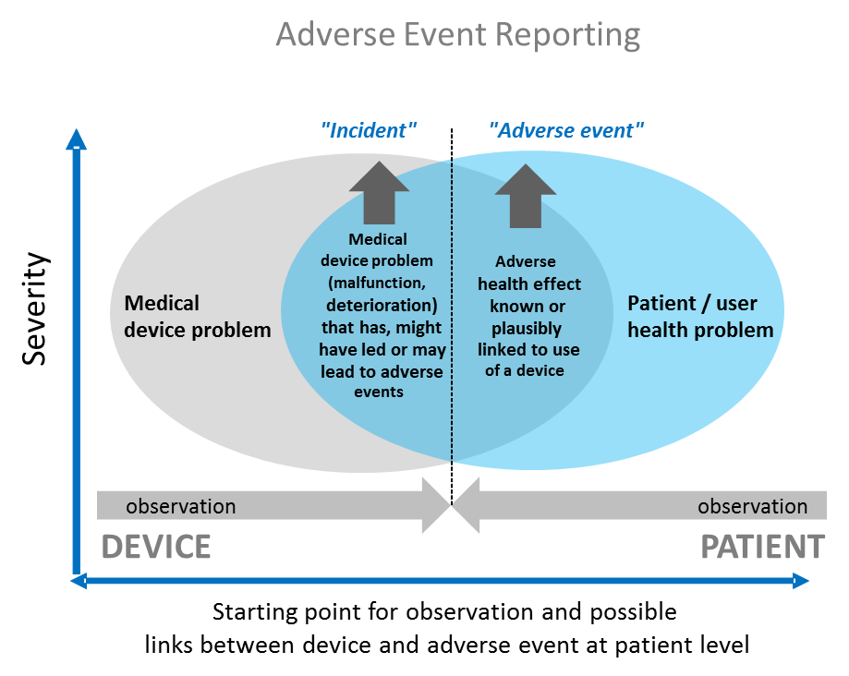

***Figure 2:*** *Adverse event reporting covers (1) notification of incidents that typically start with observations at device level or for which device malfunctions / failures are well documented. Importantly, incidents may but need not have led to manifested adverse health effects. Adverse event reporting further covers (2) adverse events such as adverse clinical signs or otherwise in patients or users that cannot be linked to other factors and appear to correlate with the use of the device, possibly indicating causality.*

## 5.2 Basic considerations regarding terms, codes and hierarchical coding structure

To ease use of terminologies (in particular in databases) and to reduce possible ambiguities of meaning, each term is uniquely identified by a alphanumerical code and is further explained by a definition and concrete examples. The set of terminologies is based on currently available terminologies which have been revisited, improved, and as appropriate, either expanded or simplified.

The four keywords (term, terminology, code and hierarchical coding structure) are briefly explained in the following:

* **Term/Terminology:** The use of terminologies (i.e. a controlled set of well-defined terms) can aid the description of events by reducing ambiguity of narrative text through categorization of events.
* **Code/coding:** Ambiguity can be further reduced by the use of numerical *codes*, assigned to a predefined *term* from a given pre-defined and controlled *terminology*. This assignment is called "*coding*".
* **Hierarchical coding structure** refers to the logical arrangement of such coded terms in branching structures comprising several hierarchical levels, i.e. comparable to a logical decision tree.

Although such hierarchical arrangement has been referred to as "coding structure" (e.g. ISO TS 19218), it is important to note that it is primarily the *terms* and their descriptions that are of interest, while the codes are merely used to unambiguously identify the terms and are thus of secondary importance. In such a hierarchical term structure (coding structure), more general terms comprise the entry level (e.g. "Level 1"). From each level 1, second level terms (level 2) branch-off that allow to resolve various options of finer description of the level 1 term. Therefore, with increasing number of level 2 terms, the resolution and descriptive power of the hierarchical system grows. Another option to increase the resolution is to introduce additional hierarchical levels that each branch-off from the previous hierarchal level (e.g. levels 3, 4 etc.). The advantage of a hierarchically arranged terminology ("coding structure"), a large variety of terms can be handled by users in a relatively accessible way, i.e. without the need to know all terms before using the system. Developing an effective hierarchical coding structure however requires that (1) level 1 terms are kept to a small number so as to ease entry into the logical tree of the hierarchical coding structure, (2) that the arrangement of second and third and any other levels follows intrinsically decision-logic and/or maps logical options and (3) avoids duplication of terms / codes which would be confusing. Finally, there is obviously a trade-off between *resolution* (i.e. number of levels and number of terms/codes) and *practicability* of such systems for users, including health care workers, manufacturers and regulatory authorities.



***Figure 3:*** *Schematic summary of relevant keywords with respect to adverse event terms: "term", "terminology", "code", "coding", “hierarchical coding structure" and associated "levels".*

## 5.3 The four terminologies comprising the complete adverse event reporting terminology

As indicated in section 5.1 the complete adverse event terminology is comprised of four distinct sets of terminologies and their associated alphanumerical codes (***Table 1, Figure 3***):

1. **Medical Device Problem terms / codes:** these terms allow capturing the problems encountered at device(s) level through observational language without yet describing possible reasons or causes for the problems or failures (defined as complete non-performance) observed. Annex A provides a comprehensive list of medical device problem terms. It is recognized that not all jurisdictions may want to code to such detailed levels. The hierarchical structure will allow jurisdictions to choose the number of levels of codes to use – this possibly also concerns the other nomenclatures below. Reporters should be encouraged to code/report to the lowest level required. These terms are largely based on FDA's device issue terms and are harmonized with ISO TIR 19218-1, where possible. The corresponding ISO codes as well as corresponding US FDA codes are provided in a separate background document.
2. **Cause investigation terms / codes:** these terms allow capturing the methods, results and conclusions of investigations into the possible causes for the problems at medical device level and may allow capturing the plausibility of medical device problems being causally linked to adverse events observed at patient level. These need to be developed and will be outlined in Annex B once available.
3. **Patient problem terms / codes:** these terms allow describing the clinical problems and outcomes observed, i.e. the actual adversity or adverse event at patient or user level. These need to be developed and will be outlined in Annex C once available.
4. **Component terms / codes:** these terms identify and describe specific components that were involved and played a key role with respect to the problems or failures observed and may hence have played a causal role in possible related adversity at patient or user level. These need to be developed and will be outlined in Annex D once available.

The four terminologies will be phased gradually and will constitute Annexes A to D of this document. At present, only Annex A (Medical Device Problem terms/codes) has been finalized and included in this document. An overview of the four terminologies and associated codes is given in Table 1.

The code structure for the nomenclature is foreseen as follows and has been used for the medical device problem terminology (Annex A):

X|nn|nn|nn

X is a placeholder for the annex in which the relevant nomenclature is reproduced:

Annex A: Medical Device Problem Terminology

Annex B: Cause Investigation Terminology

Annex C: Patient Problem Terminology

Annex D: Component Terminology

N are placeholders for Arabic numbers uniquely identifying the term (three levels) with Level 1 terms populating digits 1-2 only, Level 2 terms populating digits 3 to 5 (and maintaining the Level 1 parent term digits), Level 3 terms using digits 6 to 7 – again maintaining the level 1 and 2 parent term digits.

Each code thus reflects the relationship to the parent / child term and the body of nomenclature it belongs to. Having three digits per level allows for changes in the future (deletion of terms / introduction of terms), which requires assignment of *new* codes so as to allow *backward compatibility* with existing terms/codes from previous reporting and as compiled in data bases.

***Table 1:*** *Overview of the four terminologies comprising the complete terminology for adverse event reporting.*

|  |  |  |  |  |
| --- | --- | --- | --- | --- |
| **Nr.** | **Name of terminology** | **Description** | **Annex** | **Coding system** |
| 1 | Medical device problem | Terms/codes for describing problems (malfunction, deterioration of function, failure) of medical devices that have occurred in pre- or post-market contexts (e.g. clinical studies, clinical evaluation or post-market surveillance) | A | A|00|00|00 |
| 2 | Cause investigation | Terms/codes for describing the methods, results and conclusions of investigations into possible causes of the medical device problem which may also allow to conclude on causal links between device problem and adverse event and on the pathway of adversity. | B – to be developed | B|… (to be defined) |
| 3 | Patient Problem | Terms/codes for describing the clinical signs at patient and/or user level. | C – to be developed | C|… (to be defined) |
| 4 | Component | Terms/codes for describing the components involved in the medical device problem | D – to be developed | D|… (to be defined) |

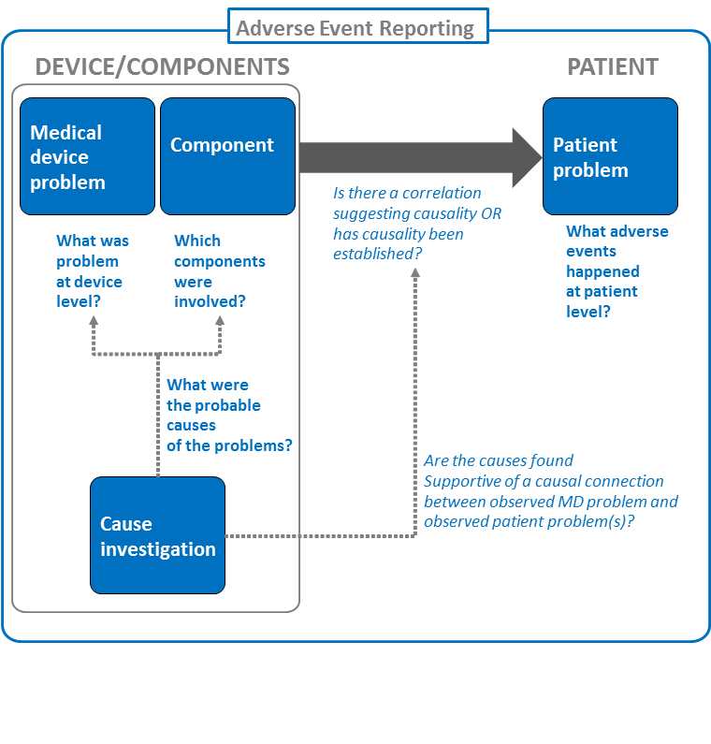

***Figure 4:*** *The Adverse Event Reporting terminology is composed of four sets of terminologies: (1) Medical device problem terminology, (2) components terminology, (3) cause investigation terminology and (4) patient problem terminology. Note that for an effective monitoring of adverse events, means of effectively identifying devices as well as the category they belong to (e.g. GMDN) are important.*

# Maintenance of adverse event terminology

Due to the nature of the medical device industry and the implementation of new technologies, materials, designs, procedures etc., the medical device problem terms, and its associated component terms are expected to require updating to adapt to technical progress. For this reason there is need for periodic review and maintenance of the constituting terminologies and codes in view of adding, modifying or removing terms as required.

However, it is important to stress that changes to the AE terminology should be restricted to the absolute necessary, i.e. mainly reserved for adaptation to technical progress (new terms as new devices, designs and materials emerge). Too frequent an adaptation or change of the terminology would be counterproductive and costly for all involved parties and end users since this may require re-programming of automated coding systems at the level of industry and regulators alike.

### 6.1 Work streams for modifying/updating terminology

Modifications may be triggered (1) by competent authorities or (2) by stakeholders:

1) Jurisdictions (i.e. the competent authorities) may identify necessary modifications to the terminology. In such as case the respective authority will submit the requested change to the IMDRF Adverse Event Terminology Maintenance Working Group (AETM WG). The AETM WG will review the medical device problem terms, patient problem terms, component terms and cause investigation terms, and any requested changes and, based on consensus, prepare a recommendation for the management committee in view of endorsing the relevant change (see below "decision making".

2) Proposals for amendment/changes can also be forwarded by stakeholder associations representing manufacturers or other interested stakeholders (e.g. patients, professional medical associations etc.).

### 6.2 Decision making on modifying/updating

Irrespective of the source of the proposal, the AETM WG will consider the proposals for modifications and, based on consensus, submit a formal proposal (“Change request”) to the IMDRF MC for consideration and decision making. Once the MC has approved the modification, the AETM WG will revise this guideline document and relevant annexes accordingly.

### 6.3 Publication of adapted terminology

While changes will be discussed by the working group due to the time it takes for regulatory authorities and industry to incorporate any coding changes, an updated coding list will be released only. Schedule for modifying/updating the terminology is to be decided by the AETM WG.

# Annexes

## Annex A: Medical Device Problem Terms and Codes