**AE WG(PD1)/N43(Edition 3)R1**



**PROPOSED DOCUMENT**

**(for Annex E and F)**

**Title: IMDRF terminologies for categorized Adverse Event Reporting**

**(AER): terms, terminology structure and codes**

**Authoring Group: IMDRF Adverse Event Terminology Working Group**

**Date: 12 July 2018**

**Table of Contents**

1. Introduction 5

2. Scope 6

2.1 Use of the adverse event reporting terminology 6

2.2 Intended end-users of the adverse event reporting terminology 6

3. References 7

4 Adverse event terminology 7

4.1 Adverse Event Reporting 7

4.2 Adverse event terminology used in adverse event reporting 8

4.3 Basic considerations regarding terms, codes and hierarchical coding structure 9

4.4 The four sets of terminologies and coding system comprising the complete adverse event reporting terminology 11

4.5 Description of the four sets of terminologies 15

5. Maintenance of adverse event terminology 18

Annexes 19

Annex A: Medical Device Problem Terms and Codes 20

Annex B: Cause Investigation – Type of Investigation Terms and Codes 21

Annex C: Cause Investigation – Investigation Findings Terms and Codes 22

Annex D: Cause Investigation – Investigation Conclusion Terms and Codes 23

Annex E: Health Effect – Clinical Signs, Symptoms and Conditions Terms and Codes 24

Annex F: Health Effect – Health Impact Terms and Codes 25

#### Preface

This guidance document was produced by the International Medical Device Regulators Forum (IMDRF), a voluntary group of medical device regulators from around the world. The document has been subject to consultation throughout its development.

There are no restrictions on the reproduction, distribution or use of this document; however, incorporation of this document, in part or in whole, into any other document, or its translation into languages other than English, does not convey or represent an endorsement of any kind by the International Medical Device Regulators Forum.

# 1. Introduction

This document has been prepared by the IMDRF Adverse Event Working Group, charged with developing a harmonized terminology for reporting adverse events related to medical devices including in-vitro diagnostics (IVDs).

Widespread use of a single, appropriate adverse event terminology and coding system is expected to improve signal detection by adverse event management systems enabling a faster response by both industry and regulatory authorities.

Use of defined **terms** as well as associated **codes** to describe problems encountered with medical devices provides several benefits:

it improves the accuracy of capturing and reporting of medical device related adverse events;

it reduces ambiguity and hence increases effectiveness of the evaluation process; and

it is readily usable, in contrast to narrative text, for more sophisticated approaches to signal detection (i.e. the identification of potential novel risks) and trending analysis by incident management systems including advanced querying functions and data visualization. Thus enabling a faster response by both regulatory authorities and device manufacturers.

A globally harmonized terminology and associated codes also has the following benefits:

* **For manufacturers (including local distributors/authorized representatives):** it provides **consistency for manufacturers** reporting to multiple jurisdictions, reducing the burden of managing multiple coding systems when preparing medical device adverse event reports for multiple jurisdictions;
* **For regulatory authorities:** by providing common terms and definitions, it supports analysis of safety, quality and performance information in a manner that can readily be shared globally: common terms will increase accuracy and reliability of information exchanged about medical device adverse events between regulatory authorities, and may facilitate more rapid detection of potential safety signals when pooled at inter-regional levels;
* **For patients:** it protects patients by **enabling faster local and international response** to medical device adverse events including those related to medical device malfunctions/deteriorations;
* **For healthcare providers:** the use of common terms with manufacturers and regulators may enhance accuracy, reliability and utility of the reports, especially when larger datasets can be pooled and analyzed. It may also, provide terms and definitions, some of which are within a hierarchical form, to be used for adverse event reporting within or between healthcare facilities.

# 2. Scope

## 2.1 Use of the adverse event reporting terminology

This document provides the IMDRF terms, definitions and IMDRF alpha-numerical codes to be used for Adverse Event (AE) reporting concerning medical devices and in vitro diagnostics both pre and post market as described in section 5.

Notably, the precise criteria for reporting adverse events are defined by each regulatory authority and are not subject to this guidance document. Reference is made to the relevant guidance documents of each jurisdiction and the GHTF document on Post Market Surveillance: Global Guidance for Adverse Event Reporting for Medical Devices (GHTF, 2006).

## 2.2 Intended end-users of the adverse event reporting terminology

The set of terminologies outlined in this document are intended for use by:

1. *reporters* of adverse events which are obligated to be reported to the authorities in accordance with the relevant regulations of each jurisdiction;
2. *regulatory authorities*, collecting and processing such information and related data in databases and other electronic systems to monitor and analyze adverse events to improve the protection of patients and public health. Regulatory authorities may be national competent authorities (NCAs) or supranational bodies charged with these tasks.

# 3. References

The following documents were used in the development of this document.

* ISO /TS 19218-1 Medical device- Hierarchical coding structure for adverse event – Part 1 Event –type codes
* ISO /TS 19218-2 Medical device- Hierarchical coding structure for adverse event – Part 2 Evaluation codes
* GHTF/SG1/N70:2011 Label and Instructions for Use for Medical Devices
* GHTF/SG2/N54R8:2006 Post Market Surveillance: Global Guidance for Adverse Event Reporting for Medical Devices
* GHTF/SG2/N87:2012 Medical Devices: Post Market Surveillance:  An XML Schema for the electronic transfer of adverse event data between manufacturers, authorized representatives and National Competent Authorities
* GHTF/SG5/N5:2012 Reportable Events During Pre-Market Clinical Investigations
* Event Problem Codes of the US FDA, which is available at: <http://www.fda.gov/MedicalDevices/DeviceRegulationandGuidance/PostmarketRequirements/ReportingAdverseEvents/EventProblemCodes/default.htm>
* Manufacturer Evaluation Codes of the US FDA, which is available at:  
  <http://www.fda.gov/MedicalDevices/DeviceRegulationandGuidance/PostmarketRequirements/ReportingAdverseEvents/ManufacturerEvaluationCodes/default.htm>

# 4 Adverse event terminology

## 4.1 Adverse Event Reporting

GHTF/SG2/ N54R8:2006 outlines GHTF global guidance for **post-market adverse event reporting**. The GHTF guidance covers: what to report; to whom to report; when to report; and how to report (content, including dataset elements). While it does not provide a definition of an adverse event or an incident or a serious incident involving a medical device (and IVD) it does outline the types of adverse events that that should be reported to regulatory authorities.

Notably, the term "**adverse event**" in the context of clinical trials (i.e. in the pre-market space) has a more restricted meaning (c.f. GHTF/SG5/N5:2012) than in the post-market space (see above and GHTF/SG2/ N54R8:2006).

Finally, it should also be noted that, depending on jurisdictions, the term **adverse event** (in its post-market meaning) and **incident** can typically be used interchangeably.

## 4.2 Adverse event terminology used in adverse event reporting

This adverse event terminology is intended to serve as a tool for addressing reporting needs identified in previous guidance (e.g. GHTF/SG2/N54R8:2006) and relating to the occurrence of adverse events in the post-marketing period. The terminology may also be used for events and incidents occurring during the pre-market period (e.g. during clinical trials GHTF/SG5/N5:2012).

The adverse event terminology outlined here consists of four main sets of specific terminologies (see section 4.4 for more details) and is intended to facilitate the reporting of:

* **observations** at the level of the ***medical device***
* its ***components*** including accessories,
* **observations** (typically adverse effects on health) at the level of subjects, i.e. ***patients, users or other persons,***
* **investigations** into possible ***causes*** of the event as well as ***causal links*** between use of the device (independent of whether malfunctioning or not) and adverse health effects.

For the time being the adverse event terminology does not include subsets such as actions taken by manufacturers (e.g. field safety corrective action/ recall) or regulatory authorities, and extent of problem (e.g. case restricted to a single case, many devices, or systematic problem).

## 4.3 Basic considerations regarding terms, codes and hierarchical coding structure

To ease the use of these terminologies (in particular in databases) and to reduce possible ambiguities of meaning, each term is uniquely identified by an alphanumerical code and is further explained by a definition and, in some cases, examples. The set of terminologies is based on currently available terminologies which have been reviewed, improved, and as appropriate, either expanded or simplified.

The four keywords (term, terminology, code and hierarchical coding structure) are briefly explained in the following:

* **Term/Terminology:** The use of terminologies (i.e. a controlled set of well-defined terms) can aid in the description of events by reducing ambiguity of narrative text through categorization of events.
* **Code/coding:** Ambiguity can be further reduced by the use of alphanumerical *codes*, assigned to a predefined *term* from a given pre-defined and controlled *terminology*. The assignment of these codes is known as "*coding*".
* **Hierarchical coding structure** refers to the logical arrangement of such coded terms in branching structures comprising several levels, i.e. comparable to a logical decision tree.

Although the hierarchical arrangement has been referred to as a "coding structure" (e.g. ISO TS 19218), it is important to note that it is primarily the *terms* and their descriptions that are of interest, while the codes are merely used to unambiguously identify the terms. In such a hierarchical term structure (coding structure), more general terms comprise the entry level (e.g. Level 1). From each level 1 term, second and in some cases third level terms (Level 2 and 3) branch-off which allow various more detailed options of finer description of the level 1 term. Therefore, with an increasing number of levels, the resolution and descriptive power of the hierarchical system grows. The advantage of a hierarchically arranged terminology ("coding structure") is that a large variety of terms can be utilized by users in a relatively accessible way, i.e. without the need to know all terms before using the system. Developing an effective hierarchical coding structure however requires that;

1. level 1 terms are kept to a small number so as to ease entry into the hierarchical coding structure;
2. that the arrangement of second and third and any other levels follows intrinsically and/or maps logical options; and
3. avoids duplication of codes which would be confusing.

Inevitably, there is a trade-off between *resolution* (i.e. number of levels and number of terms/codes) and *practicability* of such systems for users, including health care workers, manufacturers and regulatory authorities.



***Figure 1:*** *Schematic summary of relevant keywords with respect to adverse event terms: "term", "terminology", "code", "coding", “hierarchical coding structure" and associated "levels".*

## 4.4 The four sets of terminologies and coding system comprising the complete adverse event reporting terminology

The complete adverse event terminology is comprised of four distinct sets of terminologies and their associated alphanumeric codes (***Figure2, Table 1***). Reporters should be encouraged to code to the most detailed level as possible, and use as many codes as necessary, in agreement with requirements of relevant jurisdictions.

An overview of the terminologies and associated codes is given in Table 1.

The code structure for the nomenclature is as follows and has been used for the medical device problem terminology (Annex A):

X|nn[nn][nn]

X is a placeholder for the annex in which the relevant nomenclature is reproduced (i.e. A to F):

Annex A: Medical Device Problem Terms and Codes

Annex B: Cause Investigation – Type of Investigation Terms and Codes

Annex C: Cause Investigation – Investigation Findings Terms and Codes

Annex D: Cause Investigation – Investigation Conclusion Terms and Codes

Annex E: Health Effects – Clinical Signs, Symptomsand Conditions Terms and Codes

Annex F: Health Effects – Health Impact Terms and Codes

Annex G: Component Terms and Codes

Each letter n is a placeholder for an Arabic number which together uniquely identify the term with Level 1 terms populating digits 1-2 only, Level 2 terms populating digits 3 to 4 (maintaining the Level 1 parent term digits), Level 3 terms using digits 5 to 6 – again maintaining the level 1 and 2 parent term digits.

Each code thus reflects the relationship to the parent / child term and the body of nomenclature it belongs to. Having two digits per level allows for changes in the future (deletion of terms / introduction of terms), which requires assignment of *new* codes so as to allow *backward compatibility* with existing terms/codes from previous reporting and as compiled in databases.

In Annex E, level 1 terms are used as categories only and these codes cannot be selected as a term for reporting.

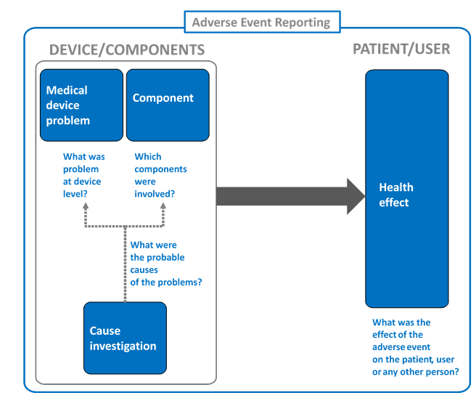

***Figure 2:*** *The Adverse Event Reporting terminology is composed of four sets of terminologies: (1) Medical device problem terminology, (2) components terminology, (3) cause investigation terminology and (4) Health Effects terminology. Note that for an effective monitoring of adverse events, means of effectively identifying devices as well as the category they belong to (e.g. GMDN) are important.*

***Table 1:*** *Overview of the four sets of terminologies comprising the complete terminology for adverse event reporting.*

|  |  |  |  |  |
| --- | --- | --- | --- | --- |
| **No.** | **Name of terminology** | **Description** | **Annex** | **Coding system** |
| 1 | Medical device problem | Terms/codes for describing problems (malfunction, deterioration of function, failure) of medical devices that have occurred in pre- or post-market contexts (e.g. clinical studies, clinical evaluation or post-market surveillance) | A | A|00[00][00] |
| 2 | Cause investigation   * Type of Investigation | Terms/codes for describing the type of investigation of the device involved in the reported event. | B | B|00 |
| Cause investigation   * Investigation Findings | Terms/codes for describing the findings of the device involved in the reported event. | C | C|00[00][00] |
| Cause investigation   * Investigation Conclusion | Terms/codes for describing the conclusion of the device involved in the reported event. | D | D|00[00] |
| 3 | Health Effects   * Clinical Signs, Symptoms and Conditions | Terms/codes for describing the clinical signs, symptoms and conditions of the affected person appearing as a result of the medical device adverse event/incident. | E | E|00[00][00] |
| Health Effects   * Health Impact | Terms/codes for describing the consequences of the medical device adverse event/incident on the person affected. | F | F|00[00][00] |
| 4 | Component | under development | G – to be developed | G|… (to be defined) |

## 4.5 Description of the four sets of terminologies

1. **Medical Device Problem terms/codes (Annex A):** these terms allow capturing of the problems encountered at device(s) level through observational language without yet describing possible reasons or causes for the problems or failures observed. Annex A provides a comprehensive list of medical device problem terms and codes. It is recognized that not all jurisdictions may want to code to such detailed levels. The hierarchical structure will allow jurisdictions to choose the level of coding to use. These terms are largely based on FDA's device issue terms and are harmonized with ISO Technical Specifications 19218-1, where possible.
2. **Cause investigation terms/codes (Annex B-D):** these terms allow capturing of the type of investigation conducted and the findings in the investigation and the conclusion of root cause from the investigation *(Figure3)*. These terms are largely based on FDA's device issue terms and are harmonized with ISO Technical Specifications19218-2, where possible.
3. **Type of Investigation terms/codes (Annex B):** Annex B provides what was investigated and what kind of investigation was conducted to specify the root cause of the adverse event.
4. **Investigation Findings terms/codes (Annex C):** Annex C provides the findings in the specific investigation that are the keys to identify the root cause. This annex has hierarchical levels, allowing jurisdictions to choose the level of coding to use.
5. **Investigation Conclusion terms/codes (Annex D):** Annex D provides the conclusions derived from the investigation. The conclusion specifies the root cause of the specific adverse event. This annex has hierarchical levels, allowing jurisdictions to choose the level of coding to use.

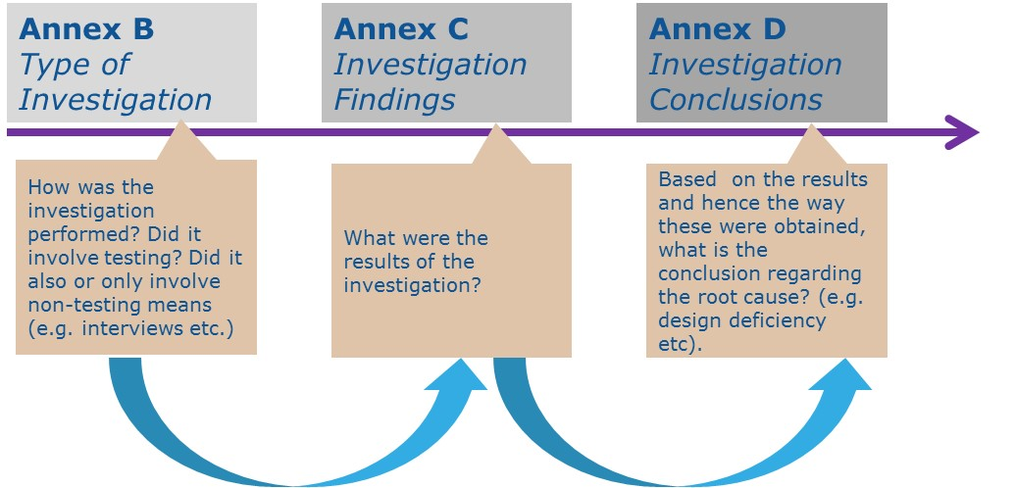

***Figure 3:*** *The three annexes (Annex B: Type of Investigation, Annex C: Investigation Findings, and Annex D: Investigation Conclusion) for Cause Investigation.*

1. **Health Effects terms/codes (Annex E and F):** these terms allow capturing of the patient signs and symptoms observed and the outcomes related to the medical device adverse event through observational language without using diagnostic specifics (*Figure* 4). Annex E provides a list of clinical signs, symptomsand conditions that are granular enough to capture the health effect for the purposes of medical device adverse event/incident reporting, while being general enough to avoid rebuilding other comprehensive terminology systems. Annex F provides a list of potential outcomes and consequences of the medical device adverse event/incident. Terms from these two annexes together will provide a description encompassing both the clinical observation and the impact on the person affected.
   1. **Clinical Signs, Symptoms and Conditions terms/codes (Annex E):** Annex E provides terminology to describe the observed condition of the affected persons after the medical device adverse event occurs. These terms are largely based on a subset of MedDRA terms. This annex is organized along organ systems as well as physiological problems.
   2. **Health Impact terms/codes (Annex F):** Annex F provides terminology to describe the resulting consequences of the medical device adverse event/incident on the person affected.

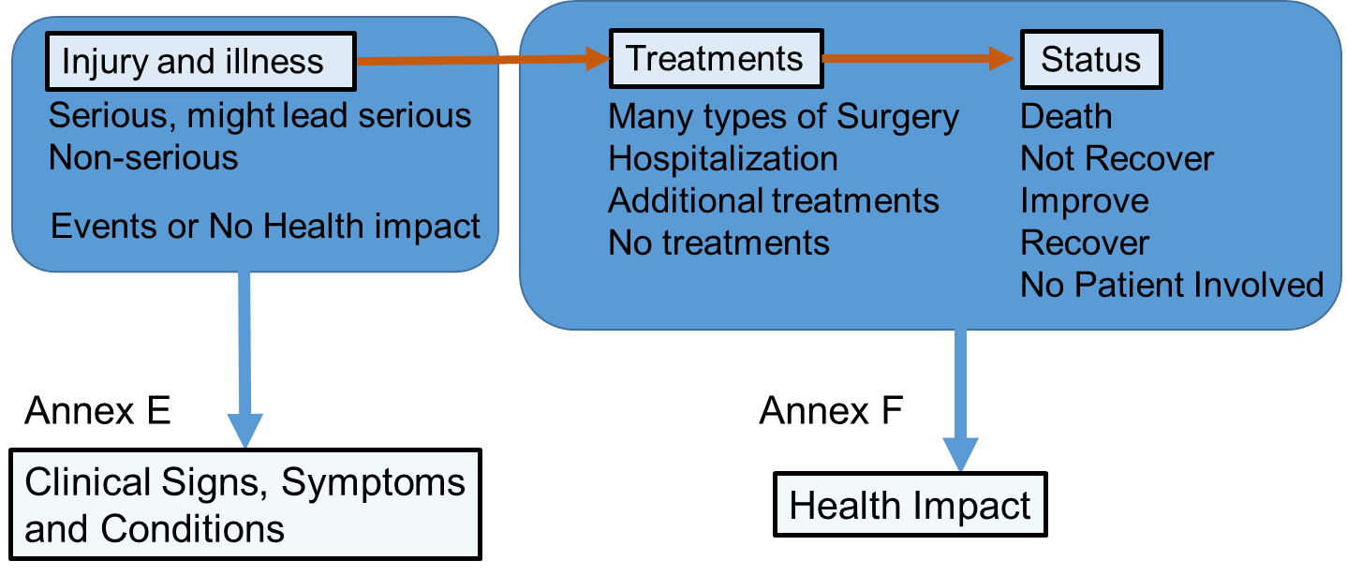

***Figure 4:*** *The two annexes (Annex E, Clinical Signs, Symptoms and Conditions, Annex F: Health Impact) for Health Effect.*

1. **Component terms/codes (Annex G – currently under development)**

# Maintenance of adverse event terminology

Due to the nature of the medical device industry and the implementation of new technologies, materials, designs, procedures etc., the medical device problem terms, and its associated component terms are expected to require updating to adapt to technical progress. For this reason there is need for periodic review and maintenance of the constituting terminologies and codes in view of adding, modifying or removing terms as required.

However, it is important that changes to the AE terminology should be restricted to the absolute necessary, i.e. mainly reserved for adaptation to technical progress (new terms as new devices, designs and materials emerge). Frequent changes to the terminology are not anticipated. Any change for involved parties and end users will require re-programming of existing coding systems at the level of industry, healthcare facilities and regulators alike so needs to be managed with this in mind.

The detailed maintenance plan of IMDRF AE terminology can be found in IMDRF/AE WG/N44 - Maintenance of IMDRF AE Terminologies.

# Annexes

## Annex A: Medical Device Problem Terms and Codes

## Annex B: Cause Investigation – Type of Investigation Terms and Codes

## Annex C: Cause Investigation – Investigation Findings Terms and Codes

## Annex D: Cause Investigation – Investigation Conclusion Terms and Codes

## Annex E: Health Effect – Clinical Signs, Symptoms and Conditions Terms and Codes

## Annex F: Health Effect – Health Impact Terms and Codes