IMDRF/PMD WG/N74 Draft:2022

FINAL WORKING DRAFT

Title: Personalized Medical Devices – Production Verification and Validation
Technical guidance on verification and validation aspects of specified design envelope
and medical device production system

Authoring Group: Personalized Medical Devices

Date: 10 August 2022

Tracey Duffy, IMDRF Chair

This document was produced by the International Medical Device Regulators Forum. There are no restrictions on the reproduction or use of this document; however, incorporation of this document, in part or in whole, into another document, or its translation into languages other than English, does not convey or represent an endorsement of any kind by the International Medical Device Regulators Forum.

Copyright © 2022 by the International Medical Device Regulators Forum.

Table of Contents

1.0 Introduction 4
2.0 Scope 5
3.0 References 6
4.0 Definitions 8
5.0 Verification and validation aspects of specified design envelope 16
5.1 Device description 16
5.2 Range of user needs & Intended uses 16
5.3 Design envelope schema 17
5.4 Implantable versus non-implantable medical device 19
5.5 Use of imaging data for patient-matching 20
5.6 Design verification and validation activities 21
5.7 Clinical evidence requirements 22
5.8 Labelling requirements 24
6.0 Verification and validation aspects of medical device production systems (MDPS) 26
6.1 MDPS description 27
6.2 Key Considerations in MDPS Design Development 27
6.2.1 Resultant Medical Device Design Development 28
6.2.2 Medical Device Production Process Design Development 28
6.2.3 Medical Device Production System Verification 32
6.2.4 Medical Device Production System Validation 33
6.3 Risk management plan for MDPS 34
6.3.1 Medical Device Production Process 34
6.3.2 Resultant medical device 34
6.4 User facility requirements, competence, training, and human factors validation 34
6.5 Clinical evidence requirements 35
6.6 Labelling requirements 35
6.6.1 Medical Device Production Process (MDPP) 36
6.6.2 Resultant medical device 36

Preface

The document herein was produced by the International Medical Device Regulators Forum (IMDRF), a voluntary group of medical device regulators from around the world. The document has been subject to consultation throughout its development.

There are no restrictions on the reproduction, distribution or use of this document; however, incorporation of this document, in part or in whole, into any other document, or its translation into languages other than English, does not convey or represent an endorsement of any kind by the International Medical Device Regulators Forum.

Introduction
The purpose of this IMDRF guidance is to provide harmonized recommendations for verification and validation aspects of a patient-matched medical device and a medical device production system (MDPS). The adoption of consistent, harmonized requirements for such medical devices and systems will underpin a harmonized regulatory approach for controls and offer significant benefits to the manufacturer, user, patient, Regulatory Authorities (RAs) and Conformity Assessment Bodies (CABs). Eliminating differences between jurisdictions supports global convergence, reduces the cost of gaining regulatory compliance, and allows patients and authorized healthcare professionals timely access to new treatments and technologies.
The IMDRF has published IMDRF/PMD WG/N49 Definitions for Personalized Medical Devices, establishing harmonized definitions for various categories of personalized medical devices (PMDs), including custom-made, patient-matched, and adaptable medical devices. This document introduces the concept of a specified design envelope, a characteristic feature in the definition of patient-matched medical device. Another IMDRF document IMDRF/PMD WG/N58 Personalized Medical Devices – Regulatory Pathways, provides recommendations for regulatory pathways for different categories of PMDs. This document further provides considerations for near or at point-of-care (defined as POC throughout this document) manufacturing and different models of regulatory oversight (manufacturing under special arrangements, MDPSs, fully regulated manufacturing) that may be implemented to ensure the quality, safety and performance of the medical devices produced.
The present guidance is a continuation of these two documents (N49 and N58) and is intended for use by industry, RAs, CABs, and others. The first half of this guidance provides technical considerations for verification and validation aspects of specified design envelope for patient-matched medical devices. The second half of the guidance covers technical considerations for verification and validation aspects of an MDPS (which is a medical device in its own right).

Technology has progressed since the Global Harmonization Task Force (GHTF) foundation documents were published. It is now possible to produce medical devices that are individualized on a commercial rather than an artisanal scale. Healthcare professionals, engineers, and scientists now work collaboratively to develop medical devices to match an individual's unique anatomical/physiological requirements and needs. Additive and subtractive manufacturing can be leveraged to create patient-matched medical devices such as anatomical models for diagnosis, monitoring, and pre-surgical planning for complex procedures, as well as implants to match a patient's anatomy and requirements. The manufacturing processes for medical devices is also shifting closer to the point-of-care (such as 3D printing in hospitals), which brings numerous advantages to patients and authorized healthcare professionals alike. Timely access to these technologies and devices can be lifesaving, allow physicians to offer better treatment alternatives to their patients, and decrease the overall cost of providing healthcare services. However, new risks have also emerged with PMDs and POC manufacturing, which did not exist for traditional mass-produced medical devices. Regulatory oversight in the production of these devices commensurate with the level of risk is required to ensure their safety and performance.

Scope
This document provides pre-market application guidance on verification and validation aspects of the specified design envelope, one of the salient features of a patient-matched medical device defined in the IMDRF/PMD WG/N49 (Definitions for Personalized Medical Devices).
The document further provides pre-market application guidance on verification and validation aspects of MDPS, a new concept in the manufacturing of medical devices, introduced in the IMDRF/PMD WG/ N58 (Personalized Medical Devices – Regulatory Pathways).
This document does not apply to in vitro diagnostic medical devices (IVD MDs). However, this document is applicable to patient-matched anatomical models for diagnostic purposes as stated in the Introduction (1.0).

Furthermore, the document does not provide any guidance on device verification and validation where personalization is intended in one or more of the following characteristics of the medical device: incorporating materials of biological origin; incorporating a substance considered to be a medicinal product or drug; active componentry of an active medical device; incorporating software or software that is a medical device.

References
IMDRF/GHTF documents
GHTF/SG3/N99-10:2004 (Edition 2) Quality Management Systems – Process Validation Guidance
GHTF/SG1/N71:2012 Definitions of the Terms' Medical Device' and 'In Vitro Diagnostic (IVD) Medical Device'
GHTF/SC/N4:2012 (Edition 2) Glossary and definition of terms used in GHTF documents
IMDRF/ UDI WG/N48 FINAL: 2019 Unique Device Identification system (UDI) Application Guide
IMDRF/PMD WG/N49 Final: 2018 Definitions for Personalized Medical Devices
IMDRF/GRRP WG/N47 FINAL: 2018 Essential Principles of Safety and Performance of Medical Devices and IVD Medical Devices
IMDRF/MDCE WG/N55 FINAL: 2019 Clinical Evidence – Key Definitions and Concepts
IMDRF/MDCE WG/N56 FINAL: 2019 Clinical Evaluation
IMDRF/MDCE WG/N57 FINAL: 2019 Clinical Investigation
IMDRF/GRRP WG/N52 FINAL: 2019 Principles of Labelling for Medical Devices and IVD Medical Devices
IMDRF/PMD WG/N58 Final: 2020 Personalized Medical Devices – Regulatory Pathways
IMDRF/ MDCE WG/N65 FINAL: 2021 Post-Market Clinical Follow-Up Studies
International standards
ISO 13485 Medical Devices – Quality Management Systems – Requirements for Regulatory Purposes
ISO 14971 Medical Devices – Application of Risk Management to Medical Devices
ISO 14155 Clinical Investigation of Medical Devices for Human Subjects: Good Clinical Practice
IEC 62366-1 Medical devices – Part 1: Application of usability engineering to medical devices
Guidance documents published by Regulatory Authorities
Australia TGA, Guidance on Personalized Medical Devices (including 3D-printed Devices) regulatory reforms, 2021
Health Canada, Supporting Evidence for Implantable Medical Devices Manufactured by 3D Printing, Apr 2019
China NMPA, Technical Review Guidance for the Registration of Personalized Additive Manufacturing Medical Devices of Passive Implantable Bone, Joint and Oral Hard Tissues
Europe MDCG 2021-3, Questions and Answers on Custom-Made Devices (& considerations on Adaptable medical devices and Patient-matched medical devices), Mar 2021
Japan MHLW, Guidance on Evaluation of Customized Orthopedic Devices for Osteosynthesis, Dec 2010
Japan MHLW, Guidance on Evaluation of Orthopedic Customized Artificial Hip Joint Prosthesis, Dec 2011
South Korea MFDS, Guidance for Patient-matched Medical Devices manufactured using 3D printers, Dec 2015
US FDA 21 CFR 820.30, Design Control Guidance for Medical Device Manufacturers, Mar 1997
US FDA CDRH, Technical Considerations for Additive Manufactured Devices – Guidance for Industry and Food and Drug Administration Staff, Dec 2017
US FDA CDRH, Applying Human Factors and Usability Engineering to Medical Devices – Guidance for Industry and Food and Drug Administration Staff, Feb 2016
US FDA CDER, CBER - Q7 Good Manufacturing Practice Guidance for Active Pharmaceutical Ingredients – Guidance for Industry (Revision 1), Sept 2016
Other References
World Medical Association – Declaration of Helsinki – Ethical principles for medical research involving human subjects

Definitions
Active Medical Device: Any medical device, operation of which depends on a source of electrical energy or any source of power other than that directly generated by the human body or gravity and which acts by converting this energy. Medical devices intended to transmit energy, substances or other elements between an active medical device and the patient, without any significant change, are not considered to be active medical devices. Standalone software is considered to be an active medical device. (GHTF/SG1/N77:2012)
Adaptable Medical Device: A medical device that meets the following requirements:
- it is mass-produced; and
- it is adapted, adjusted, assembled, or shaped at the point of care, in accordance with the manufacturer's validated instructions, to suit an individual patient's specific anatomo-physiologic features prior to use. (IMDRF/PMD WG/N49 FINAL: 2018)
Authorized Healthcare Professional: An authorized healthcare professional is a person legally entitled to provide health services in the applicable jurisdiction. (IMDRF/ PMD WG/ N58 Final: 2020)
Clinical Data: Safety, clinical performance and/or effectiveness information that is generated from the clinical use of a medical device. (IMDRF MDCE WG/N56FINAL:2019)
Clinical Evaluation: A set of ongoing activities that use scientifically sound methods for the assessment and analysis of clinical data to verify the safety, clinical performance and/or effectiveness of the device when used as intended by the manufacturer. (IMDRF MDCE WG/N56FINAL:2019)
Clinical Evidence: The clinical data and its evaluation pertaining to a medical device. (IMDRF MDCE WG/N56FINAL:2019)
Clinical Investigation: Any systematic investigation or study in or on one or more human subjects, undertaken to assess the safety, clinical performance and/or effectiveness of a medical device. (IMDRF MDCE WG/N56FINAL:2019)
Clinical Performance: The ability of a medical device to achieve its intended clinical purpose as claimed by the manufacturer. (IMDRF MDCE WG/N56FINAL:2019)
Comparable Device: A medical device with related function chosen by the manufacturer to inform the clinical evaluation of the device in question. (IMDRF MDCE WG/N56FINAL:2019)
Conformity Assessment: The systematic examination of evidence generated and procedures undertaken by the manufacturer, under requirements established by the Regulatory Authority, to determine that a medical device is safe and performs as intended by the manufacturer and, therefore, conforms to the Essential Principles of Safety and Performance for Medical Devices. (GHTF/SG1/N78:2012)
Conformity Assessment Body (CAB): A body, other than a Regulatory Authority, engaged in determining whether the relevant requirements in technical regulations or standards are fulfilled. (GHTF/SG1/N78:2012)
Custom-made Medical Device: A medical device that, at a minimum, meets the following requirements:
- it is intended for the sole use of a particular individual (which could be a patient or healthcare professional); and
- it is specifically made in accordance with a written request of an authorized professional, which gives, under their responsibility, specific design characteristics; even though the design may be developed in consultation with a manufacturer; and
- it is intended to address the specific anatomo-physiological features or pathological condition of the individual for whom it is intended.
NOTE 1: Medical devices that are patient-matched, adaptable, or mass-produced shall not be custom-made.
NOTE 2: A custom-made device is intended for a case where an individual's specific needs cannot be met or cannot be met at the appropriate level of performance, by an alternative device available on the market. (IMDRF/PMD WG/N49 FINAL: 2018)
Direct Clinical Evidence: For the purposes of this document, direct clinical evidence is defined as evidence derived from an evaluation of clinical data pertaining to the subject device
Effectiveness: The ability of a medical device to achieve clinically meaningful outcome(s) in its intended use as claimed by the manufacturer. (IMDRF MDCE WG/N56FINAL:2019)
Expected Lifetime/Expected Service Life: Time-period specified by the manufacturer during which the medical device or IVD medical device is expected to maintain safe and effective use.
NOTE 1: The expected lifetime can be determined by stability or by other methods.
NOTE 2: Maintenance, repairs, or upgrades (e.g., safety or cybersecurity modifications) can be necessary during the expected lifetime. (IMDRF/GRRP WG/N52)
Harm: Physical injury or damage to the health of people or damage to property or the environment. (GHTF/SG1/N77:2012)
Hazard: Potential source of harm. (GHTF/SG1/N77:2012)
Implantable Device: Any device, including those that are partially or wholly absorbed,
which is intended: -
- to be totally introduced into the human body or,
- to replace an epithelial surface or the surface of the eye,
by surgical intervention which is intended to remain in place after the procedure.
Any device intended to be partially introduced into the human body through surgical intervention and intended to remain in place after the procedure for at least 30 days is also considered an implantable device. (GHTF/SG1/N77:2012)
In Vitro Diagnostic (IVD) Medical Device: means a medical device, whether used alone or in
combination, intended by the manufacturer for the in-vitro examination of specimens derived
from the human body solely or principally to provide information for diagnostic, monitoring or
compatibility purposes.
NOTE 1: IVD medical devices include reagents, calibrators, control materials, specimen
receptacles, software, and related instruments or apparatus or other articles and are used,
for example, for the following test purposes: diagnosis, aid to diagnosis, screening,
monitoring, predisposition, prognosis, prediction, determination of physiological status.
NOTE 2: In some jurisdictions, certain IVD medical devices may be covered by other
regulations. (GHTF/SG1/N071:2012)
Indications for Use: A general description of the disease or condition the medical device or IVD medical device will diagnose, treat, prevent, cure, or mitigate, including a description of the patient population for which the medical device or IVD medical device is intended. (IMDRF/GRRP WG/N52)
Instructions for Use: Information provided by the manufacturer to inform the device user of the medical device’s intended purpose and proper use and of any precautions to be taken. (GHTF/SG1/N70:2011)
Intended Use/ Purpose: The objective intent regarding the use of a product, process or service as reflected in the specifications, instructions and information provided by the manufacturer.
NOTE 1: The intended use/intended purpose are also part of promotional or sales materials or statements, although these materials lie outside the scope of this document.
NOTE 2: The intended use can include the indications for use. (IMDRF/GRRP WG/N52)
Kits: Kits are a collection of products, including medical devices, that are packaged together to achieve a common intended use and is being distributed as a medical device. These could also be called procedure packs or convenience kits.
NOTE: Jurisdictions may differ in their definition of kit. (IMDRF/UDI WG/N7FINAL:2013)
Label: Written, printed, or graphic information either appearing on the medical device itself, or on the packaging of each unit, or on the packaging of multiple devices.
NOTE: The definition above refers to the human readable label. (GHTF/SG1/N70:2011)
Labelling: The label, instructions for use, and any other information that is related to identification, technical description, intended purpose and proper use of the medical device, but excluding shipping documents. (GHTF/SG1/N70:2011)
Life-cycle: All phases in the life of a medical device, from the initial conception to final decommissioning and disposal (GHTF/AHWG-GRM/N1R13:2011)
Manufacturer: means any natural or legal person with responsibility for design and/or manufacture of a medical device with the intention of making the medical device available for use, under his name; whether or not such a medical device is designed and/or manufactured by that person himself or on his behalf by another person(s).
Notes:
- This 'natural or legal person' has ultimate legal responsibility for ensuring compliance with all applicable regulatory requirements for the medical devices in the countries or jurisdictions where it is intended to be made available or sold, unless this responsibility is specifically imposed on another person by the Regulatory Authority (RA) within that jurisdiction.
- The manufacturer's responsibilities are described in other GHTF guidance documents. These responsibilities include meeting both pre-market requirements and post-market requirements, such as adverse event reporting and notification of corrective actions.
- 'Design and/or manufacture', as referred to in the above definition, may include specification development, production, fabrication, assembly, processing, packaging,
repackaging, labelling, relabelling, sterilization, installation, or remanufacturing of a
medical device; or putting a collection of devices, and possibly other products, together for a medical purpose.
- Any person who assembles or adapts a medical device that has already been supplied by another person for an individual patient, in accordance with the instructions for use, is not the manufacturer, provided the assembly or adaptation does not change the intended use of the medical device.
- Any person who changes the intended use of, or modifies, a medical device without
acting on behalf of the original manufacturer and who makes it available for use under his own name, should be considered the manufacturer of the modified medical device.
- An authorized representative, distributor or importer who only adds its own address and contact details to the medical device or the packaging, without covering or changing the existing labelling, is not considered a manufacturer.
- To the extent that an accessory is subject to the regulatory requirements of a medical
device, the person responsible for the design and/or manufacture of that accessory is considered to be a manufacturer. (GHTF/SG1/N055:2009)
Medical device production system (MDPS):
A medical device production system (MDPS) is a combination of the resultant medical device and the medical device production process (MDPP) elements. The elements of an MDPP includes the raw materials, software and digital files, main production and post-processing (if applicable) equipment, and operating instructions intended to be used by specific end users at a healthcare facility (HCF), to produce a specific type of medical device for treating the patients of the HCF.
- An MDPS includes the resultant medical device it is intended to produce and the intended use for the device is validated in accordance with safety and performance requirements in the relevant regulatory jurisdiction.
- An MDPS classification should be determined by the risk-based classification of the resultant medical device it is intended to produce, which may include consideration of any additional or likely foreseeable risks that may arise as a result of the operation of the MDPS.
- An MDPS may require the use of ancillary equipment, human factors considerations, technical capability requirements, or other specified input and design limit controls; however, all components must be validated as a production process to consistently produce the resultant medical device with the use of the supplied operating instructions.
(IMDRF/ PMD WG/ N58 Proposed Revisions: 2022)
Patient-matched Medical Device: A medical device that meets the following requirements:
- it is matched to a patient's anatomy within a specified design envelope using techniques such as scaling of the device based on anatomic references, or by using the full anatomic features from patient imaging; and
- it is typically produced in a batch through a process that is capable of being validated and reproduced; and
- it is designed and produced under the responsibility of a manufacturer even though the design may be developed in consultation with an authorized healthcare professional.
Note 1: A written request from an authorized healthcare professional may be present; but is not mandatory.
Note 2: The number and type of design inputs in consultation with a healthcare professional may vary depending on the medical devices to be manufactured.
Note 3: The design must remain within the validated parameters of the specified design envelope. (IMDRF/PMD WG/N49 FINAL: 2018)
Performance: The ability of a medical device to achieve its intended purpose as stated by the manufacturer. Performance may include both clinical and technical aspects. (IMDRF GRRP WG/N47 FINAL: 2018)
Personalized Medical Device (PMD): A generic term to describe any of the types of medical devices that are intended for a particular individual, which could be either a custom-made, patient-matched, or adaptable medical device. (IMDRF/PMD WG/N49 FINAL: 2018)
Post-market clinical follow-up study: A study carried out following marketing authorization intended to answer specific questions (uncertainties) relating to safety, clinical performance and/or effectiveness of a device when used in accordance with its labelling. (IMDRF MDCE WG/N65FINAL:2021)
Process Validation: Establishing by objective evidence that a process consistently produces a result or product meeting its predetermined requirements. (GHTF/SG3/N99-10:2004 (Edition 2))
Quality Management System: Management system to direct and control an organization with regard to quality. (GHTF/SG3/N19:2012)
Regulatory Authority (RA): A government body or other entity that exercises a legal right to control the use or sale of medical devices within its jurisdiction, and may take enforcement action to ensure that medical products marketed within its jurisdiction comply with legal requirements. (GHTF/SG1/N78:2012)
Residual Risk: Risk remaining after protective measures have been taken. (GHTF/SG3/N15R8:2005)
Risk: Combination of the probability of occurrence of harm and the severity of that harm. (GHTF/SG1/N77:2012)
Risk Analysis: Systematic use of available information to identify hazards and to estimate the risk. (GHTF/SG3/N15R8:2005)
Risk Assessment: Overall process comprising a risk analysis and a risk evaluation. (GHTF/SG3/N15R8:2005)
Risk Control: Process through which decisions are reached and protective measures are implemented for reducing risks to, or maintaining risks within, specified levels. (GHTF/SG3/N15R8:2005)
Risk Evaluation: Judgment, on the basis of risk analysis, of whether a risk which is acceptable has been achieved in a given context based on the current values of society. (GHTF/SG3/N15R8:2005)
Risk Management: The systematic application of management policies, procedures and practices to the tasks of analyzing, evaluating, controlling and monitoring risk. (GHTF/SG3/N15R8:2005)
Safety: Acceptability of risks as weighed against benefits, when using the medical device according to the manufacturer's labelling. (IMDRF MDCE WG/N56FINAL:2019)
Software as a Medical Device (SaMD): The term "Software as a Medical Device" (SaMD) is defined as software intended to be used for one or more medical purposes that perform these purposes without being part of a hardware medical device.
NOTES:
- SaMD is a medical device and includes in-vitro diagnostic (IVD) medical device.
- SaMD is capable of running on general purpose (non-medical purpose) computing platforms
- "without being part of" means software not necessary for a hardware medical device to achieve its intended medical purpose;
- Software does not meet the definition of SaMD if its intended purpose is to drive a hardware medical device.
- SaMD may be used in combination (e.g., as a module) with other products including medical devices;
- SaMD may be interfaced with other medical devices, including hardware medical devices and other SaMD software, as well as general purpose software
- Mobile apps that meet the definition above are considered SaMD.
(IMDRF/SaMD WG/N10 FINAL:2013)
Specified Design Envelope: Minimum and maximum dimensions, mechanical performance limits, and other relevant factors that characterize a medical device for production purposes, which may be based on a standard device template model. (IMDRF/PMD WG/N49 FINAL: 2018)
Technical Documentation: The documented evidence, normally an output of the quality
management system that demonstrates conformity of a device to the Essential Principles of
Safety and Performance of Medical Devices. (GHTF/SG1/N78:2012)
Unique Device Identification (UDI): The UDI is a series of numeric or alphanumeric characters that is created through a globally accepted device identification and coding standard. It allows the unambiguous identification of a specific medical device on the market. The UDI is comprised of the UDI-DI (device identifier) and UDI-PI (production identifier).
NOTE: The word "Unique" does not imply serialization of individual production units. (IMDRF/UDI WG/N7FINAL:2013)
User: The person, either professional or lay, who uses a medical device. The patient may be the user. (GHTF/SG1/N70:2011)
Validation: Confirmation through provision of objective evidence that the requirements for a specific intended use or application have been fulfilled.
NOTE 1: The term "validated" is used to designate the corresponding status.
NOTE 2: The use conditions for validation can be real or simulated.
(GHTF/SG3/N18:2010)
Verification: Confirmation through provision of objective evidence that specified requirements have been fulfilled.
NOTE 1: The term "verified" is used to designate the corresponding status.
NOTE 2: Confirmation can comprise activities such as:
- performing alternative calculations,
- comparing a new design specification with a similar proven design specification, undertaking tests, performing demonstrations, and reviewing and approving documents prior to issue.
(GHTF/SG3/N18:2010)

Verification and validation aspects of specified design envelope
As it is practically impossible to assess the compliance of each individual patient-matched medical device with the relevant provisions of the Essential Principles of Safety and Performance of Medical Devices (the Essential Principles), or other applicable jurisdictional regulatory requirements, it is prudent to produce these devices within the bounds of validated parameters of a specified design envelope. Validating the specified design envelope could be one of the practical means of demonstrating the compliance of the resultant patient-matched medical devices with the relevant provisions of the Essential Principles or other applicable jurisdictional requirements.
The manufacturer of a patient-matched medical device should establish the reference intervals/categories for each of the parameters that characterize the specified design envelope, by testing production units of the device under real or simulated conditions of use. The manufacturer should demonstrate by objective evidence that devices produced within the bounds of validated parameters of a specified design envelope meets the user needs and the intended uses, and comply with the relevant provisions of the Essential Principles.

Device description
The manufacturer should describe the patient-matched medical device in the technical documentation, including its intended purpose. The device description should include a picture or image of a representative patient-matched medical device with all functional components clearly labelled, and a brief explanation of the operational principles, performance specification. The device description should also provide an overview of the raw materials used in the production, manufacturing (including quality control processes and manufacturing workflow), preferably using a flow chart.

Range of user needs & Intended uses
As a first step in the design and development activity, the manufacturer should define the range of user needs and the intended uses for all patient-matched medical devices that are meant to be produced within the bounds of the parameters of a specified design envelope. This step may be completed in consultation with authorized healthcare professionals, but the manufacturer shall bear complete responsibility for the design and/or manufacture of such devices.
In the pre-market phase, the manufacturer may form a multidisciplinary team comprising suitably trained personnel with clearly defined roles and responsibilities to establish the range of user needs and the intended uses for the patient-matched medical devices. The manufacturer should use the range of user needs and intended uses as the basis for subsequent design and development activities, including planning for verification and validation activities.

Design envelope schema
Regardless of the risk-based classification of a medical device, the concept of specified design envelope is applicable to all devices that meet the definition of a patient-matched medical device (for example patient-matched plagiocephaly helmets, patient-matched 3D printed orthognathic surgical plates), with limited exemption of materials that are medical devices. A specified design envelope can be conceived of as a set of all relevant parameters that characterize a patient-matched medical device for production purposes (Figure 1). The manufacturer should unequivocally identify all relevant parameters that constitute the specified design envelope and explicitly establish the boundaries (reference intervals/categories) for each parameter.

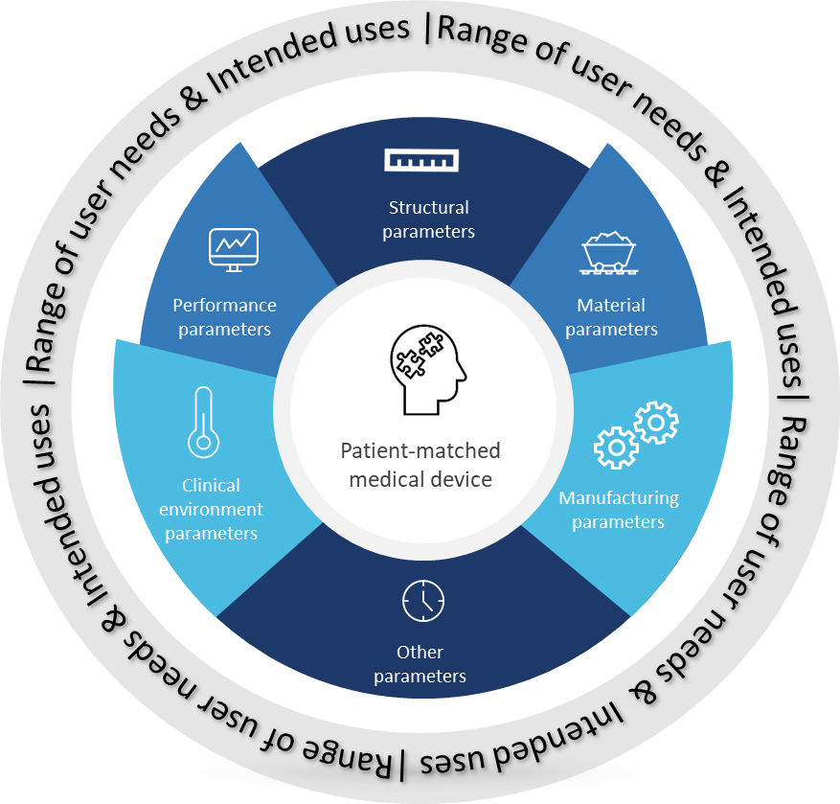

Figure 1. An illustration of a specified design envelope for patient-matched medical devices.
Parameters that characterize a design envelope may be divided broadly into six categories. Given the variety of technologies, materials and processes used in the manufacturing of medical devices, not all categories may be relevant to each patient-matched medical device.

- Structural parameters
The manufacturer should establish explicit boundaries for the dimensions, area, volume, shapes, angles, relative positions, screw hole sizing and numbers, allowed distances between screw holes, and other geometrical parameters for the device. In this category, the manufacturer should also include any patient-imaging data used in the device design process. Where the surface morphology of the anatomy is used in the device design process, the manufacturer should specify anatomical landmarks or margins to establish the geometrical limits on the device design.

In addition to the external structural parameters for the device, where applicable, the manufacturer should also establish design limits on the internal structural features of the device, such as porosity, lattice strut size, wall thickness, etc.

- Material parameters
The manufacturer should identify all raw materials used in the device's production and their characteristics (biological, physical, chemical), and adhere to relevant material standards. For example, additively manufactured orthopaedic implants may utilize Ti-6Al-4V Grade 5 and Grade 23 (extra-low interstitial) materials.

Additionally, some additive manufacturing approaches (e.g., powder bed fusion, stereolithography) allow efficient use of raw material by reusing the material that is not incorporated into the device (e.g., unsintered powder or uncured resin). However, the reused material could be exposed to conditions (e.g., heat, oxygen, humidity, ultraviolet energy) that may alter it from the virgin state. Therefore, the manufacturer should describe the material reuse process, which may include (but is not limited to), a description of processes such as filtering reused material, a limit on the percent of reused material, or monitoring for changes in physical- chemistry, oxygen, or water content.

- Manufacturing parameters
The manufacturer should identify all manufacturing parameters that can be varied during the manufacturing processes and establish explicit boundaries for each parameter. This should include parameters associated with production, post-production processing, fabrication, assembly, cleaning, sterilization (if required), packaging and labelling of the device. For example, a manufacturer may produce two variants of a spinal interbody cage using PEEK (polyetheretherketone), one with and the other without Ti coating on the superior and inferior surfaces of the interbody cage.

- Clinical environment parameters
The manufacturer should identify all parameters relating to the clinical environment in which the device is intended to be used, and establish explicit boundaries for each parameter. For example, a manufacturer may produce two different patient-matched maxillofacial bone plates in the same specified design envelope, one intended to be used in the upper jaw and the other intended to be used in the lower jaw (where the plate withstands greater dynamic forces).

- Performance parameters
The manufacturer should identify all parameters relating to the performance of the device when the device is used as intended, and establish explicit boundaries for each parameter. For example, a manufacturer may produce three variants of a spinal interbody cage (for patients with normal bone quality, osteopenia, and osteoporosis) to reduce the risk of subsidence, each with different densities and compressive stiffness characteristics.

- Miscellaneous parameters
If a parameter is not captured in any of the above categories but will characterize the device for production purposes, the manufacturer should include the parameter in the specified design envelope under this category and establish explicit boundaries for the parameter.
Where the parameter is represented using categorical data, the manufacturer should establish all the possible categories that the parameter can accept. Where the parameter is represented using numerical data (continuous or discrete), the manufacturer should establish the reference interval, minimum increment, and unit of measurement for the parameter. There may be some interdependence between the parameters included in the specified design envelope; for example, performance parameters may depend on structural, material, and clinical environment parameters.
The manufacturer may develop a design envelope schema to depict all the parameters and their respective boundaries (Figure 1). The schema may also include appropriate information on the range of user needs and intended uses of the device. The schema may also be used as a communication tool between various teams (such as clinical, design, and manufacturing) to ensure that during translation of patient characteristics into design and production processes, the predetermined limit on any of the parameters is not breached, and each patient-matched medical device is produced as intended for a specific patient.

Implantable versus non-implantable medical device
Implantable medical devices generally have a higher risk profile and higher evidential burden for demonstrating compliance with the Essential Principles than non-implantable medical devices.
There may be different verification and validation (V&V) activities for the specified design envelope for implantable and non-implantable patient-matched medical devices. Identifying the worst-case device design(s) may have a higher evidential burden for implantable compared with non-implantable patient-matched medical devices. For a non-implantable patient-matched medical device, a manufacturer should justify the identified worst-case device design(s) in the technical documentation. For an implantable patient-matched medical device, the justification provided by the manufacturer for the identified worst-case device design(s) in the technical documentation should be supported by (clinical) data from literature reviews, clinical experience/adverse events data from comparable devices, and/or nonclinical testing (for example, bench testing, validated computational modelling).
Additionally, the worst-case test sample selection(s) should account for both inter- and intra-lot variability by examining consistency and reproducibility across multiple manufacturing lots or print/production runs, when appropriate (e.g., when it is expected that such sampling is likely to impact the testing results and/or is needed to adequately capture the variability in the testing results).

Use of imaging data for patient-matching
If the design workflow for a patient-matched medical device uses data from an imaging modality such as computed tomography, magnetic resonance, ultrasound etc., the manufacturer should consider factors pertaining to the imaging modality, data acquisition, and image processing methods that may influence the reliability and validity of the patient-specific information being captured.
- Minimum requirements for the imaging data should be established (such as field of view, anatomical margins, image resolution, pixel size, slice thickness and spacing, file format, image enhancement algorithm, etc.).
- A description of any software used for manual or automatic segmentation of the imaging data should be included in the technical documentation and labelling. If automation is utilized, appropriate software V&V should be provided to support regulatory evaluation. For automated segmentation processes, the same datasets should not be used for V&V as was used for software development.
- The manufacturer should unequivocally establish the maximum period between image acquisition and the first use of the device in/on its intended recipient, and the information should be included in the product labelling. In deciding the maximum period for the expiration of imaging data, the manufacturer should consider relevant aspects of the biological maturity of the intended recipient at the time of imaging, as well as the severity and clinical course of the condition. However, minimizing the time between imaging and the first use of the device in/on its intended recipient is desirable. For skeletally immature patients where the imaging modality involves ionizing radiation, an authorized healthcare professional may recommend bone age assessment before full imaging of the anatomical structure(s) of interest is undertaken for the purposes of the patient-matched medical device.
- For implantable patient-matched medical devices, the manufacturer should discuss the timing of implantation of the device with the requesting authorized healthcare professional to decide the timing for imaging, design, and production of the device. A manufacturer may set different expiration periods for the imaging data (based on which the device is designed) for skeletally mature and immature patients, while also providing an option to the authorized healthcare professional to request another expiration period to suit their patient's clinical requirements. For example, in the case of a craniomaxillofacial plate, a manufacturer may set imaging data expiration periods of six and three months for skeletally mature and immature patients respectively, while also providing an option to the authorized healthcare professional to request a different expiration period.
- The manufacturer should establish protocols to protect a patient's identity information in the imaging data and subsequent design files according to the requirements of the jurisdiction in which the device is intended to be used. The manufacturer should establish controls to protect the integrity of the imaging data and the design files, especially when such data is stored and shared in cyberspace. Furthermore, the manufacturer should establish controls to ensure that the critical information on the device design is not lost/corrupted during file format conversions.

Design verification and validation activities
Verification and validation (V&V) activities for the specified design envelope should be based on a comprehensive risk management plan implemented in the design and/or manufacture of the devices (consistent with ISO 14971), and appropriate procedures required for the quality management system (consistent with ISO 13485). As part of the risk management activities, the manufacturer should determine the most critical or the worst-case design(s) within the specified design envelope, considering the identified risks and the outcomes of risk assessment. It may be possible to have more than one worst-case design in order to show that the associated risks have been appropriately controlled. The overall objective of the design V&V activities is to demonstrate that a device produced within the parameters of a specified design envelope meets the user needs and intended uses across a controlled and reproducible process. Where appropriate, design V&V activities should include validation of software components and processes used for patient imaging data processing, design development and production of the device.
Design verification activities should also be planned and conducted to confirm that the final design of the device(s) meets the established design inputs.
The manufacturer should establish a validation plan that includes methods, acceptance criteria and, as appropriate, statistical techniques with rationale for sample size.
If the patient-matched medical device is connected to, or have an interface with, another therapeutic good (medical device(s), medicinal product or drug, or materials of biological origin), the manufacturer should conduct interface validation to confirm that the requirements for the specified application or intended use have been met when so connected or interfaced. In such scenarios, the interfacing therapeutic good(s) must be approved for use by the RA having jurisdiction, and its use with the patient-matched medical device should not result in any change in the approved intended use of the interfacing therapeutic good (for example, heparin approved as an anticoagulant can be used for surface coating on a variety of medical devices to improve blood compatibility of biomaterials).
Accuracy of the geometrical features and their compatibility with the anatomy/physiology of the intended recipient are important considerations for patient-matched medical devices. Therefore, the manufacturer should establish clinically acceptable tolerances for critical geometrical features of the device and include this information in the product labelling. The manufacturer should also establish adequate methods (and validate their appropriateness) for examining these critical geometrical features in the final finished device to confirm that the measurements are within predetermined acceptable limits.
Patient-prosthesis mismatch (PPM) is known to be associated with undesirable clinical outcomes, especially in the case of implantable medical devices. The manufacturer should consider PPM-related risks associated with the patient-matched medical device, and must establish procedures for the objective assessment of patient-prosthesis match prior to the use of the device in/on its intended recipient.

Clinical evidence requirements
Clinical evidence is an essential aspect of design validation for medical devices and forms an important component of technical documentation to demonstrate conformity with the Essential Principles. Clinical evidence should be reviewed and updated throughout the lifecycle of the medical device to support the ongoing acceptability of the benefit-risk determination. In general, claims made by the manufacturer about the safety, clinical performance and/or effectiveness of the device should be supported by clinical evidence.
The IMDRF has published documents that provide key definitions, concepts, and requirements for clinical evidence, clinical evaluation and clinical investigation for medical devices, which are in principle also applicable to patient-matched medical devices. , ,
From the beginning of design and development activities, the manufacturer should establish and continuously update a plan containing the following elements:
- identification of Essential Principles that require support from clinical evidence;
- specification of the intended purpose and claims around safety, performance and/or effectiveness of the devices within the design envelope;
- specification of intended population groups to be covered by the design envelope (e.g. clear indications and contra-indications);
- if relevant, a detailed description of intended clinical benefits to patients with relevant and specified clinical outcome parameters;
- specification of methods to be used for examination of qualitative and quantitative aspects of clinical safety with clear reference to the determination of residual risks and side-effects;
- indicative list and specification of parameters to be used to determine, based on the state-of-the-art, the acceptability of the benefit-risk ratio for the various indications and for the intended purpose(s) of the device.
Such a plan shall be linked to a well-reasoned and comprehensive risk management plan (consistent with ISO 14971).
The depth and extent of the clinical evidence should be appropriate to the risk classification, novelty, and parameters (and their reference interval/categories) included in the specified design envelope. A manufacturer may use clinical data for a comparable medical device (either mass-produced or patient-matched) to support safety, clinical performance and/or effectiveness claims on the subject device. The extent to which such evidence may be acceptable will depend on how similar the devices are for relevant aspects, including the intended use, technical and biological characteristics, manufacturing processes, safety, and performance characteristics. Consideration should be given to how the differences may affect the safety, clinical performance and/or effectiveness of the subject device. If the manufacturer makes additional claims on the subject device, appropriate clinical evidence may be necessary for substantiation.
Similar to the risk management for a patient-matched medical device, the investigation of the clinical safety requires an analysis of the worst-case design scenario(s) within the design envelope. The manufacturer must provide clinical evidence to demonstrate the clinical safety and ongoing acceptability of the residual risks for the worst-case design scenarios. For high-risk devices or those based on technologies where there is little to no prior clinical experience, direct clinical evidence from the use of the patient-matched medical device in humans will be required to demonstrate conformity with Essential Principles.
All clinical investigations should be designed on sound scientific principles and methodology, including an appropriate statistical plan, and should be conducted following relevant standards (such as ISO 14155) and/or applicable regulatory requirements. Clinical investigation should be conducted in accordance with ethical principles, which protect the rights, safety and well-being of human subjects participating in these investigations, such as those described in the Declaration of Helsinki and/or applicable regulatory requirements. While designing clinical investigation for such devices, special consideration should be given to:
- Prevalence and incidence of clinical conditions in the general population;
- Availability of a comparable device for the same indication;
- Standard of care for the clinical condition;
- Meaningful measurable patient-relevant clinical outcome(s) and follow-up duration and study endpoints to allow for objective assessment of the clinical safety;
- Subgroup analyses of relevant parameters included in the design envelope to address residual risks and aspects of clinical performance not completely resolved by clinical evidence from comparable devices
- Subgroup analysis of worst-case design scenario(s)
If a comparable medical device (mass-produced or patient-matched) exists for the same intended use, the clinical investigation should consider including the comparable device as a positive control. If the clinical condition is deemed to be sufficiently rare to warrant a single-arm clinical investigation, data should be collected in a way that allows for objective comparison with the standard of care. If no treatment exists for the clinical condition, clinical investigation data should be collected in a way that allows for comparison with the natural clinical course of the condition and objective assessment of benefit-risk profile for the device.
In order to provide sufficient and ongoing evidence of safety and clinical benefit of devices produced within a specified design envelope, RA having jurisdiction may require manufacturers to submit a post-market surveillance (PMS) plan as part of the technical documentation. A PMS plan for a patient-matched medical device should include adequate details on post-market clinical follow-up (PMCF) activities to collect, categorize, and analyze the data to periodically review and update information on the safety, performance and/or effectiveness of such devices throughout their lifecycle. Data from PMCF activities should be collected in a way that allows for subgroup analyses of parameters included in the specified design envelope and patient characteristics, such that an objective assessment of claims made by the manufacturer on the safety, performance and/or effectiveness of the devices can be conducted.

Labelling requirements
In addition to the relevant provisions of the IMDRF N52 document Principles of Labelling for Medical Devices and IVD Medical Devices, there may be further labelling considerations for patient-matched medical devices.
Unique device identification (UDI) labels may be required by the RA having jurisdiction.
IMDRF N58 document Personalized Medical Devices – Regulatory Pathways recommends that the manufacturer provide the patient-matching information to the named patient for whom the device has been manufactured. The manufacturer should also provide an expiration date and clinically acceptable tolerances for critical geometrical features for the device in the labelling information.
In the product labelling, the manufacturer should also include a precautionary statement to the effect that before the first use of the device in/on its intended recipient, relevant aspects of the patient's anatomy should be assessed for potential changes since imaging (or capturing patient's anatomical features) to ensure the compatibility of the device with the anatomy.
For an implantable patient-matched medical device, instructions for use should also include details on the surgical access approach, use of any specific surgical treatment planning software, specific instruments, accessories, or surgical guides (if supplied with the device) to be used during the procedure, implantation, and device retrieval procedures.

Verification and validation aspects of medical device production systems (MDPS)
An MDPS is defined in the IMDRF/PMD WG/N58 Personalized Medical Devices – Regulatory Pathways document as:

A medical device production system (MDPS) is a combination of the resultant medical device and the medical device production process (MDPP) elements. The elements of an MDPP includes the raw materials, software and digital files, main production and post-processing (if applicable) equipment, and operating instructions intended to be used by specific end users at a healthcare facility (HCF), to produce a specific type of medical device for treating the patients of the HCF.

- An MDPS includes the resultant medical device it is intended to produce and the intended use for the device validated in accordance with safety and performance requirements in the relevant regulatory jurisdiction.
- An MDPS classification should be determined by the risk-based classification of the resultant medical device it is intended to produce, which may include consideration of any additional or likely foreseeable risks that may arise as a result of the operation of the MDPS.
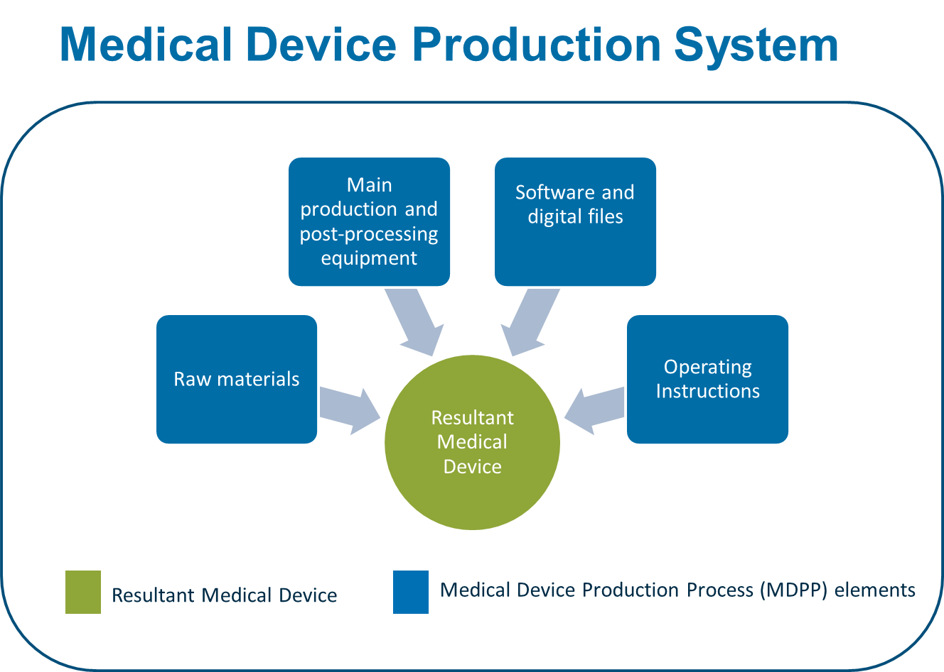
- An MDPS may require the use of ancillary equipment, human factors considerations, technical capability requirements, or other specified input and design limit controls; however, all components must be validated as a production process to consistently produce the resultant medical device with the use of the supplied operating instructions.

Figure 2. An illustration of the constituent parts of a medical device production system (MDPS).
As shown in Figure 2, an MDPS has two constituent parts:

- Medical Device Production Process (MDPP) elements: which may include raw materials, main production and post-processing equipment, software and digital files, and the operating instructions supplied by the MDPS manufacturer for the production of a specific medical device; and
- Resultant Medical Device (RMD): the specific medical device that the MDPP produces using the operating instructions supplied by the MDPS manufacturer.

From a regulatory perspective, the manufacturer of an MDPS (even if they act as an aggregator of technology, systems, components, and raw materials supplied by other suppliers) is responsible for verification and validation of both, the MDPP elements and the RMD. However, following the pre-market approval of the MDPS, and as determined by the RA having jurisdiction, there may be different models under which an MDPS may be supplied to a HCF (as described in Appendix 1 of the IMDRF/ PMD WG/N58 Personalized Medical Device - Regulatory Pathways document).
Technical considerations for verification and validation of an MDPS should include assessing the RMD (against the needs of and intended use in the end-user), as well as the MDPP (against the needs and requirements of the user of the MDPP) to ensure that the RMD consistently meets the predetermined quality, safety, and performance specifications set by the MDPS manufacturer. Since the definition of an MDPS includes the MDPP elements, verification and validation activities for an MDPS should include establishing effective monitoring and control measures to ensure that the validated state of the MDPP is maintained throughout its expected service life.
This guidance aims to provide general principles that a manufacturer should follow for the verification and validation of an MDPS. The recommendations, herein, are not prescriptive, and the manufacturer may develop their specific strategies to generate objective evidence (required for verification and validation) in line with the general principles described below.

MDPS description
In the technical documentation, the MDPS manufacturer should describe all aspects of the MDPP and the resultant medical device (Figure 2). The manufacturer should also provide information on the intended users of the MDPP and the intended use of the resultant medical device. The description should include a picture or image of the MDPP elements and the resultant medical device that it is intended to produce, with the main components clearly labelled and a brief explanation of the operating principles provided for both. Additionally, the MDPS description should provide an overview of the main production and post-processing (if applicable) equipment, raw materials used in production, software and digital files, manufacturing workflow, and quality control processes, preferably using a flowchart.

Key Considerations in MDPS Design Development
An MDPS consists of the Medical Device Production Process (MDPP) elements and the resultant medical device. An MDPS manufacturer should take a systems engineering approach to the design and development of the MDPS. As a result, the design and development of the MDPS involve assessments of individual pieces of the system and the whole system collectively. Some key considerations for MDPS design verification and validation include the design of the resultant medical device, design of the MDPP, verification of the MDPS, and validation of the MDPS.

Resultant Medical Device Design Development
As with any traditional device development activity, as a first step, the manufacturer should unambiguously establish user needs and intended uses of the resultant medical device that the MDPP is intended to produce. These requirements should form the basis of the development plan for the resultant medical device and to develop comprehensive design characteristics and performance requirements, that can be subsequently verified and validated against predetermined acceptance requirements.
Defining the design characteristics and performance requirements of the resultant medical device is essential to ensuring the development of an MDPP capable of producing the intended resultant medical device. MDPP technologies vary in their technical capability to produce the necessary dimensional precision and material properties/characteristics desired in a given device design. As a result, there are a few key activities in the design and development of the resultant medical device to which the manufacturer should pay particular attention.
With a resultant medical device, the manufacturer determines those elements of the design that are variable and capable of personalization, and those that are standardized, not personalized to the patient. The personalized elements are described in the design envelope. Section 5.6 of the document describes key considerations in verifying a defined design envelope. Additionally, the manufacturer identifies the critical features and tolerances for the design of the resultant medical device. Where the resultant medical device is a PMD, an additional consideration for the design is the development of the Patient Personalization Workflow. This workflow defines responsible parties in gathering patient data and incorporating that data to personalize the device.
The final design of the resultant medical device, including critical features and tolerances, and personalization processes (if any), become the starting point for the design of the MDPP.

Medical Device Production Process Design Development
Once the design and performance requirements for the resultant medical device have been established, the next step is the design of the MDPP such that the design and performance requirements for the process can be consistently and reproducibly achieved.

Given the different manufacturing technologies available and the material limitations associated with each technology, material and production process requirements are concurrently established based on the resultant medical device requirements, end-user requirements, and the intended use of the MDPP, which should take into account limitations of the end-user facility's infrastructure. Once the material and build system requirements are set, the post-processing requirements can be determined based on the combination of the resultant medical device requirements, and the material and production process requirements.
Once all the MDPP requirements are set, the specific elements of the system can be selected. This may include the raw material, software and digital files, and main production and post-processing (if applicable) equipment. Once selected, the production specifications, including all manufacturing parameters, material handling, software instructions, post-processing and other ancillary equipment instructions are developed with the specificity and comprehensibility for the end-user to use the selected elements to produce the resultant medical device. Once those specifications have been set, the work instructions for operating and maintaining the MDPP elements over the expected service life are developed.

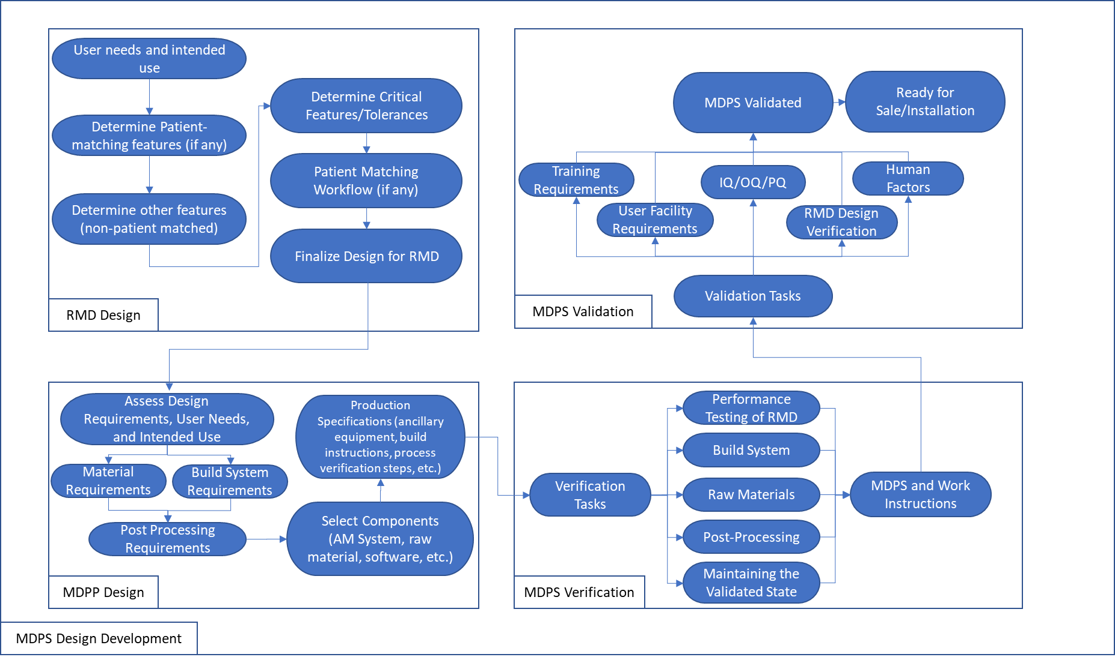
Figure 3A. An illustration of Key Consideration in the Medical Device Production System (MDPS) design development

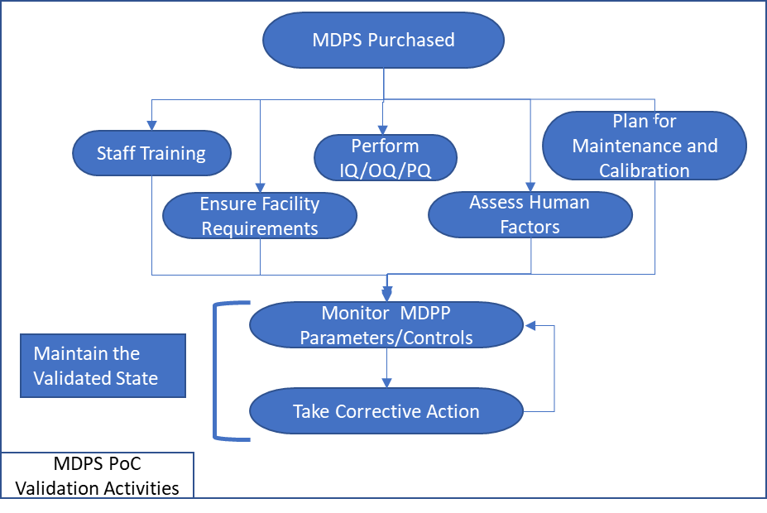
Figure 3B. An illustration of Medical Device Production System (MDPS) validation activities at POC

Medical Device Production System Verification
With the production specifications developed for the MDPP, the next step includes verification tasks for the complete MDPS design. The objective of this step is to ensure that the MDPS is capable of reliably and consistently producing the resultant medical device using the MDPP.
The foundation for verification of the MDPS is performance testing of the resultant medical device to ensure that it meets the established design specifications. Once that has been established, verification testing of the individual elements of the MDPS can be conducted to demonstrate the production specifications are sufficient to mitigate the variability in the manufacturing process, raw materials (e.g., re-use) and controls, and the post-processing. The worst-case manufacturing conditions (as applicable) for the MDPP are generally established and their effect on the performance of the resultant medical device evaluated.
Once the MDPP and the resultant medical device have been verified, the instructions for maintaining the validated state of the system are developed. This encompasses assessing the maintenance requirements of the physical systems, software verification, and any verification coupon testing or other tasks to ensure the system is performing as expected. Guidance on maintaining the validated state of a process is provided in Quality Management Systems – Process Validation Guidance. The MDPS manufacturer should:
- Identify critical process parameters and input variables that affect the quality, safety, and performance characteristics of the resultant medical device;
- Establish procedures and provide tools/instruments for continuous monitoring and control of the critical process parameters and input variables;
- Establish triggers for corrective action and/or revalidation;
- Establish a schedule for preventive maintenance, periodic calibration, and revalidation of the MDPP elements and
- Incorporate the above points in developing training program/materials for the MDPP users.
Once verified, the MDPS is ready for validation.

Medical Device Production System Validation
Design validation addresses the classic question, did the manufacturer develop the correct device to meet the user needs and the intended use. For the MDPS, the manufacturer is responsible for addressing both the ability of health care facilities to use the MDPP to produce the resultant medical device, and ensuring that the resultant medical device meets the user needs for the established intended use. Validation of the resultant medical device could be established using methods typically used for a comparable medical device produced at traditional manufacturing facilities.
Validation of the MDPS assesses if the intended user(s) of the MDPP and the resultant medical device is able to use the collective elements of the system to consistently and reliably produce and use the resultant medical device. This validation is more complex than the validation for a typical medical device produced at traditional manufacturing facilities. It involves assessing the variability associated with:
- MPDS functioning in its intended environment
- the MDPP elements (software, raw materials, post-production, and production equipment, etc.)
- instructions for use
- IQ/OQ/PQ, and
- human/MDPS interface.

This could potentially be accomplished through a combination of simulated use testing, on-site testing, human factors testing and/or user competence testing depending on the risks associated with the manufacturing technology and the resultant medical device. Some regulatory authorities may request clinical evidence to support the product application. The collective elements of the system to be assessed include user training requirements, user facility requirements (defined by production and post-processing equipment requirements), the verified MDPP (software/digital files, raw materials, main production, and post-processing (if applicable) equipment), operating instructions, and the MDPP user's ability to maintain the validated state.
6.2.5 POC Validation Activities
Once the MDPS is validated by the manufacturer under factory or offsite settings, POC validation activities may be required at each site before the MDPP can be used and for ensuring its ongoing maintenance. These activities include, but are not limited to, installation and qualification of the MDPP elements, staff training, and maintaining the validated state (monitoring the parameters and controls, and take corrective action as needed) of the MDPP.

Risk management plan for MDPS
The manufacturer may adopt an integrated risk-assessment approach for the resultant medical device-design and manufacturing process-design activities for an MDPS. Such an approach may be useful to identify weaknesses in the design of the MDPS (MDPP + resultant medical device) in the early stages, and to demonstrate the robustness and safety of the MDPS in the later stages of the project. Additionally, the manufacturer could develop separate risk management plans for the MDPP and the resultant medical device, or a combined plan that adequately addresses both the constituent parts. Guidance on the application of risk management to medical devices is provided in ISO 14971.

Medical Device Production Process
The manufacturer's comprehensive risk management plan should consider the intended use and reasonably foreseeable misuse of the MDPP. The monitoring and control measures adopted to maintain the validated state of the MDPP should also assess the ongoing acceptability of the overall residual risks. The manufacturer should establish procedures to capture safety issues reported by the MDPP users in the post-market phase and review the risk management plan periodically.
Additionally, it is highly encouraged and may be required by some RAs, that the manufacturer in conjunction with the MDPP users, should develop a site-specific risk management plan during the commissioning of the MDPP. Although the manufacturer may provide guidance and training to the MDPP users to establish a site-specific risk management plan, periodic review and updating of the risk management file should remain the responsibility of the MDPP users at the site.

Resultant medical device
The manufacturer's comprehensive risk management plan should consider the intended use and reasonably foreseeable misuse of the resultant medical device. The manufacturer should establish procedures to capture any safety issues reported for the resultant medical device in the post-market phase and review the risk management plan periodically.

User facility requirements, competence, training, and human factors validation
The manufacturer should unambiguously establish user facility requirements, minimum competence levels required of the MDPP users and develop adequate training programs/ materials for them.
The manufacturer should define any installation/facility requirements for the site where MDPP is intended to be used. This may include requirements such as power, clean room level, air flow/turnover, compressed air, water, antistatic flooring, etc., needed to ensure that the MDPP is able to produce the resultant medical device with pre-defined quality requirements throughout the service life of the MDPP.
MDPP user competence should be assessed, which may be based on education, prior training, certifications, skills, and experience relevant to the medical device production and post-production activities that the users are expected to perform.
Prior to using an MDPP, the user must complete any training mandated by the manufacturer. The manufacturer should maintain user training records, periodically assess user-training levels, and establish triggers for retraining. Under real-use conditions, the manufacturer may decide to restrict MDPP access only to adequately trained users through verification of the user's digital identity or similar means.
If required by the RA having jurisdiction for the specific device, the manufacturer should conduct human factors validation to assess the MDPP user-interface design with the intended users under simulated-use or real-use conditions (consistent with IEC 62366-1). The manufacturer should ensure that the test participants represent the population of the intended users of the MDPP, and the participants are provided with the same training that the real users will receive. The test should also assess inter-user and intra-user reliability of the quality characteristics of the resultant medical device. The test protocol, data collected, results analysis, and the residual risks identified should be documented appropriately. Further guidance on human factors validation is provided in Applying Human Factors and Usability Engineering to Medical Devices.

Clinical evidence requirements
The manufacturer of an MDPS shall be responsible for generating and maintaining appropriate clinical evidence for the resultant medical device that an MDPS is intended to produce, as required by the RA having jurisdiction.
The clinical evidence requirements for the resultant medical device that an MDPS is intended to produce are the same as for a comparable device (produced under traditional manufacturing arrangements or by another MDPS in clinical use). For a resultant medical device that is only produced by an MDPS and for which no comparable device exists, the clinical evidence requirements should be commensurate with the risk classification and novelty of the device as well as the safety, performance, and effectiveness claims made by the manufacturer.

Labelling requirements
An MDPS is considered a medical device in its own right. Therefore, a manufacturer should apply all relevant labelling provisions for medical devices to the MDPP elements and the resultant medical device it is intended to produce, as required by the RA with jurisdiction.

Medical Device Production Process (MDPP)
All critical elements of the MDPP which the user may need to identify during routine use should be appropriately labelled. Such labels should remain legible over the expected service life of the MDPP. The manufacturer should also attach a tamper-evident label to display the calibration and/or preventive maintenance status of the critical elements of the MDPP, including the next calibration and/or preventive maintenance date.

The manufacturer may use appropriate graphical symbols, safety warnings, colours and signs to caution the users of any potential hazards associated with the use of the system. Depending upon the complexity of the MDPP, user training, potential hazards and associated risks, the manufacturer should prepare appropriate operating instructions for the MDPP users.

The operating instructions should contain a precautionary statement notifying the MDPP user that failure to follow the instructions could result in a medical device that is not safe and fit for its intended purpose. If the RA having jurisdiction requires Unique Device Identification (UDI) labels, the manufacturer should establish a UDI for the MDPS consistent with the RA's UDI requirements.

Resultant medical device
Labelling requirements for the resultant medical device that a MDPP is intended to produce are the same as for a device produced under traditional manufacturing arrangements.
The RA having jurisdiction may require UDI labels for the resultant medical device. The manufacturer should discuss with the RA having jurisdiction to understand the UDI expectations for the resultant medical device produced by the MDPP. For example, the RA may expect the manufacturer to establish a separate UDI for the resultant medical device that the MDPP is intended to produce. In such cases, the RA may require the manufacturer to provide in the UDI-DI (device identifier) for the resultant medical device appropriate linking information for the relevant MDPS. The RA having jurisdiction may further require the manufacturer to generate UDI-PI (production identifier) for the device and maintain this information in their records for traceability purposes.

Software used as part of production rather than software that meets the definition of a medical device in its own right.
“Computing platforms” include hardware and software resources (e.g. operating system, processing hardware, storage, software libraries, displays, input devices, programming languages etc.). “Operating systems” that SaMD require may be run on a server, a workstation, a mobile platform, or other general purpose hardware platform.
For further information on Essential Principles of Safety and Performance of Medical Devices and IVD Medical Devices, see IMDRF/GRRP WG/N47 FINAL: 2018.
The upper and lower limits (and all permissible values in between) for a parameter that only assumes numerical data
IMDRF/PMD WG/N58 Appendix 1 - Materials that are medical devices
For the purposes of this document, boundaries mean the reference intervals (for a parameter that only accepts numerical data) and categories (for a parameter that only accepts categorical data)
Software that is used as part of the design process rather than software that is a medical device in its own right
ISO 14971 Medical devices – Application of risk management to medical devices
ISO 13485 Medical Devices – Quality Management Systems – Requirements for Regulatory Purposes
Design validation activities should be conducted on the final finished device or equivalent, which may include initial production units, batches, or their equivalents with rationale for the choice of product.
IMDRF/MDCE WG/N55 FINAL:2019 Clinical Evidence – Key Definitions and Concepts
IMDRF/MDCE WG/N56 FINAL:2019 Clinical Evaluation
IMDRF/MDCE WG/N57 FINAL:2019 Clinical Investigation
ISO 14971 Medical devices – Application of risk management to medical devices
Derived from an evaluation of clinical data pertaining to the subject device
ISO 14155 Clinical investigation of medical devices for human subjects: Good clinical practice
World Medical Association – Declaration of Helsinki – Ethical principles for medical research involving human subjects
IMDRF/ MDCE WG/N65 FINAL: 2021 Post-Market Clinical Follow-Up Studies
IMDRF/GRRP WG/N52 FINAL: 2019 Principles of Labelling for Medical Devices and IVD Medical Devices
IMDRF/ UDI WG/N48 FINAL: 2019 Unique Device Identification system (UDI) Application Guide
IMDRF/PMD WG/N58 Final: 2020 Personalized Medical Devices – Regulatory Pathways
Software used as part of production rather than software that meets the definition of a medical device in its own right.
US FDA CDRH, Technical Considerations for Additive Manufactured Devices – Guidance for Industry and Food and Drug Administration Staff (Dec 2017), provides examples of worst-case manufacturing conditions
GHTF/SG3/N99-10:2004 (Edition 2): Quality Management Systems – Process Validation Guidance
ISO 14971 Medical devices – Application of risk management to medical devices
IEC 62366-1:2015 Medical devices – Part 1: Application of usability engineering to medical devices
US FDA CDRH, Applying Human Factors and Usability Engineering to Medical Devices – Guidance for Industry and Food and Drug Administration Staff, Feb 2016
IMDRF/MDCE WG/N55 FINAL: 2019 Clinical Evidence – Key Definitions and Concepts
IMDRF/ GRPP WG/N52 FINAL: 2019 Principles of Labelling for Medical Devices and IVD Medical Devices
IMDRF/ UDI WG/N48 FINAL: 2013 Guidance on Unique Device Identification (UDI) for Medical Devices
IMDRF/ GRPP WG/N52 FINAL: 2019 Principles of Labelling for Medical Devices and IVD Medical Devices

