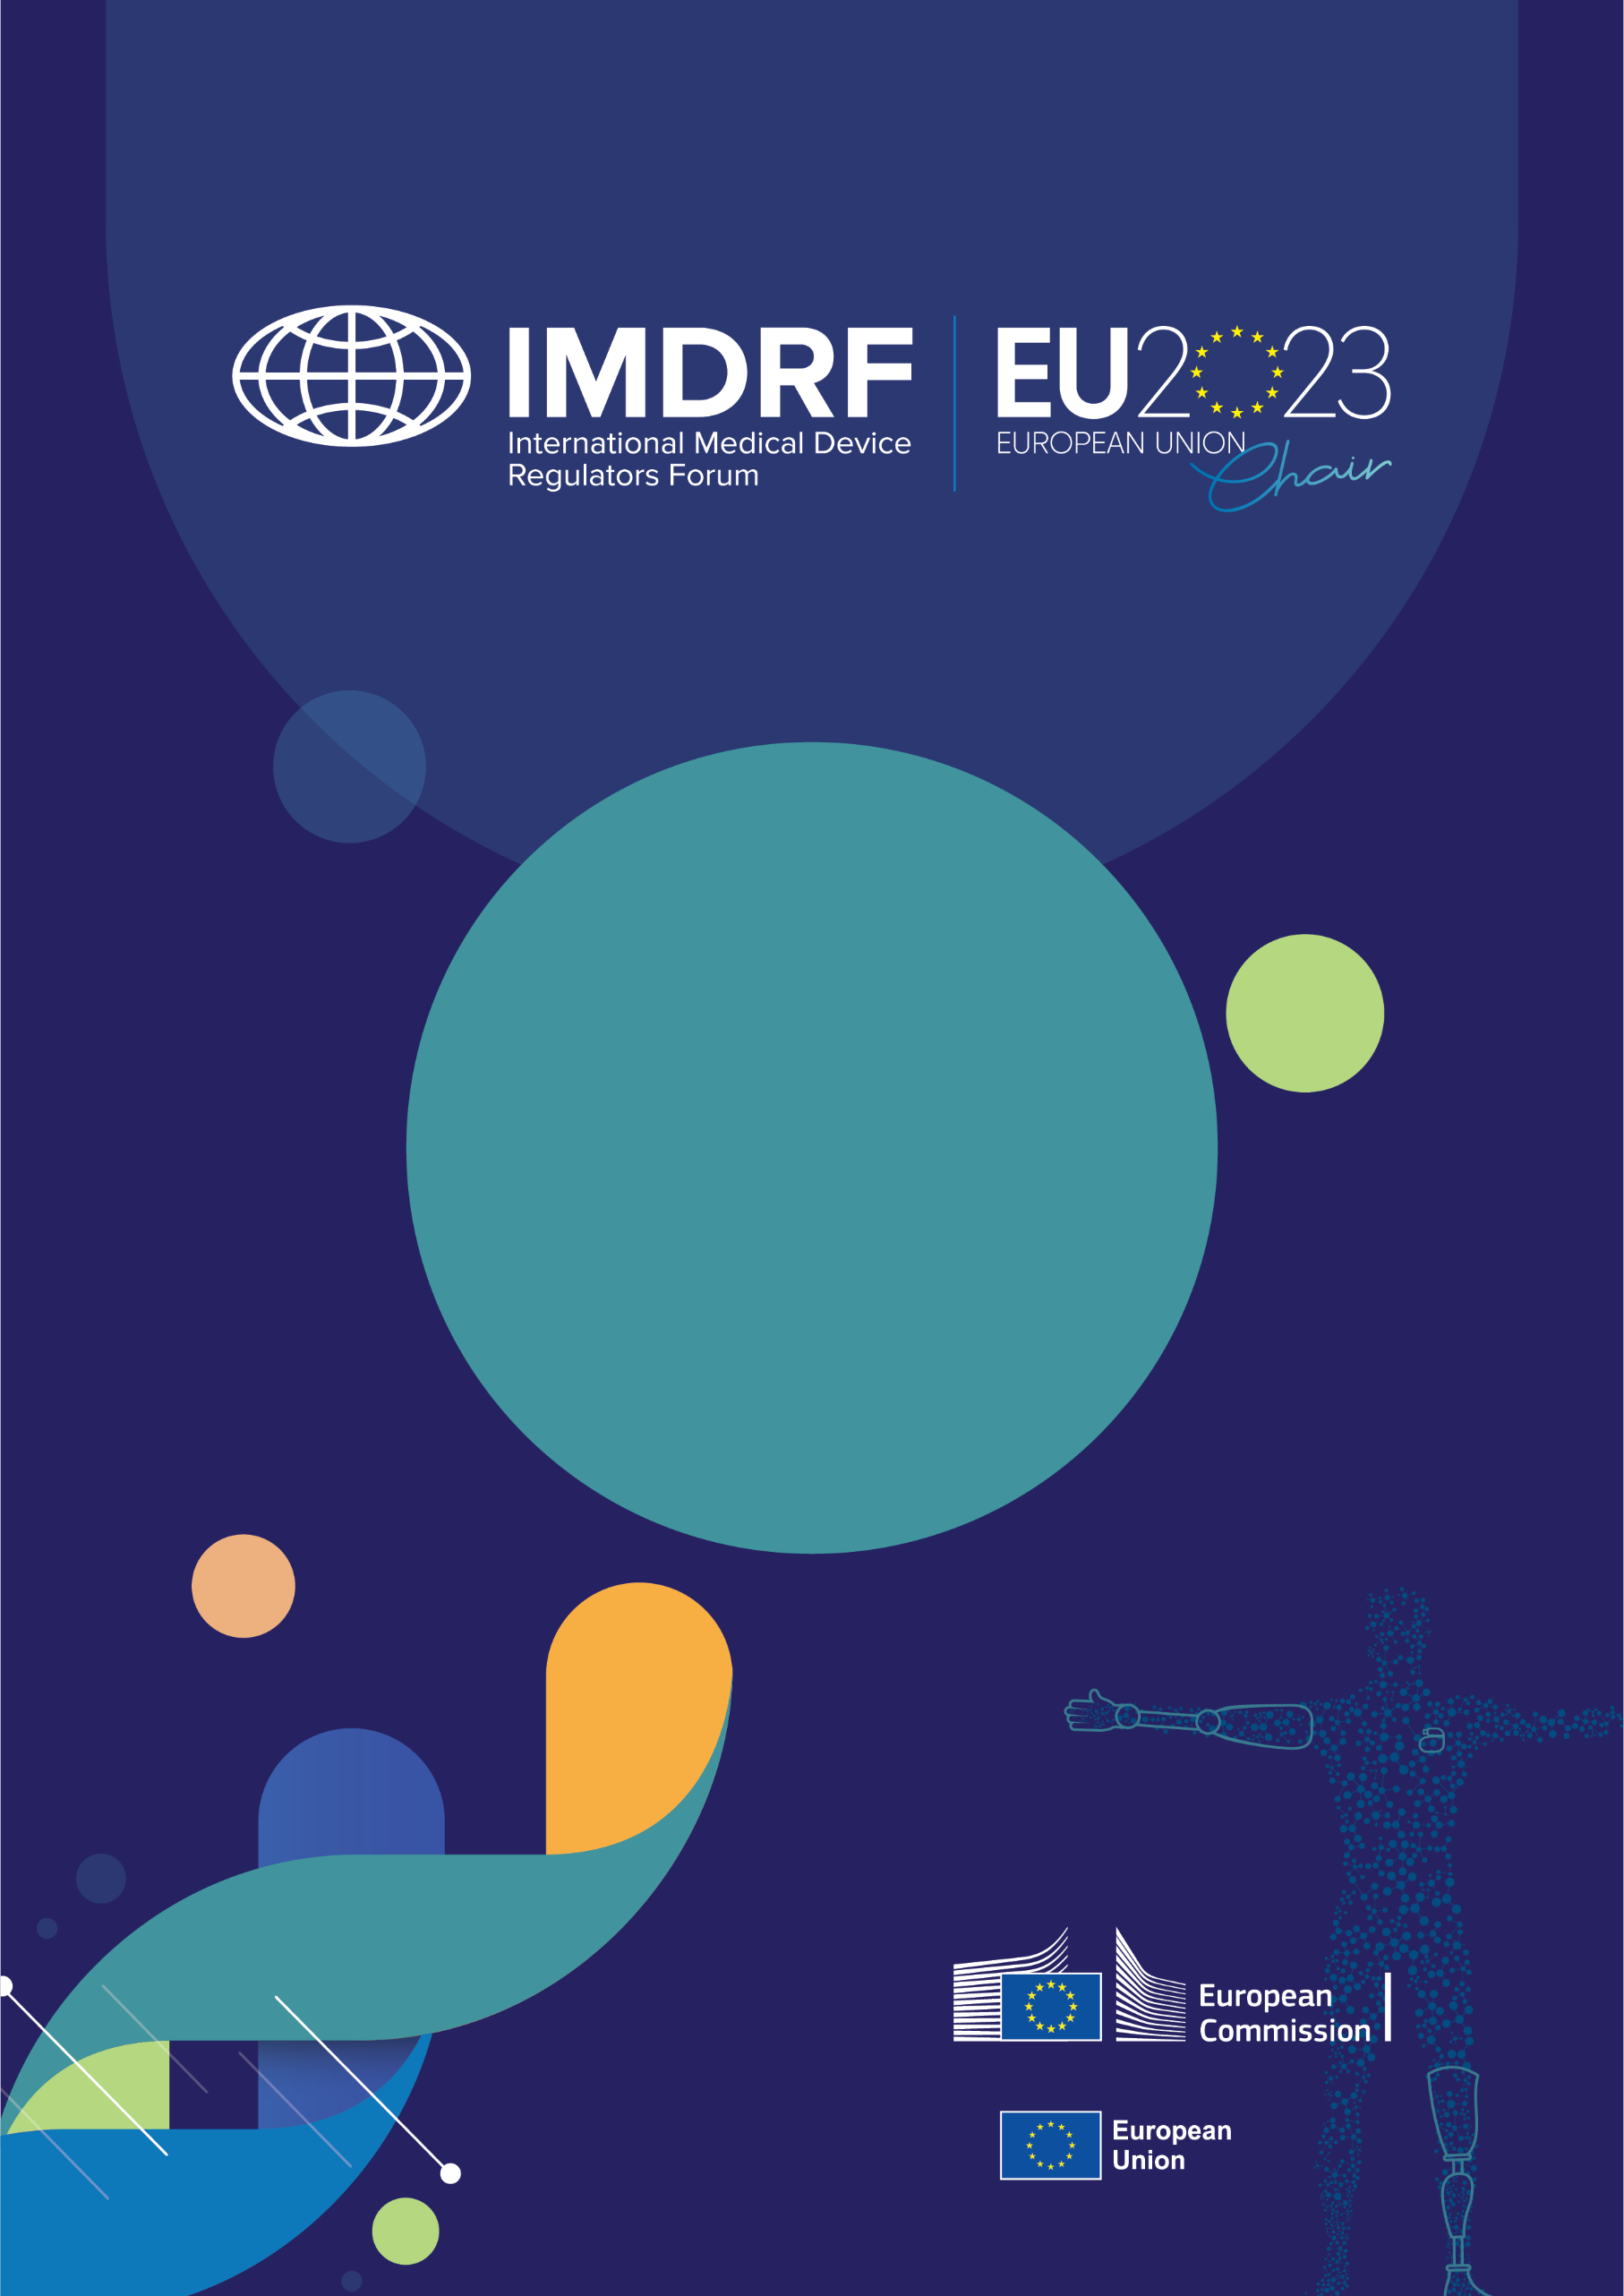
23rd IMDRF Session
Joint Workshop
by

IMDRF – DITTA and GMTA
The life cycle of medical devices: the importance of post-market related activities
Brussels, 27 March 2023

White Paper
THE LIFE CYCLE OF MEDICAL DEVICES: THE IMPORTANCE OF POST-MARKET RELATED ACTIVITIES

This White Paper summarises key outcomes and observations arising from the International Medical Device Regulators Forum (IMDRF) 23rd Session Joint IMDRF – DITTA and GMTA workshop on post-market related activities. It was Chaired by the European Commission, on behalf of the European Union under its role as IMDRF Chair.

The workshop kicked off with a reminder of the importance of continued surveillance of medical devices (MDs) while on the market, maintaining a forward-looking eye into the evolution of technologies and how regulatory systems are required to adapt accordingly. Twenty years ago, addressing cybersecurity pre- and post-market was simply not on the radar. Today, it is an example of how all actors in the system have adapted to meet those challenges. A scene-setting presentation on the lifecycle approach to MDs and the importance of having a robust and efficient feedback mechanism for data acquired from post-market activities was emphasised. The opportunities for enhancing patient safety and product innovation were emphasised. In addition, the need to continuously address the challenges posed by emerging technologies in the field, including software and Artificial Intelligence (AI), was discussed. Post-market activities present endless opportunities and can help all actors in the system reap benefits, all in the common interest of patients.

Post-market surveillance and real-world evidence

Session 1 – Safety notices and vigilance

The session focused on the issues related to safety notices and vigilance for MDs from the perspectives of regulators, manufacturers and healthcare professionals. From the regulator standpoint, post-market surveillance (PMS) is not only essential as a continuous safety indicator for devices on the market, but also presents opportunities for pre-market approval and fostering the iterative development of safer, more performant technologies.​ Low adverse event reporting (AER) levels and the lack of global alignment in terminology related to AER and safety notices/recalls, were recognised as key challenges to achieving an overview on vigilance and surveillance of device safety. Stakeholders also recognised the importance of IMDRF work on creating and implementing a comprehensive harmonised terminology and coding system for adverse events (AEs), as well as updating existing post-market focused guidance documents. From the healthcare perspective, the importance of increasing post-market feedback outlets and accessibility was emphasised. The need to improve healthcare practitioners’ awareness of AER and to consider possible barriers to reporting was stressed. The importance of education and training in this area was noted.

Observations:
- Continue to develop the IMDRF AE Terminology and support widespread uptake through the development of training materials so as to increase the rate of reporting and facilitate pooling of data.
- Increase efforts to harmonise AE definitions, criteria, reporting forms (or at least essential parts of forms) where possible, as well as reporting timelines.
- Consider updating IMDRF documents on PMS in the upcoming IMDRF strategic plan.
- Consider increasingly harnessing the use of identification and traceability tools such as UDI and AE Terminology, to investigate and improve the quality of post-market data.
- Consider increasing opportunities for use of PMS data for pre-market approval and certificate renewal or recertifications.

Session 2 – Real-world evidence

This session presented increasing opportunities and growing acceptance globally for the use of real-world evidence (RWE) as a complement to traditional evidence sources in the regulatory decision-making process for MDs and in-vitro diagnostics.

It is clear a multitude of potentially valuable real-world data (RWD) sources exist, and the challenge will be to identify how these can appropriately be used in regulatory submissions going forward. Discussions on this topic highlighted the potential benefits of setting common clinical methodology in areas where RWD is available and regulatory requirements are similar. Achieving this would involve mapping areas of compatibility and identifying remaining gaps to find common ground. In spite of the potential for RWE, concerns remain around data quality, methodologies for identification collection, as well as transparency with regard to patient data protection, informed consent and ethical matters.

Areas pointed out as requiring attention included the development of clear policies for data privacy and management​; standardisation of interactions with industry and regulators on RWE; development of quality assessments for data sources (including registries); application of appropriate statistical methods to RWE collected; transparency; and ensuring any studies involving RWE are reproducible.

Observations:
- Identify solutions to pool and analyse RWD effectively for its use in regulatory decision-making.
- Identify and compile best practices on RWE in the regulatory process by building on existing jurisdictional guidance documents and field experience of regulatory submission using RWD to achieve this.
- Agree on collaborative methods to harmonise best practices and work together towards common clinical methodologies to harness RWD.
- Consider harnessing RWE for sub-populations of rare diseases to systematically improve functioning of ‘orphan’ devices.

Post-market considerations for software including AI: Opportunities and challenges

Session 3 – Criteria, methods and strategies to monitor safety and performance of software

The particular challenges of PMS for software include faster life cycles, increased input sources (passive and active), and the potential challenges for competent authorities in dealing with increased vigilance notifications. The increasingly widespread use of apps and wearables brings with it new challenges. The fact that apps are spread over a wide population and range of devices and platforms and operated by lay people rather than health professionals brings new considerations to the regulatory environment. There is more passive collection of data, but also more sources for active input (social media, customer services, ratings, updates) that need to be managed.

The challenges and opportunities of dealing with vast amounts of data in the modern world, including the MD sector, were discussed. Regarding data quality, standards have been developed, or are being developed to address this. However, the conflicting need to access high quality data whilst ensuring data privacy was also recognised, particularly in the context of training and development of machine learning models

From the regulator perspective, the most common post-market issues encountered with software and how to address them were presented, including lack of incident reporting, provision of vague intended use, and issues with dependability and interoperability. Addressing the issues should involve simplification of language and terminology for users, ensuring testing matches the clinical workflow, and adapting the intended use formulation to meet the true target audience.

Observations:
- Identify methods to increase transparency and improve citizen awareness of post-market reporting, including knowledge on how and what to report to improve quality of post-market data.
- Simplify user-reporting mechanisms software and apps qualified as a medical device apps through accessible language and procedures to increase rates of reporting and patient safety.
- Increase overall awareness/education of users and consumers of MD regulations, and what software may qualify as an MD in view of future technologies, and appliances, including in the home setting.

Session 4 – Specific post-market consideration for AI medical devices

The added complexity of PMS and monitoring of endpoints for AI MDs was reviewed. The various endpoints for different stakeholders and the steps to be followed to ensure transparency were outlined. Discussions followed on the potential role of the post-market phase to monitor for bias in AI MDs, thus contributing to building fairer AI models.

Presentations on change management in AI MDs highlighted the need for a tailored, risk-calibrated regulatory approach, especially for post-approval changes based on the manufacturer’s quality management system. The challenges for change management in a complex multimodal system in which the rate of change and level of complexity are constantly increasing were also highlighted.

From the industry perspective, the challenge and need for companies to adopt a continuous learning approach in the post-market phase for AI software, to be able to react to input from RWD, respond to change and open feedback from an uncontrolled clinical environment was explained.

Observations:
- A robust regulatory framework and clear guidance is recommended for the training and use of AI in order to harness its full potential while limiting any potential risks, including bias (inherent or learned), and threats to fundamental rights and patient privacy. AI should be used to assist clinicians, not replace them.

Conclusions:
- There is clear consensus around the need for increased alignment of AE terminology, reporting requirements and forms. This will help increase the compatibility and usability of data, make the detection of safety signals on a global level much more reliable and ultimately increase patient safety.
- IMDRF work on AE terminology should be widely adopted internationally to provide a common foundation to work on, thus facilitating the exchange and analysis of data.
- Information and training on AE terminology and reporting would help to enhance reporting, standards and increase reporting rates, particularly by health professionals.
- There are challenges with respect to ensuring PMS for software and AI qualified as medical devices given the very fast pace of change in this area and the growing complexity of the field. There are opportunities for AI to be harnessed in a safe and controlled way to help to improve surveillance in this area and manage the wide range of data sources.
- Simplifying the user reporting process will improve the level of reporting. The digitalisation of the application process could help to rationalise and streamline processes and make them more accessible and user-friendly.

