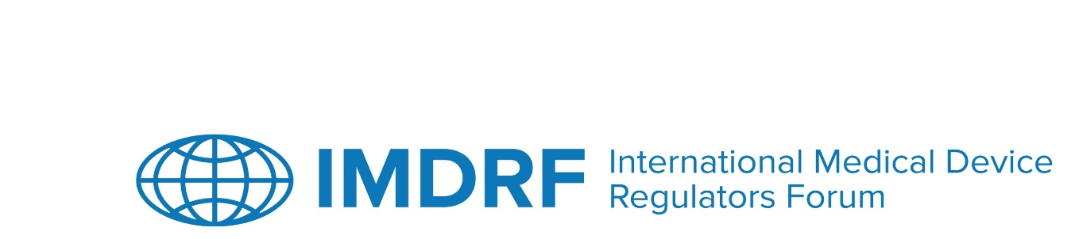

OUTCOME STATEMENT
24th Management Committee Meeting of the International Medical Device Regulators Forum
25-29 September 2023
Berlin, Germany

The 24th meeting of the International Medical Device Regulators Forum (IMDRF) Management Committee (MC) and Official Observers took place both in person in Berlin, Germany, and online from 25 to 29 September 2023. The meeting was chaired by the EU. Over 350 participants attended in person and a further 200 virtual attendees participated in the first two public days. Presentations can be found here.

Joint IMDRF / Stakeholder (DITTA-GMTA) Workshop
Specialized Regulatory Pathways
On 25 September 2023, the IMDRF/DITTA-GMTA Joint Workshop on ‘Specialized Regulatory Pathways’ was held. Regulators, industry representatives and healthcare professionals took part in three sessions and accompanying panel discussions. The first session focused on medical devices (MDs) intended for specific patient populations, including orphan, humanitarian use, paediatric, personalised and custom MDs. The second looked at innovative MDs, their existing pathways in several countries around the world, as well as opportunities for convergence and reliance. Participants presented lessons learned and exchanged ideas and experiences on the regulation of the aforementioned MDs. Session 3 dealt with regulatory toolboxes to foster innovation, including the use of regulatory sandboxes and predetermined change control plans (PCCPs). The audience heard about experiences and examples of regulatory sandboxes in the MD context and presented components and considerations with respect to PCCPs. Lessons learned and presented opportunities to encourage innovation for the benefit of patients were discussed.
IMDRF Stakeholder Forum
On 26 September 2023, the IMDRF Stakeholder Forum was held where regulatory updates were provided by IMDRF MC Members and Official Observers. These included short updates on the IMDRF’s Working Groups which were published on the IMDRF website prior to the meeting, providing the opportunity to anyone interested to submit questions to the speakers.

- Adverse Event Terminology – (USA/EU)
- Good Regulatory Review Practices – (USA/Singapore)
- Medical Device Cybersecurity Guide – (USA/Canada)
- Personalized Medical Devices – (Australia)
- Quality Management Systems – (USA/EU)
- Regulated Product Submission – (Canada/USA)
- Software as a Medical Device – (USA/Canada)
- Artificial Intelligence/Machine Learning-enabled – (USA/UK)
Presentation materials were also provided to update on the work of:
- African Medical Devices Forum (AMDF)
- Asia-Pacific Economic Cooperation (APEC)
- Global Harmonization Working Party (GHWP)
- Global Diagnostic Imaging, Healthcare IT, and Radiation Therapy Trade Association (DITTA)
- Global Medical Technology Alliance (GMTA)
Another novel feature introduced based on feedback from the 23rd IMDRF session in Brussels, was the interactive ‘flash panel’ discussions on two subjects of interest: Unique Device Identification (UDI) as well as Digital Therapeutics.
All presentation materials for the IMDRF/DITTA-GMTA workshop and the IMDRF Stakeholder Forum are available here.
IMDRF Management Committee Open Session

On 27 September 2023, the MC Open Session was held, providing an opportunity for Regional Harmonization Initiatives (RHIs), Invited Observers (regulators), DITTA and GMTA (industry associations) to provide updates and interact with the MC.

Presentations were made to update on the work of RHIs:
- African Medical Devices Forum (AMDF)
- Global Harmonization Working Party (GHWP)
- Asia-Pacific Economic Cooperation (APEC)
Presentations were made to provide updates on the work of Invited Observers (regulators):
- Central Drugs Standard Control Organization (CDSCO) – India
- Centro para el Control Estatal de Medicamentos, Equipos y Dispositivos Médicos (CECMED) – Cuba
- Public Health Institute of Chile (ISP)
- Egyptian Drugs Authority (EDA)
- Medicines and Medical Devices Agency of Serbia
- Institute for medicines and medical devices of Montenegro (CInMED)
- Division of the State Market Surveillance of Medical Devices – Ukraine
- National Institute of surveillance of medicines and food (INVIMA) – Colombia

Presentations were made to provide updates on the work of industry associations:
- Global Diagnostic Imaging, Healthcare IT, and Radiation Therapy Trade Association (DITTA)
- Global Medical Technology Alliance (GMTA)

IMDRF Management Committee Closed Session

The IMDRF MC Closed Session was held over two days, 28 and 29 September 2023. The MC discussed and took decisions regarding membership applications, as well as on procedural matters, including IMDRF governance documentation (See Annex) and noted the release and publication of the first IMDRF training pilot on adverse event terminology, available here.

ANNEX
DECISIONS BY THE IMDRF MANAGEMENT COMMITTEE

28 and 29 September 2023

Berlin, Germany

In summary:

- The MC agreed to accept the IMDRF Regional Harmonization Initiative application of the African Medical Device Forum (AMDF)
- The MC agreed to accept the IMDRF Affiliate Member applications of:
  - Institute for Medicines and Medical Devices of Montenegro (CInMED)
  - Centro para el Control Estatal de Medicamentos, Equipos y Dispositivos Médicos (CECMED)
  - Medical Technology Health Information Innovation & Research Directorate (MTIIR)
  - Public Health Institute of Chile (ISP)
  - Egyptian Drug Authority (EDA).
- The MC agreed to the:
  - proposed updates to the IMDRF Standard Operating Procedure document, including the criteria for IMDRF membership.
  - proposed updates to the IMDRF membership application form and the New Work Item Proposal template.
  - closing of the Medical Device Cybersecurity Guide Working Group.
- The MC supported the publication of a White Paper on the outcomes of the 24th IMDRF Session Joint Workshop on specialised regulatory pathways.

