Final Document
IMDRF/MC/N2FINAL:2023 (Edition 10)
IMDRF Standard Operating Procedures
Authoring Group
IMDRF Management Committee

Preface
© Copyright 2023 by the International Medical Device Regulators Forum.
This work is copyright. Subject to these Terms and Conditions, you may download, display, print, translate, modify and reproduce the whole or part of this work for your own personal use, for research, for educational purposes or, if you are part of an organisation, for internal use within your organisation, but only if you or your organisation do not use the reproduction for any commercial purpose and retain all disclaimer notices as part of that reproduction. If you use any part of this work, you must include the following acknowledgement (delete inapplicable):
“[Translated or adapted] from [insert name of publication], [year of publication], International Medical Device Regulators Forum, used with the permission of the International Medical Device Regulators Forum. The International Medical Device Regulators Forum is not responsible for the content or accuracy of this [adaption/translation].”
All other rights are reserved and you are not allowed to reproduce the whole or any part of this work in any way (electronic or otherwise) without first being given specific written permission from IMDRF to do so. Requests and inquiries concerning reproduction and rights are to be sent to the IMDRF Secretariat.
Incorporation of this document, in part or in whole, into another document, or its translation into languages other than English, does not convey or represent an endorsement of any kind by the IMDRF.

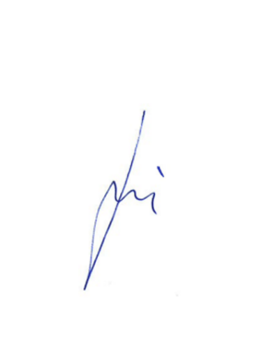

Andrzej Rys, IMDRF Chair

Contents
1. Introduction 4
2. IMDRF Sessions 5
3. IMDRF Membership 6
3.1. Management Committee Members 6
3.2. Official Observers 8
3.3. Affiliates 9
3.4. IMDRF Membership Status Change 10
4. Engagement with IMDRF 16
5. Sub-Committees and Working Groups 17
5.1. IMDRF MC Subcommittees 17
5.2. IMDRF Working Groups 17
6. Development of Technical Documents 20
6.1. General Principles 20
6.2. Stage 1 – Assignment of Work Items 20
6.3. Stage 2 – Document Development 21
6.4. Stage 3 – Advancement from Working Draft to Proposed Document 21
6.5. Stage 4 – Consultation on Proposed Documents 22
6.6. Stage 5 – Advancement from Proposed to Final Document 22
6.7. Stage 6 – Publication 22
6.8. Stage 7 – Implementation 23
7. Development of Information Documents 24
8. Document Status Designation 25
8.1. Location of Designation Code 25
8.2. Working Drafts (WD) 25
8.3. Proposed Documents (PD) 25
8.4. Final Document 25
9. Review and Revision of IMDRF Documents 27
9.1. Maintenance of IMDRF Documents 28
10. Management and Maintenance of GHTF Documents 29
11. Translation of IMDRF guidance documents 30
12. IMDRF-Related Presentations and Training 31
13. IMDRF Logo 32
14. Annex A – IMDRF Organisational Structure 33
15. Annex B - IMDRF Membership Roles and Criteria 34
16. Annex C - Suspension and Termination of Membership 37

Introduction
The International Medical Device Regulators Forum (IMDRF) is a voluntary group of medical device regulators from around the world who have come together to build on the strong foundational work of the Global Harmonization Task Force on Medical Devices (GHTF) and aims to strategically accelerate international medical device regulatory convergence.
This document complements and is intended to be read in conjunction with the IMDRF Terms of Reference (ToR). It describes the procedures that the IMDRF follows when revising the membership of the IMDRF Management Committee (MC), Official Observers and Affiliates, establishing Subcommittees or Working Groups, developing IMDRF documents or managing documents previously developed under the GHTF.
The operating procedures outlined in this document, in conjunction with the IMDRF ToR, are designed to be flexible so that should the need arise, the IMDRF can respond to challenges with respect to its objectives in a timely manner.

IMDRF Sessions
The IMDRF MC holds three successive Sessions in March and September of each year corresponding with the IMDRF MC Closed Sessions. The IMDRF MC Members are expected to attend the Sessions held during the calendar year physically (face-to-face). Hybrid Sessions (in person and virtual attendance) may be facilitated, should situations arise that prevent IMDRF MC Members from attending physically.
The IMDRF MC also meets virtually via web/teleconferences twice a year, in January and June of each year. At the discretion of the IMDRF Chair, the IMDRF MC may also meet when required or as a result of extraordinary circumstances.
Information on Sessions and how decisions are made by the IMDRF MC are covered in the IMDRF ToR.

IMDRF Membership
IMDRF membership criteria, roles, and responsibilities are listed in the Sections below and are also outlined in Annex B. A visual representation of the IMDRF organisational structure can be found in Annex A. In summary, the IMDRF MC takes part in decision making concerning membership and engagement, sets the direction of IMDRF work, contributes to work outputs and implementation activities.

Management Committee Members
The IMDRF MC consists of regulatory authorities. All IMDRF MC Members, except for the European Union, may appoint two (2) representatives. The European Union may appoint four (4) representatives. Regional unions and cooperatives composed of several countries with their own regulatory authorities will be allowed to appoint up to four (4) representatives. The appointed representatives need to be knowledgeable on IMDRF matters. It is expected that these representatives would consistently attend subsequent IMDRF Sessions and that any changes to representation would require notification to the IMDRF Chair and Secretariat.
The IMDRF MC Members are responsible for the oversight and decision making for all IMDRF activities. The IMDRF MC Members are voting members and are expected to attend all face-to-face IMDRF MC Sessions and teleconferences as well as to ensure regular contribution to IMDRF activities and participate in at least 2/3 of the IMDRF Working Groups. In exceptional circumstances, the IMDRF MC may choose to hold hybrid Sessions (in person and virtual attendance) should a situation arise that prevent IMDRF MC Members from attending the face-to-face Sessions.
In reviewing MC Member application requests, the IMDRF MC will consider whether the regulatory authority has met each of the following requirements, including having:
- a regional influence;
- participated in all IMDRF MC Sessions (including teleconferences) for the last three (3) consecutive years;
- participated in at least half of the IMDRF Working Groups as an Official Observer for the last three (3) consecutive years, providing active contribution;
- been an Official Observer for at least the last three (3) consecutive years prior to the application for membership; and
- sufficient capacity to chair the IMDRF MC and provide the IMDRF Secretariat for a year, including hosting two (2) face-to-face Sessions and two (2) scheduled teleconferences.
Having been an Official Observer for the last three (3) consecutive years prior to the application for membership, while being an essential precondition for becoming an MC Member, does not give the applicant any automatic presumption of conformity with the other criteria listed above.
Applications to become an IMDRF MC Member are to be made in writing by completing the application form (located on the IMDRF website) and sending it to the IMDRF Chair and Secretariat. All applications must be submitted at the latest two (2) months before the next MC Closed face-to-face Session for consideration. The IMDRF MC will ask the applicant to provide a presentation at the IMDRF MC face-to-face Session where the application will be considered. The presentation should provide an overview of the applicant’s existing regulatory framework including the extent to which IMDRF documents are currently or are planned to be implemented. In particular, the presentation should outline how the applicant meets the above set requirements. Any new IMDRF MC Member will be approved with the unanimous agreement of existing IMDRF MC Members.
The membership of the IMDRF MC will be published on the IMDRF website here.

Expedited Procedure
In exceptional circumstances, a regulatory authority who is an Official Observer may apply for IMDRF membership under an expedited procedure, to become an IMDRF MC Member. To apply the regulatory authority must:
- provide a clear, justified and comprehensive motivation as regards the exceptional circumstance which qualifies the review of their application under the expedited procedure;
- have a regional influence;
- demonstrate their regulatory framework includes principles outlined in the IMDRF and GHTF guidance documents;
- be an Official Observer for at least one (1) year and have attended at least two (2) IMDRF MC teleconferences and two (2) IMDRF MC Closed Sessions as an Official Observer;
- have previously contributed to IMDRF activities including having actively contributed to 2/3 of IMDRF Working Groups for the last four (4) years. Note that this contribution could have been on behalf of another jurisdiction or a Regional Harmonization Initiative (RHI) or as an Affiliate Member;
- have demonstrated that they have sufficient capacity to host IMDRF face-to-face Working Group meetings; and
- have demonstrated that they have sufficient capacity to Chair the IMDRF MC and provide the Secretariat for a year, including hosting two (2) face-to-face Sessions and two (2) scheduled teleconferences.
Applications to become a IMDRF MC Member are to be made in writing by completing the application form (located on the IMDRF website) and sending it to the IMDRF Chair and Secretariat. All applications must be submitted at the latest two (2) months before the next IMDRF MC Closed face-to-face Session for consideration. The IMDRF MC will ask the applicant to provide a presentation at the IMDRF MC face-to-face Session where the application will be considered. The presentation should provide an overview of the applicant’s existing regulatory framework including the extent to which IMDRF documents are currently or are planned to be implemented. In particular, the presentation should outline how the applicant meets the above set requirements. Any new IMDRF MC Member will be approved with the unanimous agreement of existing IMDRF MC Members.

Official Observers
Official Observers consist of regulatory authorities and the World Health Organization (WHO). Official Observers participate in the oversight of all IMDRF activities, but do not participate in the decision making process. Official Observers are expected to attend all face-to-face IMDRF MC Sessions and teleconferences as well as participating in at least half of the IMDRF Working Groups. Official Observers will be expected to maintain the confidentiality of the Closed IMDRF MC Sessions per the IMDRF ToR. When a discussion or portion of an IMDRF MC Session is designated as Closed, Official Observers may attend. As with IMDRF MC Members, Official Observers may have two (2) representatives and these representatives need to be knowledgeable on IMDRF matters.
In reviewing application requests to become an Official Observer, the IMDRF MC will consider whether the applicant has met each of the following requirements:
- is a regulatory authority;
- is a regional influence;
- operates a mature or maturing system for medical device regulation which should include:
  - established laws and regulations for medical devices building substantially on GHTF and IMDRF foundations and principles;
  - proper competencies for effective implementation and enforcement of the established laws and regulations;
  - a system for conformity assessment of devices building on GHTF and IMDRF guidance documents; and
  - sufficient resources and regulatory expertise to perform its duties.
- Demonstrated contribution to scientific or regulatory innovation in the field of medical devices as demonstrated by development of guidance(s) in emerging technical and regulatory issues;
- having a demonstrated capacity to contribute resources and expertise to the objectives of IMDRF by participation in Open IMDRF MC Sessions for the last two (2) consecutive years, participation in at least two Working Groups for the last two (2) consecutive years as an Affiliate Member or invited expert, and providing input to document consultations; and
- having a recognized commitment to the objectives of IMDRF demonstrated by implementation of IMDRF documents (work items).
Applications to become an Official Observer are to be made in writing by completing the application form (located on the IMDRF website) and sending it to the IMDRF Chair and Secretariat. Applications must be submitted at the latest two (2) months before the next MC Closed face-to-face Session for consideration. The IMDRF MC will ask the applicant to provide a presentation at the IMDRF MC face-to-face Session where the application will be considered. The presentation should provide an overview of the applicant’s existing regulatory framework including the extent to which IMDRF documents are currently or are planned to be implemented. In particular, the presentation should outline how the applicant meets the above set requirements.
IMDRF MC Members will aim to reach agreements on Official Observer applications unanimously. Should unanimity not be achieved, the Chair may recommend advancing with a majority agreement (75%) of existing IMDRF MC Members.
The list of Official Observers are published on the IMDRF website here.

Affiliates

Affiliate Members
Regulatory Authorities who would like to engage with IMDRF, but do not wish to become or are not Official Observers, may apply to become Affiliate Members. As an Affiliate Member, the regulatory authority will participate in IMDRF by attending IMDRF MC Open Sessions and using IMDRF documents in part or in whole as the basis for their own regulatory framework. Affiliate Members may also participate in Open Working Groups. Affiliate Members do not participate in the decision-making process of IMDRF.
As with IMDRF MC Members and Official Observers, Affiliate Members may have two (2) consistent representatives per delegation at face-to-face Sessions and these representatives need to be knowledgeable on IMDRF matters.
In reviewing application requests to become an Affiliate Member, the IMDRF MC will consider whether the applicant has met each of the following requirements:
- being a regulatory authority;
- having a recognized commitment to the objectives of IMDRF demonstrated by implementation of IMDRF documents or a detailed plan for implementation of IMDRF documents as part of their regulatory framework; and
- commit to providing annual updates on the implementation of IMDRF documents at IMDRF MC Open Sessions.
Applications to become an Affiliate Member are to be made in writing by completing the application form (located on the IMDRF website) and sending it to the IMDRF Chair and Secretariat. Applications must be submitted at the latest two (2) months before the next IMDRF MC face-to-face Session for consideration.
The IMDRF MC will ask the applicant to provide a presentation at the IMDRF MC face-to-face Session where the application will be considered. The presentation should provide an overview of the applicant’s existing regulatory framework including the extent to which IMDRF documents are currently or are planned to be implemented. In particular, the presentation should outline how the applicant meets the above set requirements.
IMDRF MC Members will aim to reach agreements on Affiliate Member applications unanimously. Should unanimity not be achieved, the Chair may recommend advancing with a majority agreement (75%) of existing IMDRF MC Members.
Affiliate Members will be asked to report on a yearly basis, via presentation at an IMDRF MC Open Session, on their progress regarding how they have implemented IMDRF documents or plan to implement IMDRF documents in their regulatory framework.
The list of Affiliate Members will be published on the IMDRF Website.

Regional Harmonization Initiatives
Regional Harmonization Initiatives (RHIs) are comprised of legislative or administrative authorities of any jurisdiction with responsibility for the regulation of medical devices. RHIs participate in Open Sessions of the IMDRF MC or portions of IMDRF MC Closed Sessions by invitation of the IMDRF Chair. RHIs do not participate in the decision-making process. RHIs may nominate up to two (2) representatives.
In reviewing application requests to participate in IMDRF as an RHI, the IMDRF MC will consider whether the applicant has:
- a mandate for regional harmonization amongst its members;
- associations/initiatives comprising medical device regulatory authorities representing the majority of countries in a certain region/area of the world; and
- a demonstrated interest in medical device regulatory activities that are directly related to the common goals of fostering global regulatory convergence, leveraging resources and making available safe and effective medical devices globally;
- a recognized commitment to the objectives of IMDRF demonstrated by recognition of IMDRF documents or plan for gathering feedback from membership regarding implementation of IMDRF documents.
Applications to participate in IMDRF as an RHI are to be made in writing by completing the application form (located on the IMDRF website) and sending it to the IMDRF Chair and Secretariat. Applications must be submitted at the latest two (2) months before the next MC face-to-face Session for consideration and must be submitted by the Chair of the RHI. The application(s) will then be reviewed by the IMDRF MC at their next face-to-face Session where the applicant(s) will provide a presentation.
IMDRF MC Members will aim to reach agreements on Regional Harmonization Initiatives applications unanimously. Should unanimity not be achieved, the Chair may recommend advancing with a majority agreement (75%) of existing IMDRF MC Members.
The RHIs will be asked to report on a yearly basis, via presentation at a face-to-face Open Session, on
- how they have fostered regulatory convergence,
- how they have leveraged resources and made available safe and effective medical devices globally.
- their organisation’s strategic plans, work programs and any feedback from their members on implementation of IMDRF guidance. Should the RHIs be making use of IMDRF documents, a report on implementation, potential overlap in activities and opportunities for convergence is also requested.
The list of RHIs is published on the IMDRF Website.

IMDRF Membership Status Change
IMDRF MC Members, Official Observers and Affiliates (collectively referred to as “IMDRF Members” hereafter) may have their IMDRF Membership suspended or terminated by the IMDRF MC or individual IMDRF Members may voluntarily withdrawal from the IMDRF at any time.

Membership Status Change via Suspension, Termination, and Withdrawal
Suspension
Suspension is a decision made by the IMDRF MC and must follow the process described below. When IMDRF Membership is suspended, the IMDRF Member is no longer allowed to attend Open or Closed Sessions, participate in Working Groups, or participate in the decision-making process (where applicable).
All privileges of IMDRF Membership (whether it be IMDRF MC Member, Official Observer, or Affiliates) are on hold while IMDRF Membership is suspended.
Suspension of an IMDRF Membership is time-limited in order to encourage prompt resolution of the issue(s) resulting in suspension. A Suspension Notice, issued to the IMDRF Member, will include the issues resulting in suspension and the date by which the relevant IMDRF Member may request reinstatement of their IMDRF Membership. This date is typically six months after the issuance of the Suspension Letter but may be a different duration as determined appropriate by the IMDRF MC. The six-month timeline is aligned with the frequency of IMDRF MC face-to-face Sessions.
During the period of suspension, it is expected that the relevant IMDRF Member is actively working to address the issues that resulted in the suspension.
All requests to reinstate IMDRF Membership should provide evidence demonstrating that all concerns identified in the Suspension Letter have been addressed. If the relevant IMDRF Member is unable to address all concerns, but has made significant progress, they may request a one-time extension. The one-time extension request should include a detailed plan on how and when the remaining concerns will be addressed.
Suspended IMDRF Members will no longer be listed on the IMDRF website.
Termination
Termination is a decision made by the IMDRF MC to end an IMDRF Membership and must follow the process described below. When IMDRF Membership is terminated, the IMDRF Member is no longer a member of the IMDRF.
Terminated IMDRF Members will no longer be listed on the IMDRF website. A record of the termination will be included in the Outcome Statement published on the IMDRF website.
All former IMDRF Members may reapply to become an IMDRF Member at any time in the future.
Withdrawal
Withdrawal is a voluntary request by the IMDRF Member to no longer be a member of the IMDRF and must follow the process described below. IMDRF Members who voluntary withdrawal will no longer be listed on the IMDRF website.
All former IMDRF Members may reapply to become an IMDRF Member at any time in the future. The “News and Events” section of the IMDRF website will be updated to indicate that the IMDRF Member voluntarily withdrew their membership as of the applicable date.

Considerations for Suspension, Termination, and Withdrawal of IMDRF Membership
Suspension
IMDRF Membership suspension may be appropriate if the IMDRF Member is unable to meet its roles and responsibilities outlined in Section 3.1 to 3.5 of this document. Suspension may also be appropriate if an IMDRF Member, through their behavior, seriously impairs the proper functioning or reputation of the IMDRF.
Note that an IMDRF Member may not voluntarily request suspension.
Termination
IMDRF Membership termination may be appropriate if an IMDRF Member is unable to adequately address the issues identified in a Suspension Notice. In circumstances where it is brought to the IMDRF MC’s attention that behaviour of an IMDRF Member egregiously is unable to meet its role and responsibilities or if the IMDRF Member’s actions extremely and critically impairs the proper functioning or reputation of the IMDRF, IMDRF Membership may be terminated prior to suspension.
Withdrawal
An IMDRF Member may voluntarily request to withdraw their membership at any time and for any reason.

Process for Suspension, Termination, and Withdrawal
Suspension
  - Identification of Concerns
It may come to the attention of the IMDRF Chair that suspension of an IMDRF Member may warrant consideration by the IMDRF MC. In such a case, the IMDRF Chair shall bring the topic to the IMDRF MC for discussion and decision on how to proceed. If the IMDRF MC determines that suspension is warranted based on the criteria outlined in this SOP, the IMDRF Chair drafts a Letter of Concern advising the IMDRF Member that their membership may be suspended.
Voting may occur out of Session and, at the discretion of the IMDRF Chair, may be conducted over email. If the IMDRF Member being considered for suspension is a member of the IMDRF MC, that IMDRF Member does not participate in any voting related to their membership status. A majority vote (75%) is required for the IMDRF MC Members to issue the Letter of Concern.
- Issuing a Letter of Concern
If the IMDRF MC Members vote to send a letter of concern to the relevant IMDRF Member, the IMDRF Chair, on behalf of the IMDRF MC, issues the letter to the appropriate IMDRF contacts. The IMDRF Chair ensures that the language included in the letter is reflective of the IMDRF MC’s concerns and it includes a response timeline for the IMDRF Member.
- Responding to a Letter of Concern
The relevant IMDRF Member may respond within three weeks to the IMDRF MC with evidence to address the concerns outlined in the letter. This response may be made in person or via teleconference at an IMDRF MC Closed Session or via written correspondence to the IMDRF MC.
- Voting on Suspension
After the relevant IMDRF Member has responded to the letter or three weeks have passed without response, the IMDRF MC Members vote on whether to suspend the IMDRF Member’s membership. In extraordinary circumstances, voting may occur out of Session in a virtual or face-to-face Session, or at the discretion of the IMDRF Chair, may be completed over email. If the IMDRF Member being considered for suspension is a member of the IMDRF MC, that IMDRF Member does not participate in any voting related to their membership status.
The decision to suspend an IMDRF Membership will be decided by a three quarters (75%) majority of all other IMDRF MC Members.
- After the Vote
After a decision is made, the IMDRF Chair notifies the relevant IMDRF Member.
If the IMDRF MC voted to suspend IMDRF Membership, the IMDRF Chair sends an official Suspension Notice to the relevant IMDRF Member, with the effective date being the date of the Notice. The Suspension Notice lists the specific concerns that resulted in the suspension and provides a date (e.g., six months from the issuance of the Suspension Notice) by which a response may be provided by the suspended IMDRF Member before their membership is terminated. The IMDRF Chair requests that the IMDRF website be updated to remove the suspended IMDRF Member.
- Responding to Suspension Notice
A response from the suspended IMDRF Member must be provided within a prespecified period of time (e.g., six months) to the IMDRF MC. This response should include evidence demonstrating that the concerns outlined in the Suspension Notice have been rectified. This response may be made in person or via teleconference at an IMDRF MC Closed Session or via written correspondence to the IMDRF MC.
In extraordinary circumstances, a suspended IMDRF Member may request a single extension if necessary to fully address all of the issues that resulted in suspension. A request for extension needs to include a detailed plan and timeline of activities the IMDRF Member proposes to take in order to rectify all remaining issues. This request may be made in person or via teleconference at an IMDRF MC Closed Session or via written correspondence to the IMDRF MC.
- Voting on an Extension to the Suspension
After the relevant IMDRF Member has responded to the Suspension Notice (either by providing evidence to demonstrate all issues have been resolved or by requesting an extension) or the timeframe specified on the Suspension Notice (e.g., six months) has passed without response, the IMDRF MC Members will vote on whether to extend the suspension of IMDRF Membership.
An extension to the suspension may only be granted once and is intended for circumstances in which a suspended IMDRF Member has made significant, but incomplete progress towards addressing the issues identified in Suspension Notice. As with the initial suspension, an extension is for a limited period of time.
Voting on whether to extend the suspension may, in extraordinary circumstances, occur out of Session in a virtual or face-to-face Session, or at the discretion of the IMDRF Chair, may be completed over email. If the IMDRF Member being considered for extension of IMDRF Membership is a member of the IMDRF MC, that IMDRF Member does not participate in any voting related to their membership status.
The decision to extend the suspension of an IMDRF Membership will be decided by a three quarters (75%) majority of IMDRF MC Members. If three quarters (75%) majority is not reached for extension of suspension (including if an extension has been granted previously), the IMDRF MC will vote on terminating the Membership.
Refer to Annex B - Figure 1 for the process flow for suspension of IMDRF Membership.
Termination
- Identification of Concerns
It may come to the attention of the IMDRF Chair that termination of an IMDRF Member may warrant consideration by the IMDRF MC. In such a case, the IMDRF Chair shall bring the topic to the IMDRF MC for discussion and decision on how to proceed. If the IMDRF MC determines that termination is warranted based on the criteria outlined in this SOP, the IMDRF Chair drafts a Letter of Concern advising the IMDRF Member that their membership may be terminated.
The IMDRF MC then discusses and votes on whether to send a Letter of Concern. In extraordinary circumstances, voting may occur out of Session and, at the discretion of the IMDRF Chair, may be conducted over email. If the IMDRF Member being considered for termination is a member of the IMDRF MC, that IMDRF Member does not participate in any voting related to their membership status. A majority vote (75%) by the MC Members is needed for the IMDRF MC to send a letter.
- Issuing a Letter of Concern
If the IMDRF MC votes to send a Letter of Concern to the relevant IMDRF Member, the IMDRF Chair, on behalf of the IMDRF MC, drafts and sends the letter to the appropriate IMDRF contacts. The IMDRF Chair ensures that the language included in the letter is reflective of the IMDRF MC’s concerns and it includes a response timeline for the IMDRF Member.
- Responding to a Letter of Concern
The relevant IMDRF Member may respond within three weeks to the IMDRF MC with evidence to address the concerns outlined in the letter. This response may be made in person or via teleconference at an IMDRF MC Closed Session or via written correspondence to the IMDRF MC.
- Voting on Termination
After the relevant IMDRF Member has responded to the letter or three weeks have passed without response, the IMDRF MC votes on whether to terminate the IMDRF Member’s membership. In extraordinary circumstances, voting may occur out of Session in a virtual or face-to-face Session, or at the discretion of the IMDRF Chair, may be completed over email. If the IMDRF Member being considered for termination is a member of the IMDRF MC, that IMDRF Member does not participate in any voting related to their membership status. The decision to terminate an IMDRF Membership will be decided by a three quarters (75%) majority of IMDRF MC members.
- After the Vote
After a decision is made, the IMDRF Chair notifies the relevant IMDRF Member of the decision.
If the IMDRF MC voted to terminate IMDRF Membership, the IMDRF Chair sends a Termination Notice to the relevant IMDRF Member, with the effective date being the date of the Notice. The Termination Notice lists the specific concerns that resulted in the termination and reminds the recipient that they may reapply for IMDRF Membership at any time in the future. The IMDRF Chair requests that the IMDRF website be updated to remove the terminated IMDRF Member.

Refer to Annex B - Figure 1 for the process flow for termination of IMDRF Membership.

Withdrawal
- Voluntary Request
Any IMDRF Member may request to withdraw their membership at any time by written notification to the IMDRF Chair. The IMDRF Chair will notify the IMDRF MC of the voluntary request for withdrawal. No vote or review by the IMDRF MC is needed given that the request is voluntary.
- Communication of Withdrawal
A communication statement will be placed on the “News and Events” section of the IMDRF website stating that the IMDRF Member has voluntarily withdrawn their IMDRF Membership and is, therefore, no longer a member of the IMDRF. As with any termination of IMDRF Membership, the former IMDRF Member will no longer be listed as an IMDRF Member on the IMDRF website, and they may reapply at any time in the future for IMDRF Membership.
Refer to Annex B - Figure 3 for the process flow for withdrawal of IMDRF Membership.

Engagement with IMDRF
A regulatory authority, global industry association, or stakeholder association may request to attend IMDRF Open Sessions as an Invited Observer(s).
Invited Observers can be invited by the IMDRF MC on an ad hoc basis. Invited Observers may only attend the open portions of IMDRF MC Sessions. Being an Invited Observer does not constitute being a member of IMDRF (see Section 3 for IMDRF membership categories). Invited Observers may nominate up to two (2) representatives to attend Open IMDRF MC Sessions.
Medical device manufacturers are critical stakeholders to IMDRF. Therefore, the medical device industry will be represented as Invited Observers. The representatives from the medical device industry, by accepting the Invited Observer status on behalf of industry, agree to solicit input for the IMDRF MC upon request and to take IMDRF outputs back to industry organizations or companies for review and comment during consultation stages.
In reviewing requests to be an Invited Observer, the IMDRF Chair will consider whether the applicant has a perceived contribution or value to IMDRF.
Requests to become an Invited Observer are to be made in writing to the IMDRF Chair and Secretariat. All requests must be submitted at least two (2) months before the next MC Closed Session for consideration. The request will then be reviewed and approved/denied by the IMDRF Chair.

Sub-Committees and Working Groups

IMDRF MC Subcommittees
IMDRF MC Subcommittees are groups established by the IMDRF MC to draft policy documents that are created to address governance, procedural and decision-making matters of the IMDRF, or other matters that are not appropriate for a Working Group.
Subcommittee members should be from the IMDRF MC Members. In exceptional cases, the IMDRF MC Members may invite other participants to contribute to the work of a Subcommittee on a short or long-term basis.
The Chair of a Subcommittee must be an IMDRF MC Member or the IMDRF Secretariat.
Calls for representatives to participate in a Subcommittee will be made by the IMDRF Chair and Secretariat. It is not a requirement that all IMDRF MC jurisdictions be represented on a Subcommittee.

IMDRF Working Groups
IMDRF Working Groups are groups that are established by the IMDRF MC to undertake defined work tasks (e.g. development of technical documents, training material), as identified in the work plan. When the IMDRF MC decides to establish a Working Group, it will call for nominations for the role of Working Group Chair. They will also indicate whether the Working Group is to have Closed or Open membership.
The IMDRF MC has authority over the scope of work undertaken by the Working Group. The Working Group cannot change the scope of work without IMDRF MC approval. If the agreed scope of work requires changes, the Working Group must take their request to the next IMDRF MC Session for endorsement. The Working Group must take into account IMDRF MC feedback at all times.
The membership of Working Groups is published on the IMDRF website.

Closed or Open Membership
Closed Working Groups are responsible for developing technical documents or undertaking activities that involve the exchange of sensitive or confidential information or involve the specific practices or procedures of the regulatory authorities and will typically be composed exclusively of representatives from the IMDRF MC and Official Observers. At the discretion of the IMDRF MC, Affiliate Members may be invited to join a closed Working Group.
Membership of open Working Groups include representatives IMDRF MC Members, Official Observers, Affiliate Members, RHIs, stakeholders other than regulatory authority members or invited experts from other regulatory authorities. These stakeholders should be nominated/selected based on their technical capacity or expertise in the specific matter and their ability to actively contribute to the activities of the Working Group. Where appropriate for the nature of the issue, membership may be selected based on geographical or regional considerations.

Working Group Chair and Rapporteur
The Chair(s) of a Working Group should be an individual from an IMDRF MC Member, or a technical expert designated by an IMDRF MC Member. If the Working Group is chaired by a designated technical expert, the designated technical expert shall keep the designating IMDRF MC Member continuously appraised regarding developments within the Working Group through established regular reporting. The IMDRF MC Member will serve as Rapporteur for the Working Group and will make the presentations to the IMDRF MC on behalf of the designated technical expert Chair and the Working Group.
The Working Group Chair or the Rapporteur is responsible for identifying potential members, extending invitations, considering all nominations received, and providing a membership list to the IMDRF MC. Invitations may be sent by the IMDRF Secretariat on behalf of the Working Group Chair or Rapporteur. In this case, the Working Group Chair or Rapporteur provides a draft invitation to the IMDRF Secretariat.
The Working Group Chair is responsible for overseeing the development of documents and trainings according to the approved New Work Item Proposal (NWIP), hosting and managing Working Group meetings and reaching consensus among Working Group members. In addition, the Working Group Chair is responsible for responding to inquiries from the public regarding matters related to the Working Group.
If a Working Group Chair is unable to continue in the role, they shall identify a volunteer among the Working Group Members to be appointed as the Interim Working Group Chair. If a volunteer could not be identified, the Rapporteur or another individual from the same IMDRF MC Member will be appointed as the Interim Working Group Chair. The Interim Working Group Chair is responsible to call for nominations for the role of a new Chair and to coordinate any outstanding issues within the Working Group. The new candidate will be submitted for approval at the next IMDRF MC teleconference or face-to-face Session.
In extraordinary circumstances, IMDRF MC may appoint a new Working Group Chair if the current Chair is unable to fulfil their duties or is moving in a direction not endorsed by the IMDRF MC.

Working Group Co-Chair
If not already included as part of the NWIP, the Working Group Chair or Rapporteur with approval from the IMDRF MC may issue an invitation to Working Group Members requesting nominations for a Working Group Co-Chair at the first Working Group Meeting. The Co-Chair position needs to be agreed by the IMDRF Working Group. The proposed Co-chair appointment will then be provided at the next IMDRF MC Session for noting.

Working Group Members
Once the IMDRF MC agrees to establish a new Working Group, an invitation will be issued by the Working Group Chair, Co-Chair, Rapporteur, or the IMDRF Secretariat to the appropriate entities.
If a Working Group is closed, MC Members and Official Observers will be invited to nominate up to two (2) representatives. Regional unions and cooperatives composed of several countries with their own regulatory authority as well as a regional regulatory authority may nominate up to four (4) representatives in total.
If the Working Group is open, MC Members and Official Observers, Affiliate Members, and RHIs will be invited to nominate up to two representatives. Regional unions and cooperatives composed of several countries with their own regulatory authority as well as a regional regulatory authority may nominate up to four (4) representatives. Industry and other representatives may also be invited to participate in open Working Groups (up to two (2) representatives).
Nominations should be sent directly to the Working Group Chair, Co-Chair, Rapporteur or IMDRF Secretariat for consideration and decision. Decisions on Working Group membership are made by the Working Group Chair and notified to the IMDRF MC.
Should the identification of additional sources of expertise be identified at a later stage, the WG Chair or Rapporteur shall inform the IMDRF MC that the proposed sources will be invited to the next Working Group meetings.
In addition, when the Working Group is made public on the IMDRF website, experts that are not IMDRF MC Members, Official Observers or Affiliates (see Section 3) can submit an application form to the IMDRF Secretariat and the WG Chair to participate in open Working Groups. The application form will include:
- justification for their participation;
- nominating authority or organisation (e.g. regulatory authority or stakeholder association);
- a description of their nominated individual’s technical capacity or expertise in the specific matter;
- ability to attend face-to-face meetings and teleconferences for the Working Group; and
- the ability of their nominated individual to actively contribute to the activities of the Working Group.
As with decisions on other Working Group membership, the decision to include non-IMDRF applicants in a Working Group will be made by the WG Chair. It is expected that the rationale for this inclusion be communicated to the IMDRF MC.

Development of Technical Documents
The rotating IMDRF Secretariat is the point of contact on behalf of the IMDRF Chair. The IMDRF Secretariat also ensures that the IMDRF Webmaster maintains the integrity of the information displayed on the IMDRF website.
The procedures set forth in this section apply to all IMDRF technical documents that are intended to be published on the IMDRF website as Final Documents.
To assist in effective processing, a Document Transmittal Record is to accompany IMDRF documents whenever submitted to the IMDRF MC for consideration and approval.

General Principles
A NWIP can be submitted by any IMDRF MC Member. Any new work item must have a clearly articulated scope and a timeline for key milestones and delivery.
Working Groups should liaise and/or meet as often as required to meet the agreed timelines. It is the responsibility of each Working Group Chair to ensure that work is allocated equitably among group members.
Working Group Chairs or their Rapporteur must provide an update at every IMDRF MC Session on progress against milestones. Written or verbal updates shall be provided for the IMDRF MC at the request of the IMDRF Chair or IMDRF Secretariat.
Where a Working Group is unable to meet the milestones and final delivery timeline, the IMDRF MC may consider alternatives to completing the work.

Stage 1 – Assignment of Work Items

New Work Item Proposals (NWIP) and revision of a work item
The IMDRF MC will consider at each Session the need for new work items to be undertaken. The IMDRF MC may establish a new Working Group to undertake the new work item. The IMDRF MC may also direct an existing Working Group to undertake the analysis of a new or related issue. In each of these cases, the IMDRF MC Member bringing forward the request for the analysis of a new or related issue will be responsible for proposing the rationale for the work assignment.
A NWIP should be drawn up following the relevant template.
The IMDRF MC should, in particular, consider the following issues:
- scope, purpose and rationale including an outline of issues to be addressed and opportunities for regulatory convergence;
- the IMDRF objectives as set out in the Terms of Reference document;
- proposed sources of necessary expertise;
- whether an open or closed membership is preferable;
- relevant existing documents at the IMDRF, GHTF and national level; and
- proposed timeframes and milestones.
Upon approval of the NWIP, a finalized version of the NWIP will be circulated to IMDRF MC Members if revised during the Session. It is expected that the assigned new work item will be completed by the Working Group within 18 – 24 months of referral.
When a Working Group discovers that it cannot accomplish the tasks foreseen under the approved NWIP within the expected timelines, the Working Group Chair shall inform the MC accordingly when providing the Working Group update at the next IMDRF MC Closed Session.
When a Working Group discovers that it cannot accomplish the tasks within an approved NWIP, the Working Group can request the IMDRF MC’s approval for splitting the work item into more than one document. The WG Chair will need to provide justification and rationale as to why the work cannot be completed in one (1) document and must propose a revised timeline for the original document and the additional document(s). This justification and revised timeline should be submitted to the IMDRF MC for approval in the form of an amended NWIP.

Stage 2 – Document Development
The Working Group will undertake the development of a Working Draft consistent with the scope, purpose and rationale of the approved NWIP.
The Working Group Chair is responsible for ensuring that terms and definitions used in their documents are consistent with previously established IMDRF and GHTF definitions. These definitions should be referenced using the original source IMDRF or GHTF document.
Once a Working Group has decided that a Working Draft is suitable for circulation, the Working Group Chair should invite members to disseminate the Working Draft to relevant experts amongst their regulatory authority, RHI, and stakeholders as appropriate. In case of Working Groups with closed membership, drafts will only be circulated to regulatory authority members. Any comments at this stage will be coordinated by that regulatory authority, RHI or stakeholder representative to the Work Group, as appropriate.
Working Drafts will not be posted on the IMDRF Website and will not be publicly available, as they are subject to considerable change.
Comments should be submitted to the Working Group Chair, either directly, or via the regulatory authority’s or stakeholders' representatives to the group.

Stage 3 – Advancement from Working Draft to Proposed Document
Final Working Drafts should be forwarded, in the prescribed IMDRF format, using the Document Transmittal Record (in electronic format to the IMDRF Secretariat. Working Group Chairs are to nominate the consultation period for approval by the IMDRF MC. Generally, the comment period for Proposed Documents will be no longer than three (3) months, starting from the date the document is posted on the IMDRF website. Under Part II of the Transmittal Record, Working Group Chairs should also indicate an appropriate contact person to contact, for when persons accessing the document via the website can address their comments, using the appropriate format.

The IMDRF Secretariat will forward a copy of the document, with the Document Transmittal Record upon receipt to the IMDRF MC, which will review the document against the following criteria, before proceeding with the advancement process:
- consistency with the project scope, purpose and rationale as originally approved by the IMDRF MC in the NWIP; and
- conformity to IMDRF procedures.
Decisions regarding Working Group requests for advancement of a document to Proposed Document stage shall be authorized by the IMDRF MC. A document may be referred back to a Working Group where the IMDRF MC requests further work. Typically, the IMDRF MC would provide direction and not re-draft the document.
The IMDRF MC may also determine that the document should not be advanced further.
The decision of the IMDRF MC, including document change requests, should be documented in the record of discussion of the IMDRF MC face-to-face Session or teleconference.

Stage 4 – Consultation on Proposed Documents
Unless the IMDRF MC determines otherwise, all Proposed Documents will be posted on the IMDRF website by the IMDRF Webmaster through the IMDRF Secretariat immediately following approval by the IMDRF MC as a Proposed Document. Documents, which remain on the website, will be marked with a disclaimer once the comment period has closed. It should state that the document is under revision.
It is also recommended that each IMDRF MC Member establishes a process for soliciting comments from interested persons and organizations within their area and that Working Group Members then use this process to merge/facilitate responses/comments within their jurisdictions.
All documents should be available in electronic format.

Stage 5 – Advancement from Proposed to Final Document
Once consensus is reached within a Working Group that its work on a document is complete, and that all comments have been appropriately resolved, the Working Group Chair or the Rapporteur will present the document proposed as final to the IMDRF Secretariat using the Document Transmittal Record. Under Part III of the Transmittal Record, the Working Group Chair must provide the IMDRF Secretariat with clarification on where to upload the document on the IMDRF website and must confirm in the notification what document (both GHTF and/or previous versions of the IMDRF document) are outdated and can be archived.
Decisions regarding Working Group requests for endorsement of a Final Document should occur by authorization of the IMDRF MC. A document may be referred back to a Working Group where the IMDRF MC requests further work.
Note: The IMDRF MC may also determine that the document should not be advanced further.
Generally, decisions on final documents are undertaken at a face-to-face IMDRF MC Closed Session and documented in the record of discussion. Updated or revised documents may be approved at a teleconference.
Endorsement of the document will be formalized with the signature of the current IMDRF Chair on a standardized cover page, authorizing publication as an IMDRF document. The signature may be given in electronic format.
Signature by the IMDRF Chair signifies acceptance of the Final Document.

Stage 6 – Publication
Once endorsement of a Final Document is obtained from the IMDRF MC, the Working Group Chair provides the IMDRF Secretariat with the clean, final version of the document with the appropriate designation codes provided by the IMDRF Secretariat.
Once the final document has been received by the IMDRF Secretariat, the IMDRF Secretariat must check that the document contains the appropriate document designation before forwarding to the IMDRF Chair for signature. The signed scanned copy (PDF) and its corresponding Word version, or other related documents, must be then sent to the IMDRF Webmaster for publication.
The IMDRF Webmaster is responsible for publication of the correct information after receiving it from the IMDRF Secretariat. The IMDRF Webmaster will not place the document/s on the IMDRF Website if there are any discrepancies between the Word and PDF version provided, and an email will be sent to the IMDRF Secretariat to provide the correct documents.
Once publication has occurred, the IMDRF Webmaster will notify the IMDRF Secretariat, who will then notify the relevant Working Group/s that the information has been published.
The IMDRF Chair may also notify the IMDRF MC Members, if they believe the document should be disseminated further.

Stage 7 – Implementation
Once endorsement takes place in Stage 6, the Final Document is available for implementation in the respective jurisdictions.
There are 4 (four) levels of implementation:
Fully implemented: All relevant elements, concepts and principles of the IMDRF document are followed.
Partly implemented: The IMDRF document has been implemented in a modified way that a) incorporates additional requirements beyond those defined in the IMDRF document, or b) does not include all relevant elements, concepts and principles of the IMDRF document, or c) requires application of the document for a smaller range of products than outlined in the IMDRF document.
Not applicable: The implementation of a specific IMDRF document is not applicable in a country/region.
Not implemented: The process for the implementation of the IMDRF document has not yet started or is not completed.
Implementation of IMDRF guidance is at the discretion of each regulatory authority responsible for public health in the area.

Development of Information Documents
Information documents can be created to provide clarification, status, and/or needed information about a particular work item or issue where public consultation is not needed. All information documents will be assigned an appropriate identification code, as described below. All information documents must be circulated to the IMDRF MC for approval prior to any posting on the IMDRF website.
The IMDRF MC will have four (4) weeks from receipt of the document to review and clear the document. Any comments or negative opinions should be sent to the Working Group Chair (where applicable) with a copy to the IMDRF Secretariat within that timeframe for further resolution. If a member does not provide a response in that timeframe, the IMDRF Secretariat will assume it is cleared for posting.

Document Status Designation
Documents will bear appropriate identification codes.
The document identification practices described below are intended to apply to all IMDRF outputs created by any person or group involved in IMDRF activities.

Location of Designation Code
All IMDRF documents are to have their official designation code noted in the upper right-hand corner of the cover sheet.
Each document is designated a document number, which remains the same throughout the development of the document. The IMDRF Secretariat will distribute the document number and maintains a central register of document numbers and titles.

Working Drafts (WD)
All document identification codes are to include identification of the authoring group, i.e. “MC” for the Management Committee, “SC” for a Subcommittee, or “WG” for a Working Group plus the Working Group identifier, followed by an indication of WD for the document status, followed by an oblique and then the document number (N) and revision number (R). Document numbers will be given according to the following system:
Examples: RPS WG (WD)/N21R5
UDI WG (WD)/N7R3
MC (WD)/N1R2
MDSAP WG (WD)/N2R5

Proposed Documents (PD)
Documents at the Proposed Document Stage are being disseminated for comment. The document code described above is to be modified with the addition of the letters ‘PD’ and version of the document posted - in parentheses (i.e., PD1, PD2), after the authoring group identifier.
Example: MC(PD1)/N1R3
SMDS WG(PD1)/N3R2

Final Document
Once endorsed by the IMDRF MC and signed off by the IMDRF Chair, all IMDRF documents are to be designated using the letters “IMDRF”, followed by an oblique and the authoring group identifier. This will then be followed by an oblique, the document number (N), the word ‘FINAL’, a colon and the current calendar year.
Examples: IMDRF/MDSAP WG/N21FINAL:2010 (Edition 1)
IMDRF/RPS WG/N7FINAL:2011 (Edition 1)

For security and to prevent unauthorized alteration, final documents should normally be published in PDF format, unless PDF is not appropriate. Any forms and related documents intended for downloading and use of the public may be posted in another format.

Review and Revision of IMDRF Documents
All IMDRF documents are to be considered for review on a periodic basis, typically three (3) years after publication. The revision procedure is to be used when the content of an IMDRF document needs to be revised or modified.
In addition, the revision procedure can be used in cases when there is new information that needs to be incorporated into an existing IMDRF guidance document in order to enhance the document. The IMDRF Secretariat is responsible for maintaining a table with information that includes all current IMDRF documents and their publication date. On an annual basis, during the January IMDRF MC teleconference, the IMDRF Secretariat will identify the documents requiring review and include this on the IMDRF MC Session Agenda for discussion with the IMDRF MC.
The formal IMDRF process for the development of Technical Documents () should be followed for all revision activities in conjunction with the process outlined below.
Where revision is agreed to be undertaken, the IMDRF MC may refer the revision to either a Subcommittee or a Working Group that is covering a related topic, if possible.
If the endorsed revision is not related to any active Working Group, the IMDRF MC may consider either assigning a Subcommittee, resuming a related Working Group, or establishing a New Work Item.
The contact person for the document indicated on the website should also be re-designated if needed.
Where IMDRF MC Members or stakeholders become aware that an IMDRF document requires updating, they should advise the IMDRF Secretariat.
Documents undergoing revision must receive IMDRF MC endorsement and therefore, proposed changes should be indicated, by highlighting additions and deletions, when they submit a document for re-endorsement using the Document Transmittal Record.
When re-published (and therefore re-posted on the IMDRF website), amended documents must be designated as described above but with the inclusion of the text “(Edition X)” (where “X” represents the number of the current revision).

Example: IMDRF/UDI WG/N10FINAL:2000 (Edition 2)
IMDRF/MC/N3FINAL:2000 (Edition 3)
It should be noted that the endorsement year will change in the document identification code.

Example: IMDRF/MC/N3FINAL:2000 (Edition 3)
IMDRF/MC/N3FINAL:2001 (Edition 4)

Maintenance of IMDRF Documents
This procedure applies to IMDRF documents that establish specific terminology and codes unique to IMDRF. These types of documents require periodic review and maintenance of the terminology and codes. Separate procedures may be established by a Working Group to address the review, maintenance, and any changes that might be required for these types of documents.
The maintenance procedure also applies to any IMDRF document that contains out-of-date information. In cases where minor updates are necessary (e.g., out-of-date references, links, etc), the documents may be updated by the IMDRF Secretariat without the establishment of a Working Group. In cases where an entire document is out of date, the IMDRF MC will review and determine if the document is obsolete. The documents that are being updated or determined to be obsolete must receive IMDRF MC endorsement prior to publication or removal.
For those minor editorial changes, not involving substantive changes, the updated version will be numbered to indicate the revision, such as “Edition X.X”.

Example: IMDRF/MC N3FINAL:2000 (Edition 3) with a minor editorial would become,
IMDRF/MC N3FINAL:2000 (Edition 3.1).

Management and Maintenance of GHTF Documents
Documents created under GHTF will be maintained via a repository on the IMDRF website. GHTF documents will be periodically reviewed to ensure the content remains current. Should IMDRF MC Members, Official Observers, Affiliate Members or stakeholders become aware that a GHTF document is out of date, they are asked to notify the IMDRF Secretariat. The IMDRF Secretariat will bring this notification to the attention of IMDRF MC Members for their consideration.
Each year, it is the responsibility of the IMDRF Chair to provide a list of GHTF documents that may need to be reviewed/updated based on current work items or feedback received from IMDRF MC Members, Official Observers, Affiliate Members or stakeholders.
If a Working Group is tasked with a project that relates to a previously published GHTF guidance document(s), it is the responsibility of the Working Group to review and provide recommendations to the IMDRF MC regarding the potential need for revision of GHTF documents.
GHTF documents that undergo revision will be converted to IMDRF documents and will follow the Revision procedure.
The IMDRF document will clearly show what GHTF document it has been derived from.
Example: IMDRF/NCAR WG/N20/R2:2012 (formerly GHTF/SG1/N15/R4:2009).
After new IMDRF documents are endorsed by the IMDRF MC, any GHTF or IMDRF documents which are superseded by these new IMDRF documents are to be moved to the GHTF or IMDRF archive on the IMDRF website. The IMDRF Secretariat is responsible for notifying the IMDRF Webmaster which documents are to be archived.

Translation of IMDRF guidance documents
In general, IMDRF will:
(1) Make available on its website links to external sources of any translated versions of IMDRF documents. Such links will be accompanied by a disclaimer stating that visitors are leaving the IMDRF website and that IMDRF is not responsible for other websites where translated documents may be available or for the quality of those documents.
(2) Where the IMDRF MC is aware of such translated documents, it will encourage the producing party to include a statement, both on the website and in the document itself, to the effect that “This document has been translated from the original IMDRF English version <IMDRF document and revision numbers>, by <Institution or name of translator> on <date>. Where discrepancies exist between this document and the original English IMDRF document they should be resolved in favour of the current original English IMDRF document.”
(3) As and when the IMDRF MC becomes aware of documents translated by other parties, it may invite an IMDRF MC Member, if fluent in the translated document language(s), to review them for accuracy. Significant discrepancies should be brought to the attention of the translating party.

IMDRF-Related Presentations and Training
As the goal of IMDRF is to strategically accelerate international medical device regulatory convergence and to promote an efficient and effective regulatory model for medical devices worldwide, it is considered that the development of well-designed, carefully targeted and freely and easily accessible training products on the work of the IMDRF Working Groups will contribute significantly to this objective.
The IMDRF MC seeks opportunities to develop stronger relationships with organizations that help advance its mission, such as standards development organizations. The IMDRF MC is working towards promoting regulatory convergence by developing consistent training programs to facilitate harmonised regulatory approaches and consistent implementation among various jurisdictions.
It is recognized that persons involved in the IMDRF MC, Subcommittee or Working Group work may be called upon to do presentations or provide information on a part or parts of the IMDRF’s activities to their peers, trade association groups or regulatory authorities.
In all cases, the member being asked to do the presentation is asked to inform the IMDRF Chair and/or IMDRF Secretariat of the request. In the future, copies of slides used in these presentations may be made available to interested parties via the IMDRF website.
When persons or groups organize a training event and claim to represent IMDRF they shall seek prior consent from the IMDRF Chair.

IMDRF Logo
The IMDRF has adopted the logo depicted on the front cover of this document. This logo should appear on all formal IMDRF correspondence, reports, and the front cover of all IMDRF documents, and should be displayed within the IMDRF website. If the IMDRF adopts a new logo, previously developed GHTF and IMDRF documents do not need to indicate the new logo on the front cover. The new logo only appears on the newly developed documents since then.
The IMDRF logo is not registered or trademarked in any way so its use by persons outside the IMDRF is not impossible. Knowledge of such activity, however, should therefore be reported to the IMDRF Chair.

Annex A – IMDRF Organisational Structure

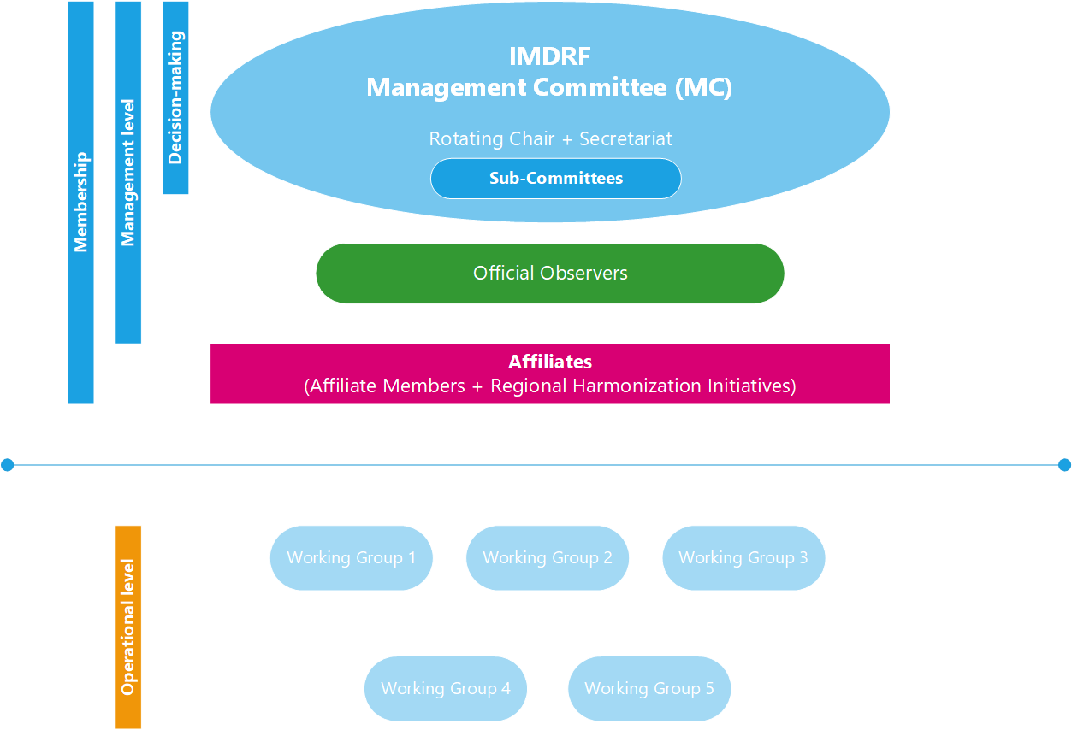

Annex B - IMDRF Membership Roles and Criteria
 |  |  | Affiliates
 | MC Member | Official Observer | Affiliate Member | Regional Harmonization Initiatives (RHIs)
Roles | - Participates and provides oversight in the decision-making process and strategic direction of IMDRF activities  - Attends all Open and Closed MC Sessions including MC teleconferences  - Ensures regular contribution to IMDRF activities  - Participates in 2/3 of IMDRF Working Groups  - Assumes the chair of the IMDRF MC on a rotating basis | - Does not participate in the decision-making process of IMDRF  - Attends all Open and Closed MC Sessions  - Participates in at least half of IMDRF Working Groups | - Does not participate in the decision-making process of IMDRF  - Only attends IMDRF MC Open Sessions  - May participate in open Working Groups  - Provides annual updates on implementation status of IMDRF documents | - Does not participate in the decision-making process of IMDRF  - Only attends IMDRF MC Open Sessions or portions of the MC Closed Session by invitation of the IMDRF Chair  - Provides annual reports on  - how they have fostered regulatory convergence,  - how they have leveraged resources and made available safe and effective medical devices globally  - their organisation’s strategic plans, work programs and any feedback from their members on implementation of IMDRF guidance. Should the RHIs be making use of IMDRF documents, a report on implementation, potential overlap in activities and opportunities for convergence is also requested.
Criteria | - Must be a regulatory authority  - Has a regional influence  - Must have been an Official Observer for at least the last three (3) consecutive years prior to the application for membership  - Must have participated in all IMDRF MC Sessions (including teleconferences) for the last three (3) consecutive years  - Must have participated in at least half of the WGs as an Official Observer, providing active contribution for the last three (3) consecutive years.  - Must have sufficient capacity to Chair the MC and provide the Secretariat for a year, including hosting two (2) face-to-face meetings and two (2) scheduled teleconferences.  In exceptional circumstances, a regulatory authority who is an Official Observer may apply for the membership under the expedited procedure to become an MC Member . To apply under the expedited procedure, the regulatory authority must:  - Provide a clear, justified and comprehensive motivation as regards the exceptional circumstance which qualifies the review of their application under the expedited procedure  - have a regional influence  - demonstrate their regulatory framework includes principles outlined in the IMDRF and GHTF guidance documents;  - be an Official Observer for at least one (1) year and have attended at least two (2) IMDRF MC teleconferences and two (2) IMDRF MC Closed Sessions as an Official Observer;  - have previously contributed to IMDRF activities including having actively contributed to 2/3 of IMDRF WGs for the last four (4) years. Note that this contribution could have been as an Affiliate Member or on behalf of another jurisdiction or a Regional Harmonization Initiative (RHI);  - have demonstrated that they have sufficient capacity to host IMDRF face-to-face Working Group meetings; and  - have demonstrated that they have sufficient capacity to Chair the MC and provide the Secretariat for a year, including hosting two (2) face-to-face Sessions and two (2) scheduled teleconferences | - Must be a regulatory authority  - Has a regional influence  - A demonstrated capacity to contribute resources and expertise to the objectives of IMDRF by participation in Open IMDRF Sessions for the last two (2) consecutive years, participation in at least two (2) Working Groups for the last two (2) consecutive years as an Affiliate Member or invited expert and providing input to document consultations.  Note: Participation of a regulatory authority as an RHI does not count towards the two (2) consecutive year requirement  - Regulatory authority should operate a mature or maturing system for medical device regulation which should include:  - Established laws and regulations for medical devices building substantially on GHTF and IMDRF foundations and principles  - Proper competencies for effective implementation and enforcement of the established laws and regulations  - A system for conformity assessment of devices building on GHTF and IMDRF guidance documents  - Sufficient resources and regulatory expertise to perform its duties  - A demonstrated contribution to scientific or regulatory innovation in the field of medical devices as demonstrated by development of guidance(s) in emerging technical and regulatory issues  - A recognized commitment to the objectives of IMDRF demonstrated by implementation of IMDRF documents (work items) | - Must be a regulatory authority  - Recognized commitment to the objectives of IMDRF demonstrated by implementation or a detailed plan for implementation of IMDRF documents  - Commitment to provide annual updates on the implementation of IMDRF documents at IMDRF MC Open Sessions | - Must be associations/initiatives comprising medical device regulatory authorities representing the majority of countries in a certain region/area of the world  - Must have mandate for global or regional harmonization amongst its members  - Must have a demonstrated interest in medical device regulatory activities that are directly related to the common goals of fostering global regulatory convergence, leveraging resources and making available safe and effective medical devices globally  - a recognized commitment to the objectives of IMDRF demonstrated by recognition of IMDRF documents or plan for gathering feedback from membership regarding implementation of IMDRF documents
Procedure | - Application file (including form) to be submitted to the Chair and Secretariat  - Application will be reviewed at the following MC face-to-face Session  - New MC members will be accepted with the unanimous agreement of existing MC members | - Application file (including form) for Official Observer to be submitted to the Chair and Secretariat  - Application will be reviewed at the following MC face-to-face Session  - Official Observers will be accepted unanimously by MC Members. Should unanimity not be achieved, the Chair may recommend advancing with a majority agreement (75%) of existing MC Members | - Application file (including form) for affiliate membership to be submitted to the Chair and Secretariat  - Application will be reviewed at the following MC face-to-face Session  - Affiliate members will be accepted unanimously by MC Members. Should unanimity not be achieved, the Chair may recommend advancing with a majority agreement (75%) of existing MC members | - Application file (including form) to be submitted to the Chair and Secretariat  - RHI will be accepted unanimously by MC Members. Should unanimity not be achieved, the Chair may recommend advancing with a majority agreement (75%) of existing MC members

Annex C - Suspension and Termination of Membership

Figure 2 – Process Flow for Suspension of IMDRF Membership.
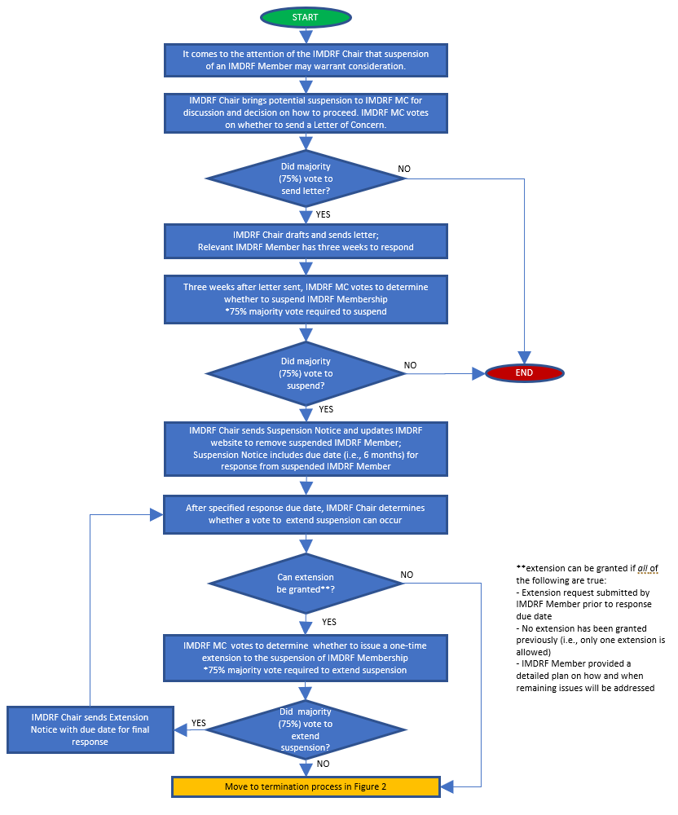

Figure 2 – Process Flow for Termination of IMDRF Membership.
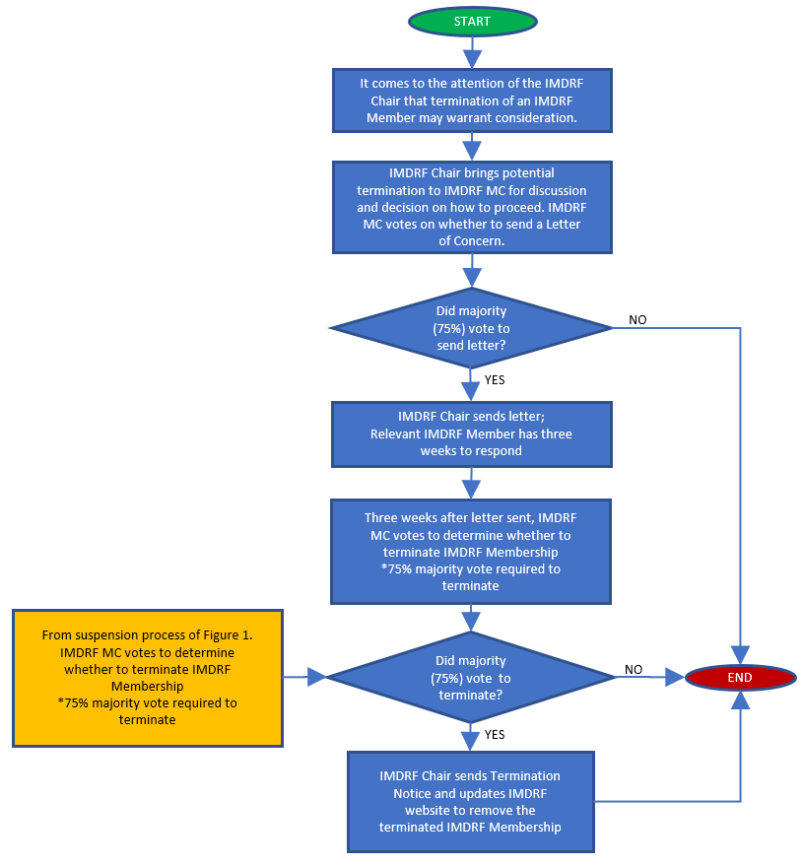

Figure 3 – Process Flow for Withdrawal of IMDRF Membership.

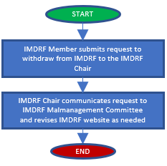
Figure 3 Process Flow for Withdrawal of IMDRF Membership

Disclaimer
© Copyright 2023 by the International Medical Device Regulators Forum.
This work is copyright. Subject to these Terms and Conditions, you may download, display, print, translate, modify and reproduce the whole or part of this work for your own personal use, for research, for educational purposes or, if you are part of an organisation, for internal use within your organisation, but only if you or your organisation do not use the reproduction for any commercial purpose and retain all disclaimer notices as part of that reproduction. If you use any part of this work, you must include the following acknowledgement (delete inapplicable):
“[Translated or adapted] from [insert name of publication], [year of publication], International Medical Device Regulators Forum, used with the permission of the International Medical Device Regulators Forum. The International Medical Device Regulators Forum is not responsible for the content or accuracy of this [adaption/translation].”
All other rights are reserved, and you are not allowed to reproduce the whole or any part of this work in any way (electronic or otherwise) without first being given specific written permission from IMDRF to do so. Requests and inquiries concerning reproduction and rights are to be sent to the IMDRF Secretariat.
Incorporation of this document, in part or in whole, into another document, or its translation into languages other than English, does not convey or represent an endorsement of any kind by the IMDRF.
Please visit our website for more details.
www.imdrf.org

All references to membership types (i.e. MC Member) shall be understood as referring to the regulatory authority and not to the individual representatives appointed.
Participation of a regulatory authority as an RHI does not count towards the two (2) consecutive year requirement.

