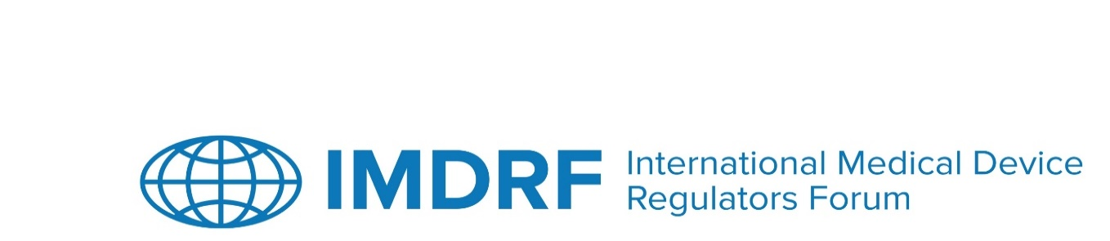
OUTCOME STATEMENT
29th Session of the International Medical Device Regulators Forum
9-13 March 2026
SINGAPORE

The 29th Session of the International Medical Device Regulators Forum (IMDRF) was chaired and held in Singapore from 9 to 13 March 2026. Approximately 350 in-person attendees and 240 virtual attendees participated in the first two days of public meetings. Approximately 100 attendees participated on the third day, and about 40 attendees participated on the fourth and fifth days.
IMDRF Industry Joint Workshop on Reliance Playbook Release and Implementation
The IMDRF Industry Joint Workshop on 9 March 2026 featured five sessions on the release of the Reliance Playbook and implementation with speakers and panellists from regulatory authorities, industry, and the World Health Organization (WHO).
The first session covered the Playbook's evolution, objectives, and core principles, with presentations on reliance frameworks and WHO alignment. Discussions included experiences with legal frameworks and the synergy between reliance and convergence.
The second session addressed reliance adoption barriers and enablers. The speakers mentioned that key facilitators include good regulatory practices, stakeholder engagement, and international alignment, while legal limitations create barriers. Discussion highlighted that successful implementation requires early collaboration, pilots, transparency, trust and technical enablers such as digital portals.
The third session focused on reliance beyond initial market access and availability, exploring product change management across the device lifecycle. Regulatory authorities and industry presented examples of current reliance practices, examining how alignment can reduce duplicative efforts, prevent supply disruption, and support continual access to medical devices.
The fourth session emphasised reliance in post-market activities through examples such as the Medical Device Single Audit Programme (MDSAP) and ISO 13485 audit programmes. Discussions covered audit output suitability for regulatory reliance, strengthening of post-market reliance throughout the device lifecycle, the importance of convergent adverse event definitions and reporting practices that support both reliance and global patient safety. This includes both proactive signal detection and reactive approaches, alongside data sharing mechanisms across regulatory jurisdictions.
The final session outlined next steps for implementing the IMDRF Reliance Playbook through capacity building and practical application. Industry and regulators discussed hands-on training events, targeted support for regulators developing reliance pathways, feedback mechanisms for Playbook updates, and reflections from participants identifying remaining gaps and future needs.
IMDRF Stakeholder Forum
The IMDRF Stakeholder Forum took place on 10 March 2026.
The first and second sessions centred on the strategic importance of medical devices in global healthcare and the need for regulatory convergence. Industry panellists emphasised diverse patient populations and extensive hospital networks, highlighting the importance of regulatory alignment and collaborative approaches.
In the third session, IMDRF Management Committee (MC) members presented on recent regulatory updates. For the fourth session, the IMDRF Secretariat provided updates on recent Working Groups (WGs) activities.
The fifth session included updates from Official Observers (OOs) and Regional Harmonisation Initiative (RHI).

The last session focused on updates from the following IMDRF Affiliate Members and Industry Members:
- National Institute for Food and Drug Surveillance (INVIMA), Colombia
- National Agency for Food and Drug Administration and Control (NAFDAC), Nigeria
- Superintendence of Health Regulation (SRS), El Salvador
- Centre for Professional Development of Pharmaceutical Specialists (CPPS), Uzbekistan
- Central Drugs Standard Control Organisation (CDSCO), India
- Diagnostic Imaging and Trade Association (DITTA) and Global Medical Technology Alliance (GMTA)
- Asia Pacific Medical Technology Association (APACMed)
- Singapore Manufacturing Federation - Medical Technology Industry Group (SMF-MTIG)
All presentation materials for the IMDRF/Industry Joint Workshop and the IMDRF Stakeholder Forum are available here.
IMDRF MC Open Session
The MC Open Session was held on 11 March 2026 with the MC, OOs, RHI, Affiliate Members, and the Industry Group.
The session covered three key topics: reflections from September 2025 and January 2026 meetings; WHO's presentation on the WHO Listed Authority policy document that includes medical devices; and presentations from Unique Device Identifier (UDI) issuing agencies Global Standards 1 (GS1), Health Industry Business Communications Council (HIBCC), and International Council for Commonality in Blood Banking Automation (ICCBBA). UDI implementation challenges were discussed with attendees agreeing that collaboration across regulatory authorities, industry members and issuing agencies are essential for successful UDI implementation.

IMDRF MC Bilateral Meetings
IMDRF MC and OOs held bilateral meetings with Affiliate Members, and the IMDRF Industry Group on 11 March 2026.
IMDRF MC, OOs, and Affiliate Members explored regulatory reliance implementation through presentations from Uzbekistan, Chile, Malaysia, and Mexico. This was followed by presentations from MC members Australia and Brazil on their reliance implementation experiences. The session concluded with an interactive discussion to address key challenges and opportunities in regulatory reliance adoption.
The IMDRF MC and Industry Group Bilateral meeting followed up on September 2025 discussion topics. The meeting also included industry feedback on the March 2026 Workshop and potential topics for the September 2026 Workshop.
IMDRF MC Closed Session
The IMDRF MC Closed Session was held on 12 and 13 March with the MC and OOs. The MC discussed a number of topics including WGs’ progress, governance aspects including membership applications and training. The MC also took a decision on a membership application and approved the publication of a document for consultation.
All MC decisions are available in the Annex.

ANNEX
DECISIONS BY THE IMDRF MANAGEMENT COMMITTEE

12 and 13 March 2026
SINGAPORE

In summary:

- There was sufficient majority in the MC to approve the application for IMDRF RHI Membership submitted by South-East Asia Regulatory Network (SEARN).

- The MC agreed to
- Publish the draft document ‘Technical Framework for Artificial Intelligence Life Cycle Management’ from Artificial Intelligence/Machine Learning WG for a 90-day public consultation.
- Archive from IMDRF and transfer the following documents to MDSAP, since MDSAP has its own website and governance structure:
  - IMDRF/MDSAP WG/N3 FINAL:2016 (Edition 2)
  - IMDRF/MDSAP WG/N11 FINAL:2021 (Edition 2)
  - IMDRF/MDSAP WG/N4 FINAL:2021 (Edition 2)
  - IMDRF/MDSAP WG/N6 FINAL:2021 (Edition 2).
- Conduct a stakeholder-industry workshop on UDI with regulatory authorities, industry members and issuing agencies.

