Draft Document
IMDRF/QMS WG/NXX DRAFT: 2026
Guidance on the Control of Products and Services Obtained from Suppliers
Authoring Group
Quality Management Systems Working Group

Preface
© Copyright 2023 by the International Medical Device Regulators Forum.
This work is copyright. Subject to these Terms and Conditions, you may download, display, print, translate, modify and reproduce the whole or part of this work for your own personal use, for research, for educational purposes or, if you are part of an organisation, for internal use within your organisation, but only if you or your organisation do not use the reproduction for any commercial purpose and retain all disclaimer notices as part of that reproduction. If you use any part of this work, you must include the following acknowledgement (delete inapplicable):
“[Translated or adapted] from [insert name of publication], [year of publication], International Medical Device Regulators Forum, used with the permission of the International Medical Device Regulators Forum. The International Medical Device Regulators Forum is not responsible for the content or accuracy of this [adaption/translation].”
All other rights are reserved and you are not allowed to reproduce the whole or any part of this work in any way (electronic or otherwise) without first being given specific written permission from IMDRF to do so. Requests and inquiries concerning reproduction and rights are to be sent to the IMDRF Secretariat.
Incorporation of this document, in part or in whole, into another document, or its translation into languages other than English, does not convey or represent an endorsement of any kind by the IMDRF.

, IMDRF Chair

Contents
Introduction 4
Scope 5
References 6
3.1. IMDRF/GHTF Documents 6
3.2. Standards 6
Definitions 7
4.1. Purchased Product (ISO 13485: 2016, 3.16) 7
4.2. Provider/Supplier (ISO 9000:2015, 3.2.5) 7
4.3. External Provider/External Supplier (ISO 9000:2015, 3.2.6) 7
4.4. Service (ISO 9000:2015, 3.7.7) 7
4.5. Product (ISO 9000:2015, 3.7.6): 8
4.6. Process (ISO 9000:2015, 3.4.1) 8
4.7. Objective evidence (ISO 9000:2015, 3.8.3) 9
4.8. Medical Device (GHTF/SG1/N55:2009, 5.1) 9
4.9. Manufacturer (GHTF/SG1/N071 2012, 5.1) 9
4.10. Outsource (ISO 9000:2015, 3.4.6) 10
4.11. Risk (ISO 14971:2019, 3.18) 10
General Principles 11
5.1. Planning 14
5.2. Selection of potential suppliers 17
5.3. Supplier evaluation and acceptance 19
5.4. Finalization of controls 21
5.5. Continuous monitoring and re-evaluation 22
5.6. General QMS requirements 23
5.7. Examples 24

Introduction
This IMDRF guidance document is intended for medical device manufacturers and it is expected that the reader is familiar with regulatory quality management system requirements within the medical devices sector. This guidance document may also be useful to regulatory authorities, auditing organisations and suppliers. This guidance document is intended for educational purposes and it is not intended to be used to assess or audit compliance with regulatory requirements.

Existing regulatory requirements, such as Sections 4.1.5 and 7.4 of ISO13485:2016, require organizations to control products and services obtained from suppliers. These requirements call for the type and extent of controls to be established and documented within the organization’s quality management system. Control could be defined and documented in the form of contractual arrangements, quality plans or other types of documents.

Several medical device quality management system regulations have their requirements harmonized around ISO 13485. Therefore, familiarity with its requirements and definitions is recommended for the application of this guidance. Furthermore, ISO/TC 210 have published a practical guidance on the development, implementation and maintenance of quality management systems in accordance with ISO 13485.

This is a revision of the document GHTF SG3 (Quality Management System - Medical Devices - Guidance on the Control of Products and Services Obtained from Suppliers - December 2008) to reflect the current state of the art and experience gained from use of the initial version.

Scope
This document provides regulatory guidance for manufacturers on the control of products and services obtained from suppliers, throughout the life cycle of medical devices.
Note: This guidance applies to all medical devices, including IVD medical devices and combination products (if regulated as medical devices).
This guidance is applicable to manufacturers of medical devices, irrespective of their size, and can be used by other interested parties providing a service or product such as importers and distributors.

References

IMDRF/GHTF Documents
- GHTF/SG1/N071:2012 Definition of the Terms ‘Medical Device’ and ‘In Vitro Diagnostic (IVD) Medical Device’
- GHTF/SG1/N55:2009 Definitions of the Terms Manufacturer, Authorized Representative, Distributor and Importer

Standards
- ISO 13485:2016 Medical Devices – Quality Management Systems – Requirements for regulatory purposes
- ISO 14971:2019 Medical Devices – Application of risk management to medical devices
- ISO 9000:2015 Quality Management Systems – Fundamentals and vocabulary

Definitions
Within the context of this guidance document, the terms used follow the definitions below. It should be taken into consideration that some terms definitions might have different definitions in different jurisdictions

Purchased Product (ISO 13485: 2016, 3.16)
product provided by a party outside the organization’s quality management system

Note 1 to entry: The provision of product does not necessarily infer a commercial or financial arrangement.

Provider/Supplier (ISO 9000:2015, 3.2.5)
organization (3.2.1) that provides a product (3.7.6) or a service (3.7.7)

EXAMPLE Producer, distributor, retailer or vendor of a product or a service.

Note 1 to entry: A provider can be internal or external to the organization.

Note 2 to entry: In a contractual situation, a provider is sometimes called “contractor”.

External Provider/External Supplier (ISO 9000:2015, 3.2.6)
provider (3.2.5) that is that is outside the organization’s quality management system (3.2.1)

EXAMPLE Producer, distributor, retailer or vendor of a product (3.7.6) or a service (3.7.7)

Service (ISO 9000:2015, 3.7.7)
output (3.7.5) of an organization (3.2.1) with at least one activity necessarily performed between the organization and the customer (3.2.4)

Note 1 to entry: The dominant elements of a service are generally intangible.

Note 2 to entry: Service often involves activities at the interface with the customer to establish customer requirements (3.6.4) as well as upon delivery of the service and can involve a continuing relationship such as banks, accountancies or public organizations, e.g. schools or hospitals.

Note 3 to entry: Provision of a service can involve, for example, the following: — an activity performed on a customer-supplied tangible product (3.7.6) (e.g. a car to be repaired); — an activity performed on a customer-supplied intangible product (e.g. the income statement needed to prepare a tax return); — the delivery of an intangible product (e.g. the delivery of information (3.8.2) in the context of knowledge transmission); — the creation of ambience for the customer (e.g. in hotels and restaurants);

Note 4 to entry: A service is generally experienced by the customer.

Product (ISO 9000:2015, 3.7.6):
output (3.7.5) of an organization (3.2.1) that can be produced without any transaction taking place between the organization and the customer (3.2.4)

Note 1 to entry: Production of a product is achieved without any transaction necessarily taking place between provider (3.2.5) and customer, but can often involve this service (3.7.7) element upon its delivery to the customer.

Note 2 to entry: The dominant element of a product is that it is generally tangible.

Note 3 to entry: Hardware is tangible and its amount is a countable characteristic (3.10.1) (e.g. tyres). Processed materials are tangible and their amount is a continuous characteristic (e.g. fuel and soft drinks). Hardware and processed materials are often referred to as goods. Software consists of information (3.8.2) regardless of delivery medium (e.g. computer programme, mobile phone app, instruction manual, dictionary content, musical composition copyright, driver’s license).

Process (ISO 9000:2015, 3.4.1)
process set of interrelated or interacting activities that use inputs to deliver an intended result

Note 1 to entry: Whether the “intended result” of a process is called output (3.7.5), product (3.7.6) or service (3.7.7) depends on the context of the reference.

Note 2 to entry: Inputs to a process are generally the outputs of other processes and outputs of a process are generally the inputs to other processes.

Note 3 to entry: Two or more interrelated and interacting processes in series can also be referred to as a process.

Note 4 to entry: Processes in an organization (3.2.1) are generally planned and carried out under controlled conditions to add value.

Note 5 to entry: A process where the conformity (3.6.11) of the resulting output cannot be readily or economically validated is frequently referred to as a “special process”.

Note 6 to entry: This constitutes one of the common terms and core definitions for ISO management system standards given in Annex SL of the Consolidated ISO Supplement to the ISO/IEC Directives, Part 1. The original definition has been modified to prevent circularity between process and output, and Notes 1 to 5 to entry have been added

Objective evidence (ISO 9000:2015, 3.8.3)
objective evidence data (3.8.1) supporting the existence or verity of something

Note 1 to entry: Objective evidence can be obtained through observation, measurement (3.11.4), test (3.11.8), or by other means.

Note 2 to entry: Objective evidence for the purpose of audit (3.13.1) generally consists of records (3.8.10), statements of fact or other information (3.8.2) which are relevant to the audit criteria (3.13.7) and verifiable.

Medical Device (GHTF/SG1/N55:2009, 5.1)
instrument, apparatus, implement, machine, appliance, implant, reagent for in vitro use, software, material or other similar or related article, intended by the manufacturer to be used, alone or in combination, for human beings, for one or more of the specific medical purpose(s) of:

— diagnosis, prevention, monitoring, treatment or alleviation of disease;
— diagnosis, monitoring, treatment, alleviation of or compensation for an injury;
— investigation, replacement, modification, or support of the anatomy or of a
physiological process;
— supporting or sustaining life;
— control of conception;
— disinfection of medical devices;
— providing information by means of in vitro examination of specimens derived from
the human body;

and does not achieve its primary intended action by pharmacological, immunological or metabolic means, in or on the human body, but which may be assisted in its intended function by such means

Note 1 to entry: Products which may be considered to be medical devices in some jurisdictions but not in others include:

— disinfection substances;
— aids for persons with disabilities;
— devices incorporating animal and/or human tissues;
— devices for in vitro fertilization or assisted reproduction technologies.

Manufacturer (GHTF/SG1/N071 2012, 5.1)
natural or legal person with responsibility for design and/or manufacture of a medical device with the intention of making the medical device available for use, under his name; whether or not such a medical device is designed and/or manufactured by that person himself or on his behalf by another person(s).

Note 1 to entry: This ‘natural or legal person’ has ultimate legal responsibility for ensuring compliance with all applicable regulatory requirements for the medical device in the countries or jurisdictions where it is intended to be made available or sold, unless this responsibility is specifically imposed on another person by the Regulatory Authority (RA) within that jurisdiction.

Note 2 to entry: The manufacturer’s responsibilities are described in other GHTF guidance
documents. These responsibilities include meeting both pre-market requirements
and post-market requirements, such as adverse event reporting and notification of
corrective actions.

Note 3 to entry: ‘Design and/or manufacture’, as referred to in the above definition, may include specification development, production, fabrication, assembly, processing, packaging, repackaging, labelling, relabelling, sterilization, installation, or remanufacturing of a medical device; or putting a collection of devices, and possibly other products, together for a medical purpose.

Note 4 to entry: Any person who assembles or adapts a medical device that has already been supplied by another person for an individual patient, in accordance with the instructions for use, is not the manufacturer, provided the assembly or adaptation does not change the intended use of the medical device.

Note 5 to entry: Any person who changes the intended use of, or modifies, a medical device without acting on behalf of the original manufacturer and who makes it available for use under his own name, should be considered the manufacturer of the modified medical device.

Note 6 to entry: An authorised representative, distributor or importer who only adds its own address and contact details to the medical device or the packaging, without covering or changing the existing labelling, is not considered a manufacturer.

Note 7 to entry: To the extent that an accessory is subject to the regulatory requirements of a medical device, the person responsible for the design and/or manufacture of that accessory is considered to be a manufacturer.

Outsource (ISO 9000:2015, 3.4.6)
make an arrangement where an organization outside of the organization’s quality management system (3.2.1) performs part of an organization’s function or process (3.4.1).

Note 1 to entry: An external organization is outside the scope of the management system (3.5.3), although the outsourced function or process is within the scope.

Note 2 to entry: This constitutes one of the common terms and core definitions for ISO management system standards given in Annex SL of the Consolidated ISO Supplement to the ISO/IEC Directives, Part 1.

Risk (ISO 14971:2019, 3.18)
combination of the probability of occurrence of harm (3.3) and the severity (3.27) of that harm (3.3)

General Principles
These general principles, found throughout this guidance document, are fundamental for the control of suppliers by manufacturers.
The appropriate control of suppliers is essential element/necessary to ensure medical device safety and performance. Therefore, manufacturers should establish and implement a robust purchasing process including supplier control and management. The intent of the purchasing process is to ensure that purchased, subcontracted, or otherwise received products and/or services conform to specified requirements. The manufacturer is expected to establish and maintain documented procedures for planning and performing purchasing activities (including pre and post-market activities) and to keep the necessary records.
Regulatory authorities and third parties may inspect/audit a manufacturer to confirm that objective evidence of control over products and services from suppliers is present, or readily available, at the manufacturer’s site.
There may be many different types of suppliers and different terms are used for these organisations (subcontractors, suppliers, providers, outsourced contractors, etc…).
All suppliers (irrespective of whether they are external or internal to the manufacturer’s organization) need to be subject to the control of the manufacturer. The level/extent of the controls applied needs to be proportional to the risks associated with the product and/or service being supplied. The control activities consist of a balance of supplier controls (e. g. supplier evaluation and approval) and inspection/verification activities (e.g. incoming goods verification, pre-production verification activities). While these activities may be carried out, on behalf of the manufacturer, by an independent party, the manufacturer retains the ultimate responsibility for all functions within their own quality management system including the purchasing process (i.e. the ultimate responsibility cannot be relinquished or delegated).
When the supplier is part of the same organization but operates under a separate quality management system, they are to be controlled in a similar way as external suppliers.
When a medical device manufacturer chooses to utilize suppliers, the manufacturer needs to ensure control over any product or service obtained from such suppliers as defined within the quality management system (QMS). The controls may extend further if a supplier subcontracts work.
A supplier or provider is an organisation that provides a product or a service, examples include (but not limited to):
- Service providers: e.g. regulatory, marketing, consulting, R&D, Product development, CRO, pest control, sterilisation, packaging, coating, storage/distribution/transport, medical device installation and servicing.
- Manufacturing contractors: e.g. parts/raw materials/components suppliers or organisations producing the semi-finished/finished device or part of the manufacturing process, on behalf of the legal manufacturer.
The process of establishing controls for products and services obtained from suppliers typically comprises six phases, which include:
- Planning
- Selection of potential supplier(s)
- Supplier evaluation and acceptance
- Establishment of control and change management
- Delivery, measurement and monitoring, including control of changes
- Feedback and communication, including Corrective Action and Preventive Action process
Management of changes is fundamental and needs to be considered for each of the phases.

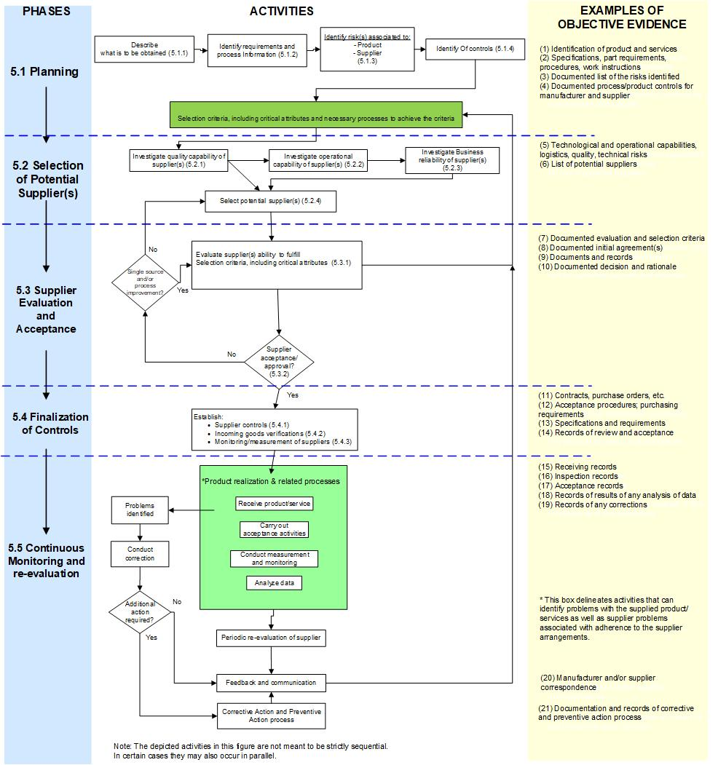

Planning
Throughout the life cycle of a new or existing medical device, manufacturers may need products or services from a supplier. Therefore, the manufacturer’s QMS should include, where deemed necessary, planned controls on these items, such as materials, parts, components, sterilisation, training, testing, regulatory services, quality services or document archiving (see 5.1.1 for additional examples)
When establishing controls for product and/or services from suppliers, it is essential to start with the planning phase. The outcome of this activity might include design and development plans, quality plans, purchasing plans, and other documents as stipulated by the manufacturer’s QMS. The manufacturer should consider the objectives, risks, requirements, processes and resources, ensuring that effective controls are implemented and regulatory obligations are satisfied. Depending on various inputs and considerations (e.g., costs, availability, sustainability, location) the manufacturer may decide to manufacture the given product and/or to perform the activities in house).
It is essential that the criteria established ensure that the selection of suppliers meets measurable quality objectives along with other factors like corporate, commercial, ethical, political, environmental aspects, and the supplier's ability to consistently deliver on time.
Planning lays the groundwork for determining the appropriate level of control over products and services obtained from suppliers. These plans are generally documented and approved, as part of the manufacturer’s QMS.
Planning provides the direction for establishing the extent of controls for product and services obtained from suppliers. These plans are typically documented and approved, as part of the QMS.

Identification of the product or service to be obtained from supplier(s)
During the planning phase, the products and/or services in scope (from suppliers) should be identified. The products may include materials, components and subassemblies being incorporated into the manufactured devices and/or materials used in product realization and/or impacting product, work environment or other QMS activities.
These are examples of products/services:
Parts and components of the final medical device made either to manufacturer’s specifications or purchased “off-the-shelf “:
- Mechanical components (screws, washers, helicoils, tubing, valves, pumps, etc.)
- Electronic components (resistors, capacitors, power supplies, detector arrays, circuit board assemblies, etc.)
- Computer hardware (laptops, recorders, etc.)
- Commercial software (operating systems, databases, etc.)
- Software for specified uses (radiation therapy planning software, planning software for hip implants, including Artificial intelligence (AI), etc.)
- Other: glucose test strips, reagents, enzymes, etc.

Services obtained from suppliers:
- Design of product and/or label
- Document archiving
- Quality and/or regulatory services (pre-clinical evaluation, clinical evaluation, pre/post-market activities)
- Packaging
- Sterilisation
- Environmental monitoring (e.g. microbial and particle counts for clean rooms, temperature monitoring and/or mapping)
- Testing
- Calibration
- Process validation
- Transport / storage
- Representatives of the manufacturer for regulatory purposes (e.g. EU Authorised representative, Australian Sponsor, etc....)

Entire/complete medical device obtained from supplier:
- Any final medical device made on behalf of the manufacturer under manufacturer’s specification
- Supplied medical device used as component in manufacturer’s medical device (X-ray tubes, ECG cables, medical batteries, patient monitors)

Identification of specific product/service requirements and the required process knowledge
Appropriate personnel and stakeholders (such as subject matter experts) should be engaged in all the appropriate steps of the process, starting with the planning phase. Trained personnel should document the specific product/service features required and identify the processes necessary to deliver these products/services in a manner that meets required criteria. The areas where these personnel may assist could include:
- Identifying the product and service requirements/specifications and/or master samples for parts, materials, process, software, environment, testing, etc, identifying critical attributes of the products, and detailed selection criteria to be met by the required services
- QMS process requirements, such as procedures/work instructions for adverse event reporting, QMS auditing, post market data, design, manufacturing, calibration, maintenance, verification activities, etc.
- Regulatory requirements relative to the markets the business is planning to access
- Business capabilities to assess the need of external vs internal services including expertise and business bandwidth/capacity
- Project management of the planning, development and implementation phase of the medical device
- Other applicable requirements, such us environmental protection, Occupational Health and Safety, Good Laboratory Practices, embargoes, ethical considerations, commercial and/or corporate requirements, etc…

Identification of risk(s) associated with products/services supplied
During the planning activities, the manufacturer should identify the risks associated with the product or services to be obtained from suppliers.
For this purpose, the manufacturer may utilize the concepts and requirements of ISO 14971:2019 Medical devices — Application of risk management to medical devices, ISO/TR 24971 – Guidance on the application of ISO 14971 and GHTF/IMDRF Documents on Risk Management Principles and Activities Within a Quality Management System,

In the process of identifying risks, consideration may be given to the following:
1. Identify the critical attributes (i.e. the characteristics of the product/service that, if changed could change the product in a way that could potentially impact the manufactured product or QMS) of the supplied product/service.
2. Identify the processes necessary to produce/deliver the product/service.
3. Identify any relevant regulatory requirements (these may relate to the product/service directly or impact the product, product realisation or QMS indirectly (e.g. environmental protection and Occupational Health and Safety requirements)

The following questions can help in the identification of the risks:
- Risks intrinsic to the device/type of product:
- Is the part custom built or off-the-shelf?
- How complex is the part to manufacture?
- What is the criticality of the part? For example, considering a Design Failure Mode & Effects Analysis (DFMEA)
- Which are the hazards and characteristics of the part/component related to safety and performance?
- Risks associated with the supplier:
- Does the supplier currently manufacture parts for medical device regulated industry or is this their first?
- Is an alternative supplier (or second supplier) identified?
- Has the supplier third party certification and undergoes audits?

Information about potential suppliers (such as technical, financial, continuity of supply, etc.) should be used to determine additional potential risks (such as business risks).
It should be noted that a potential type of supplier is to be considered in planning, not a specific supplier (specific suppliers are considered as part of evaluation and approval process).
Quality-related risks should be given precedence before other risks are considered. Other risks the manufacturer may wish to consider would include business risks such as:
- Financial viability of the supplier
- Continuity of supply (e.g., with respect to geopolitical risks, extreme weather events, disease outbreaks)
- Liability
- Amount of work awarded to supplier in view of supplier’s overall capacity
- Capital investment
- Single source suppliers
- Supplier company legal status (e.g. licensing)
- Corporate considerations

Risk assessment and identification of controls
The identified risk(s) should be evaluated to determine the type and extent of control(s) required. The extent of verification activities shall be based on the supplier evaluation results and proportionate to the associated risks of the product or service obtained from the supplier
During the planning phase, it is essential for the manufacturer to identify the high-level potential risks and eventual controls to ensure that they are thoroughly captured during the subsequent phases (for further details on controls, see section 5.4 Finalization of controls).

The manufacturer should:
- Identify what needs to be monitored/measured to ensure the supplied product/service maintains its critical attributes (as identified in 5.1.4)
- Identify the hazards that could potentially have negative impact on the critical attributes of product/service
- Identify the eventual controls that will mitigate the risks of the hazards negatively impacting the critical attributes of product/service
- Identify any additional training needs.
The controls between supplier and manufacturer should be balanced to mitigate the identified risk. Examples of controls can include:
- For the supplier:
- Control of external supplier's production or supply chain, including supplier audits
- Key Performance Indicators
- Response times

- For the manufacturer control of supplied products:

- 100% incoming product verification
- Reduced (<100%) incoming product verification
- Incoming goods confirmation of product/supplier on receipt (reliance on supplier’s controls)

- For the manufacturer’s control of supplied services:

- Witnessing/evaluation of the service provided by competent personnel.
- Reliance on external certification

Selection of potential suppliers
When selecting potential suppliers, the manufacturer should thoroughly evaluate their business and operational capabilities, including technological competence, to ensure that the supplier can deliver the necessary quality, safety, performance and reliability of the products and services. These evaluations should also include projected growth as well as disaster-planning.

Supplier quality capability
The manufacturer should determine the critical attributes of the product/service to be supplied as well as product realisation/service criteria to be met (see Section 5.3.1). When selecting potential suppliers of products/services, the manufacturer needs to investigate the supplier’s ability to fulfil these pre-determined product/product realization/service criteria. Only suppliers capable of meeting these pre-determined criteria for safety, quality, performance and reliability should be considered further. In cases where these criteria are not fully met, prior to moving to the next potential supplier, the manufacturer can consider an implementation of planned supplier education/training/development that addresses the identified shortcomings. Alternatively, the manufacturer may (where possible) decide to implement measures that mitigate the risks of a supplier not fulfilling the selection criteria.
For suppliers whose quality capabilities have been confirmed by the manufacturer to meet the defined quality objectives, the manufacturer should consider the supplier’s operational and business capabilities.

Supplier operational and technological capability
The operational capability should be investigated to determine whether the supplier is able and willing to adapt and respond to performance indicators required by the manufacturer, such as lead times, on-time delivery, response time, etc. The scope of the investigation may include the supplier’s past performance, experience, expertise, and human resources.
Investigation of the supplier’s technological capability should include the assessment of the supplier’s ability to meet the manufacturer’s product and/or service specifications. Things to consider may include the adequacy of manufacturing processes or equipment, information technology, system infrastructure, engineering resources, etc.

Supplier business reliability
The potential supplier’s business capabilities, such as business conduct, practices, reputation and financial viability, should be considered by the manufacturer as these could impact the manufacturer’s ability to deliver safe and effective devices. The outcome of these considerations, coupled with an analysis of the potential risks of the product/service provided, should drive the manufacturer’s decisions about the type and extent of controls of products/services provided by the suppliers

5.2.4 Selection of potential supplier
The manufacturer should select potential suppliers according to predefined criteria and the results of capability investigations.
The processed established by the manufacturer for the selection of the potential suppliers should be properly documented:
- The manufacturer’s assessment of the supplier’s resources (e.g. facilities, personnel, infrastructure), current product/service portfolio
- Documentation and records provided by the supplier, such as environmental control records, equipment maintenance programs, calibration records, qualification records of appropriate personnel, process validation records, capacity planning, certificates, etc.
- Documentation of potential suppliers
- Fulfillment of the predefined criteria and decision rationale

Supplier evaluation and acceptance
This section provides guidance on the process by which the manufacturer evaluates that the selected potential supplier is capable of supplying product or service in accordance with the manufacturer’s requirements.
The evaluation assures that the selection criteria (see 5.1) are met by the suppliers. The extent of evaluation and acceptance activity performed should be in proportion to the identified risk (see 5.1.3) of the procured product, and/or services, impacting the safety and effectiveness/performance of the final product, product realization processes or QMS.

Generally, the process of supplier evaluation consists of the following:
- Communication with potential supplier and refinement of the requirements
- Evaluation of the potential supplier’s ability to meet selection criteria
- Acceptance/Approval of the supplier

Evaluation of potential supplier’s ability to meet selection criteria
Prior to the evaluation of the supplier, the manufacturer should ensure adequate information / data in relation to quality, operational, technological and business capabilities (see 5.2.1-5.2.3) is available for consideration. This can be obtained through communication with the potential suppliers (e.g. through supplier questionnaires or direct contact). The data should be measurable and aimed at providing necessary evidence to establish that the selection criteria can be met by the potential supplier.
The manufacturer is responsible for communicating the selection criteria to the potential suppliers. In addition the manufacturer may request data and/or a product samples (e.g. first article, first lot, prototypes) from the potential supplier in order to evaluate their ability to fulfill the specified requirements.
The manufacturer needs to evaluate potential suppliers based on their ability to meet the defined selection criteria
The evaluation should ensure that:
- Adequate data is gathered to demonstrate that the selection criteria have been met. This comes from a number of sources, e.g. the communications with the supplier, literature, manufacturer’s data.
- Data is evaluated to determine whether the potential supplier is capable of fulfilling the selection criteria. Commensurate with the degree of risk, the data may include evaluation of first article(s), first lot(s) or prototype(s), auditing of the potential supplier and subcontractors, data from other organizations, or any combination of thereof. Where appropriate, valid statistical techniques should be employed. Certification may play a role in evaluating suppliers but manufacturers should be cautioned against relying solely on certification as evidence that suppliers have the capability to provide quality products or services.
- The evaluation is performed together with the consideration about the necessary controls that the manufacturer needs to implement (See 5.4)

Whenever selection criteria cannot be fully met by the potential supplier, other control measures mitigating the risks of this circumstance need to be implemented. The supplier cannot be fully approved until all selection criteria are met and all necessary controls are in place. If the gaps are not addressed through mitigating controls, the manufacturer / organisation need to consider finding an alternate supplier that is capable of meeting the selection criteria.
Based on the collected data and its review additional selection criteria, to be confirmed in the supplier evaluation, may be identified. These need to be documented (including the risk-based rationales for their selection) and be controlled under the QMS (including an assessment of impact on product/service, product/service realisation processes and QMS (see clause 4.1.4).
The principles listed above apply to the evaluation of both external and internal suppliers.
Examples of supplier data collection and evaluation (used alone or in combination) include:
- Desktop/ reviews: These involve off-site review of documents and records providing evidence of supplier meeting the selection criteria.
- Audits (carried out on-site and/or remote approaches): These are conducted on-site at the supplier’s location(s) and involve review of documents and records demonstrating supplier’s fulfilment of selection criteria as well as verifying the adequacy, suitability and effectiveness of the supplier’s QMS arrangements. When the supplier is using a subcontractor in relation to the product/service provided to the manufacturer, the audit involves a review of the controls exerted by the supplier over this third-party subcontractor.
- Product testing. This involves the testing of product(s) provided by the supplier to establish the products (and, by inference, the supplier) are able to meet the product/process selection criteria.
- Review of relevant data provided by affiliated parties (e.g. corporate partners) to which products/services are already provided by the supplier.
The relevant information gathered and compiled should be communicated throughout and should be considered by the manufacturer as well as the supplier. Records of communications need to be maintained.
In planning for evaluation of suppliers of products/services, the manufacturer should plan for contingency arrangements (e.g. back-up suppliers) which might arise, for example, as a result of geopolitical events, weather-related incidents, or supply chain disruptions. The evaluation of such suppliers needs to include the assessment of their capability to meet the selection criteria. It is recommended that this activity is done proactively.
In cases where there is only one supplier available (i.e. single-source supplier) the selection criteria need to be met without concessions. However, the manufacturer can implement control actions (see Section 5.4), which compensate for any gaps in supplier control.

Supplier acceptance / approval
No supplier can be fully approved until all selection criteria have been met and all necessary controls are in place. It is good practice for the selection criteria and relevant controls to be reviewed and acknowledged or approved by the supplier. Records of these activities should be maintained.
Formal record of the manufacturer’s acceptance / approval of the supplier (by an authorised person) needs to be clearly documented, defining the details of the supplier, date and expiry of the acceptance / approval, scope of the acceptance / approval, and any restrictions. Only approved suppliers can be used.
If a potential supplier is found to be acceptable then the manufacturer needs to document the acceptance/approval decision in a manner required by the manufacturer’s QMS (e.g. by inclusion of the supplier into a documented Approved suppliers list). Additionally, the records of the results of the evaluations need to be retained.

Finalization of controls
Only products and or services that meet the determined selection criteria (see 5.1) can be used in the medical device realization. The manufacturer needs to achieve this through the establishment, implementation and maintenance of appropriate QMS controls that assure that only products/services that meet the critical attributes are supplied and verified. Risks, identified in planning (see 5.1) and during supplier selection and evaluation (see 5.3), are considered and assessed to determine the type and extent of control(s) required. The arrangements need to ensure that products/services are supplied by suppliers only after the suppliers had been evaluated and approved and all the necessary controls had been established, implemented and are maintained. Clear lines of responsibilities need to be defined by the manufacturer and where relevant be agreed upon by the supplier.
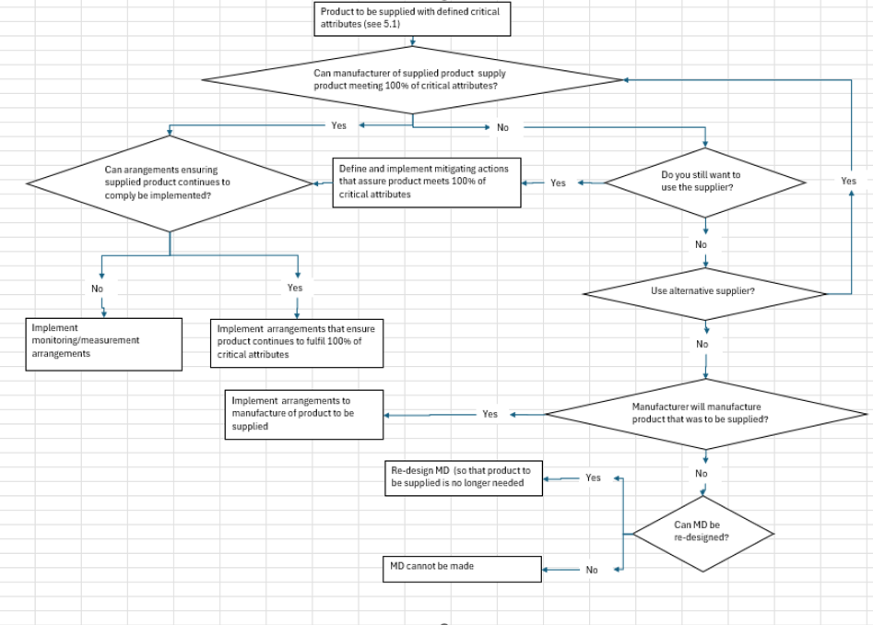
An example of a typical thought process in these activities is shown in the Figure below.
Typically, the controls relating to supplied products consist of various combinations of supplier controls, incoming goods verifications and monitoring/measurements.

Supplier controls
These controls usually established that:
- The product meets the critical attributes (e.g. through initial testing, review of specifications, etc)
- The supplier is able to produce the product in the same form consistently (e.g. under a robust QMS, using adequate processes that are validated or the outcome of which is measured/monitored)
- The supplier maintains a suitable, adequate and effective QMS that ensures appropriate change control and notification as well as appropriate action when nonconformities arise.
The manufacturer/organisation usually achieves this through documented agreements with the supplier, on-site or off-site audits, review of relevant documentation (e.g. testing reports, certifications) or through some other activities (e.g. monitoring/measurement, training, etc).
Supplier controls over the suppliers need to be implemented irrespective of whether the supplier is external (e.g. subcontractor) or internal (e.g. Global corporate partner) supplier to the manufacturer.

Incoming goods verifications
When the supplier controls do not assure all product critical attributes will always be met, the manufacturer often decides to measure/monitor on incoming goods verification. The extent of this activity depends on the risk assessment and is subject to any relevant regulatory requirements. Where the risks are deemed as high, 100% testing or statistically-based testing (e.g. see ISO2859 series of standards) may be selected. This is often implemented even when the supplier controls are considered as robust. Where the risks are considered low, reduction in the sampling size or in frequency of testing can also be considered.

Monitoring/measurement of suppliers
Control over suppliers who provide product and/or services is often achieved through reliance on accredited certification of the activity and/or by direct (e.g. witnessing of the activity being performed) or indirect (e.g. review of protocols and reports) monitoring/measurement. The extent and frequency of these controls is dictated by the risks of the activities being carried out.
When the risk dictates, defined controls around second or further-tier suppliers may be needed.

Continuous monitoring and re-evaluation
Once approved, the suppliers of products/services need to be monitored by the organisation to ensure the products/services continue to be supplied in compliance with the selection criteria and in accordance with the agreed arrangements.
Typically, monitoring and measurement inputs include:
- Inspecting/verifying/testing incoming products/services to confirm compliance with critical attributes
- Confirmation of testing being performed by the supplier or their contractor
- In-process and finished good monitoring and measurement during product realisation
- Supplier audits
- Review of nonconformities raised in relation to the quality of supplied products/services
- Review of business, technological and operational performance, according to principles described in 5.2.
These activities can identify problems with the supplied product/service as well as supplier problems associated with adherence to the supplier arrangements.
The organisation needs to plan and perform periodic supplier re-evaluations, regardless of whether problems have been identified. The purpose of this re-evaluation is to assess the supplier’s continued ability (process and output) to meet specified critical product/service attributes. Monitoring and measurement data, obtained from the inputs listed above, needs to be trended and analysed using valid statistical techniques, whenever relevant.
The length of the monitoring intervals influences how early problems can be detected. Earlier detection means the organization can take preventive actions rather than solely reactive ones.
This output should be assessed used in supplier re-evaluation. In addition, re-evaluation needs to:
- Review the continued adequacy of supplier selection criteria
- Review the currency of the information which formed the basis of the supplier’s initial or previous approval
- Identify new requirements and changes impacting the delivered product/service (e.g. new regulatory requirements)
- Review of the effectiveness of the implemented supplier controls (e.g. supplier audit program, supplier agreements)
The frequency of supplier re-evaluation is typically based on the organisation’s assessment of the risks associated with the supplier and supplied product/service.
It is expected that the organisation will communicate with the supplier in relation to the monitoring and re-evaluation activities. The frequency of these communications need to be defined and based on risk. Feedback should be both positive and negative.
The manufacturer should ensure that there are effective lines of communication (including up to date contact points) for both parties to discuss problems/complaints or other matters. It is important that trust be developed between parties so that any problems can be resolved quickly in a cooperative way.
Arrangements need to be established, implemented, and maintained to ensure that the supplier communicates relevant problems identified in relation to the supplied product/service to the organisation. Conversely, problems and nonconformities identified by the organisation, during monitoring and measurement, need to be communicated to the supplier. Evidence of corresponding corrections and corrective actions implemented by the supplier (or their subcontractor, as required) need to be communicated back to the organisation.
Depending on the nature of the procured product and/or service obtained from a supplier, portions of the activities that are to be performed under CAPA may be delegated by the manufacturer to the supplier. The combined CAPA related activities of both the manufacturer and the supplier need to satisfy the requirements of applicable regulations and standards.
The arrangements need to ensure that the manufacturer and supplier inform each other, in a timely manner, of changes that could impact the product quality, product realisation processes, or QMS. It is expected that appropriate steps will be taken to establish, implement, and maintain these changes. Changes could include improvements, CAPAs, new or revised regulatory requirements, and business or operational needs. While some of the CAPA activities may be delegated to a supplier, the overall responsibility for these activities resides with the manufacturer.

General QMS requirements
In implementing the supplier control arrangements, the manufacturer needs to ensure that the following QMS principles are adhered to:
- Documented requirements are established, implemented, and maintained (See Clause 4.2.4).
- Responsibilities and authorities are defined and assigned to relevant personnel (See Clause 5.5.1).
- Personnel performing tasks are competent on the basis of appropriate education, training, skills, and experience (See Clause 6.2).
- Records demonstrating compliance with requirements are maintained (See Clause 4.2.5).
- Activities are performed in an appropriate work environment using approved equipment (See Clause 6.3-6.4).
- Appropriate resources need to be allocated (Clause 6.1).
- Changes are evaluated for their impact on the product/services, the product realisation processes, and QMS (Clause 4.1.4).
- Processes are monitored for their functionality (Clause 4.1) and appropriate actions are taken for improvement (Clause 8.5).

Examples
The examples below illustrate possible options for a manufacturer to established appropriate control for products and/or services obtained from suppliers.

Worked Example 1: Sterile Product
Planning
The organisation determines, during design and development activities, that the risk of supplying non-sterile product is high due to the significant potential for patient harm. Therefore, it decides that the medical device needs to be sterilised.
The organisation establishes that a gamma irradiation sterilisation process needs to be used, as alternative methods, such as sterilisation by ethylene oxide exposure, are not compatible with the materials of construction.
Critical Attributes of Product
The product needs to be sterile by gamma irradiation.
The product needs to meet its defined safety and performance requirements.
Critical Attributes of Process
The sterilisation process needs to comply with ISO 11137.
- Process validation - the sterilisation process will require
  - A gamma radiation source.
  - Determination of minimum and maximum irradiation doses (e.g. minimum dose verification and maximum dose studies).
  - Dose mapping.
  - Dose audit.
  - Ability to perform product bioburden determinations and sterility testing in compliance with ISO 11737 standards.
- Routine sterilisation will require
  - Ability to deliver doses within the specified range.
  - Ability to qualify and maintain steriliser and source.
  - Ability to store products after sterilisation.
Identify Type of Supplier
The manufacturer determines that they cannot perform these activities themselves.
The manufacturer identifies that they require a gamma irradiation sterilisation service provider to meet the critical process attributes.
Selection of Specific Service Providers
The manufacturer identifies Supplier A and Supplier B as having a gamma source and being able to sterilise goods.
The manufacturer contacts Supplier A and Supplier B to perform sterilisation on the manufacturer’s behalf with the following outcome:
Supplier A
- Can perform routine irradiation.
- Can perform dose verification, dose audits, and dose mapping.
- Cannot perform microbiological (bioburden and sterility) testing.
- Is able to store products after sterilisation.
- Can perform irradiation in timely manner.
- Is more costly than Supplier B.
Supplier B
- Can perform routine irradiation.
- Cannot perform dose verification, dose audits, and dose mapping.
- Cannot perform microbiological (bioburden and sterility) testing
- Is able to store products after sterilisation.
- Can perform irradiation in timely manner.
- Is less costly than Supplier A.
Based on the provided communications, the manufacturer decides to extend their investigations and identifies Supplier C.
Supplier C
- Cannot perform routine irradiation.
- Can perform dose verification, dose audits, and dose mapping.
- Cannot perform microbiological (bioburden and sterility) testing.
- Cannot store product after sterilisation.
- Can perform irradiation studies in a timely manner.
The manufacturer determines that the critical product and process attributes will be met when (1) Supplier B and Supplier C are engaged together, or (2) when Supplier A is engaged with an additional supplier to perform microbiological testing. However, engaging Supplier B and Supplier C services is cheaper than engaging Supplier A.
The manufacturer decides to engage Supplier B and Supplier C in combination.
Evaluation and Controls
The manufacturer confirms the availability of Supplier B and Supplier C and implements agreements and the following controls:
- Supplier audits need to be carried out commensurate with the suppliers’ known ISO 13485, ISO 11137 and, as relevant, ISO 11737 compliance.
- The manufacturer’s verification of the sterilisation cycle results needs to be commensurate with the level of assessment performed at audits.
Having implemented the necessary evaluation and controls, the manufacturer approves Supplier B and Supplier C for the required activities, subject to review on an annual basis. The suppliers are entered into the Approved Supplier List, which is used by the purchasing department when routine sterilisation of product is required.
The manufacturer verifies, on an ongoing basis, the arrangements and monitors the suppliers’ performance.
The annual review needs to consider the currency of information on which the basis of supplier was approved, as well as the monitoring data gathered by the organisation over the review period.

Worked Example 2: Low risk component
Planning
The manufacturer determines, in design and development, that an absence or failure of a given component used in the medical device is associated with low risk, in that there would be no impact on the product safety and performance, or on the product realisation and other QMS processes.
The organisation does not intend to manufacture the component themselves.
Critical Attributes of Product
The given component needs to be identified and confirmed to be manufactured from an approved supplier (Supplier A). The component needs to be of the specified size and appearance.
Critical Attributes of Process
The manufacturing process needs to reliably produce components consistent with their specification.
Identify Type of Supplier
Component can be purchased from any warehouse store or can be sourced directly from the manufacturer of the component.
Selection of Specific Service Providers
Supplier A supplies only in quantities exceeding the quantities required and is located halfway across the world. The component should be sourced from Hardware Store X as only Hardware Store X sell the component manufactured by Supplier A (others have components manufactured by other suppliers).
Evaluation and Controls
No controls will be applied to Supplier A and the product distributor Hardware Store X.
The component will be bought from Hardware Store X, confirming the component catalogue number and that it was manufactured by Supplier A.
Incoming goods verifications will confirm the component complies with the component specification by measurement and approved master sample by visual inspection. The manufacturer performs a risk assessment and determines that verification activities will be performed on 100% of purchased components in the first year. If there are less than 2.5% defects in the first year, the manufacturer will proceed to perform verification activities on a statistically relevant sample size of components thereafter or will verify a randomly selected representative sample of purchased lots.
The re-evaluation of the supplier is to be performed annually. The annual review needs to consider the currency of information on which the basis of supplier was approved, as well as the incoming inspection data gathered and any other nonconformities identified by the organisation over the review period.

Worked example: Scorecard supporting standardized risk assessments
- Define score card elements:
 | Subcategory A (Score value 1) | Subcategory B (Score value 3) | Subcategory C (Score value 5)
Category I
Category II
Category III
Category IV
Score per level
Total score
  - Identify 3-4 categories that typically characterize the risk, e.g.
    - Type of supplied product/service
    - Criticality of supplied product/service to final MD
    - Number of potential suppliers
    - Impact of final MD to patient/customer safety
  - Define per category 3 subcategories – based on risk, e.g.
    - Criticality of supplied product/service to final MD, e.g.
      - Low
      - Medium
      - High
    - Nature of supplied product/service, e.g.
      - Packaging material
      - Raw material, service
      - Final MD
  - Define score values for each subcategory level – e.g. 1, 3, 5 (according to the increasing risk)
  - During the assessment the scores per category are added up to a total score value
      - The range of the total score values depends on how many categories are included in the scorecard (e,g 4 to 20)
  - Subdivide the total score range into groups (e.g. 3)
- Define for each group, according to the total risk, mandatory supplier selection evaluation criteria, e.g
Total Score | 4-8 | 9-12 | 12-20
Criteria | - Supplier quality capability | - QMS certification  - Supplier quality capability  - Design specification review  - .. | - QMS certification  - Supplier quality capability  - Design specification review  - Technical/operational capability assessment  - ..

- Example for score card application:
Intermediate material
Crucial for MD performance
used for IVDR Cl. C IVD
single source supplier

 | Subcategory A (Score value 1) | Subcategory B (Score value 3) | Subcategory C (Score value 5)
Category I (nature) |  | 3
Category II (risk to final MD) |  |  | 5
Category III (impact of final MD on patient safety) |  | 3
Category IV (number of available suppliers) |  |  | 5
Score per subcategory | 0 | 6 | 10
Total score | - 16
Mandatory evaluation criteria: | - QMS certification  - Supplier quality capability  - Design specification review  - Technical/operational capability assessment

Disclaimer
© Copyright 2023 by the International Medical Device Regulators Forum.
This work is copyright. Subject to these Terms and Conditions, you may download, display, print, translate, modify and reproduce the whole or part of this work for your own personal use, for research, for educational purposes or, if you are part of an organisation, for internal use within your organisation, but only if you or your organisation do not use the reproduction for any commercial purpose and retain all disclaimer notices as part of that reproduction.“
All other rights are reserved, and you are not allowed to reproduce the whole or any part of this work in any way (electronic or otherwise) without first being given specific written permission from IMDRF to do so. Requests and inquiries concerning reproduction and rights are to be sent to the IMDRF Secretariat.
Incorporation of this document, in part or in whole, into another document, or its translation into languages other than English, does not convey or represent an endorsement of any kind by the IMDRF.
Please visit our website for more details.
www.imdrf.org

The examples listed may be classified differently according to local regulatory requirements

