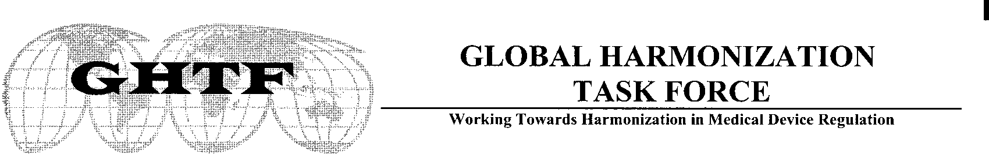

STATEMENT FROM GHTF CHAIR

Update on Future Directions of GHTF

Senior officials from all GHTF device regulatory authorities met in Washington DC, in February 2011, to discuss future directions for GHTF, following initial discussions by the GHTF Steering Committee and a request for feedback on its achievements and priorities.

The participants in the meeting wholeheartedly agreed that the work developed by the GHTF over the last 18 or so years was of major significance and had provided the opportunity for the founding members to construct regulatory systems largely aligned with the GHTF framework. The group noted that work on the GHTF regulatory model was now substantially complete. It also noted the high degree of influence the GHTF model has had, and continues to have, on countries/economies with developing needs for regulation of medical devices.

Acknowledging the significant accomplishments, the regulatory officials noted that uniform implementation of the GHTF model at an operational level amongst founding member regulators had not been fully achieved, and that the current GHTF membership is not reflective of the changing global market in 2011 and beyond.

The regulator's group was of the view that achieving harmonised regulatory requirements remains a highly desirable objective, particularly in view of the pressures of a globalised manufacturing market for medical devices and increasing demands to streamline regulatory processes in order to deliver high quality products to the marketplace with minimal delays. The regulator’s group considered that the best way to achieve such an outcome was to develop a regulator-led harmonisation and collaboration group that would allow for more detailed discussion between members on the optimum ways to achieve harmonisation at an operational level. Collaboration would be fostered by such an arrangement in areas such as new science and technologies, information and resource sharing and increased opportunities for technical expert interchanges.

Input and advice from industry will continue to be vital, and the new forum will also allow for input from other stakeholders such as healthcare professional groups, academia and consumers, as appropriate. It will also seek to include members from countries that are, or are likely to become, influential in medical device manufacture and/or regulation.

The Washington participants considered it necessary to capitalise on the GHTF 'brand' and saw the formation of a regulator-led group as the next phase in the evolution of GHTF, using the GHTF regulatory model and all of the supporting documentation as the springboard to the development of harmonisation at an operational level. It was also considered important that the valuable work currently underway through GHTF Study Groups and Ad Hoc Working Groups should be finalised.

At the next GHTF meeting in May 2011, the Steering Committee will hold further discussions, including on a strategy to provide for a smooth transition to the new arrangements. Similarly, regulators will continue to progress the task of defining the governance and role of the new group so that it can continue to build on the achievements to date.

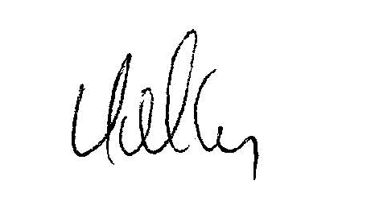

Larry Kelly
Chair
GHTF Steering Committee

28 March 2011

