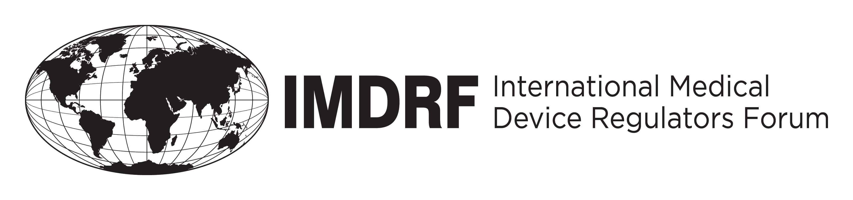
OUTCOME STATEMENT
of the IMDRF-3 MANAGEMENT COMMITTEE

19 to 21 March 2013

The third meeting of the International Medical Device Regulators Forum (IMDRF) took place in Nice and Sophia Antipolis (France) from 19 to 21 March 2013. The meeting was chaired by the European Commission (Directorate General for Health and Consumers), assisted by representatives of European Member States (France, Germany and Poland). The Management Committee (MC) consists of regulators from Australia, Brazil, Canada, China, the European Union, Japan and the United States of America. Representatives of the World Health Organization (WHO) participated as official observers and regulators from the Russian Federation and from Mexico attended as invited observers. Asian Harmonization Working Party (AHWP) participated as affiliate organization.

The Management Committee discussed the significant progress achieved on the five on-going work items:
- the review of the National Competent Authorities Report Exchange Program;
- the roadmap for Implementation of Unique Device Identification system;
- the Medical Device Single Audit Program;
- the List of Recognized Standards; and
- the Regulated Product Submission.

On the second day, there was an open Stakeholder Forum with about 130 participants from organizations representing regulators, the medical devices industry, the medical professionals, patients and academics. Participants had an opportunity to hear updates on the regulatory situation in all seven jurisdictions of the Management Committee members. In addition, update reports were provided on IMDRF’s priority work items and stakeholders had an opportunity to share their views and ideas on the work of the IMDRF.

On the final day of the meeting, the Management Committee discussed matters arising from the open Stakeholder Forum including how to improve the operation of the Forum so that it delivers input to the IMDRF work.

The Management Committee also considered new work item proposals, and decided on the international harmonization of the approach to standalone medical device software and on the definition of common data elements describing medical devices through the regulatory lifecycle. In response to a new work item proposal, there was also unanimous support on the importance of involving the medical profession in the IMDRF work. In addition, the Management Committee approved two work item extensions for the Medical Device Single Audit Program: the Assessment Program and Auditing Strategy of Medical Device Recognized Auditing Organizations and the Assessor Competency and Training Requirement for Regulatory Authorities undertaking assessments of Auditing Organizations.
ANNEX

PROGRESS ON IMDRF WORK ITEMS

The Management Committee noted with satisfaction the excellent progress of the five working groups which presented their ongoing work. In summary:

- The survey of the National Competent Authorities Report exchange program is completed. It was decided to review the GHTF N79 Guidance taking into consideration the outcome of the survey. A new proposed work program will be prepared with a view to the finalization of the revised guidance by the end of the year.

- The work on the revised Unique Device Identification Draft Guidance 2.0 on labeling specifications is progressing. A public consultation is envisaged in the near future.

- The documents on the Recognition for Organizations undertaking Audits of Medical Device Manufacturers and the Auditor Competency and Training Requirements will be submitted for public consultation with comments due by 15 June 2013.

- Discussions on the work item on the list of recognized standards continue to progress. The project should be completed by end of summer 2013. A work package for the second phase will be outlined for consideration.

- Regarding the Regulated Product Submission working item, the Management Committee endorsed the work achieved so far, including the completion of the draft non-IVD Table of Contents for marketing authorization as well as progress on the testing of the RPS standard for medical devices. The draft Table of Contents will be submitted for public consultation in the near future.

A copy of the work item update reports with further details will be available on the IMDRF website at www.imdrf.org.

The Secretariat of the IMDRF can be contacted for further information by email at:
EC-IMDRF2013-SECRETARIAT@ec.europa.eu.

The IMDRF-4 meeting will take place in Brussels on 12-14 November 2013. Details of the Stakeholder Forum will be communicated on the IMDRF website as soon as they become available, including a theme for possible presentations by stakeholders on that occasion.

Nice (France)
21 March 2013

Dr. WANG Lanming from SFDA China officially announced the membership of China on 19/03/2013.

