IMDRF/UDI WG/N54 FINAL:2019

FINAL DOCUMENT

International Medical Device Regulators Forum

Title: System requirements related to use of UDI in healthcare including selected use cases
Authoring
Group: IMDRF UDI WG

Date: 21 March 2019

Elena M. Astapenko, IMDRF Chair

This document was produced by the International Medical Device Regulators Forum. There are no restrictions on the reproduction or use of this document; however, incorporation of this document, in part or in whole, into another document, or its translation into languages other than English, does not convey or represent an endorsement of any kind by the International Medical Device Regulators Forum.

Copyright © 2019 by the International Medical Device Regulators Forum

Table of Contents

1.0 Introduction 5
2.0 Scope 6
3.0 References 6
4.0 Definitions 6
5.0 General System Requirements for Recording the UDI 6
6.0 Examples of recording UDI in healthcare 8
6.1. Use Case 1 – Recording of UDI data in electronic health records 8
6.2. Use Case 2 – Adverse Event Reporting: US FDA Medical Product Safety Network (MedSun) 10
6.3. Use Case 3 –Medical Device Registry: Society for Vascular Surgery Vascular Quality Initiative (VQI) 11

Preface
The document herein was produced by the International Medical Device Regulators Forum (IMDRF), a voluntary group of medical device regulators from around the world. The document has been subject to consultation throughout its development.
There are no restrictions on the reproduction, distribution or use of this document; however, incorporation of this document, in part or in whole, into any other document, or its translation into languages other than English, does not convey or represent an endorsement of any kind by the International Medical Device Regulators Forum.

Introduction
The fundamental elements of a UDI system can be summarized as follows:
- Development of a standardized system of Unique Device Identifiers (UDIs)
- Placement of UDI in human readable and Auto Identification Data Capture (AIDC) formats/forms on package labels and in some cases, on the device itself
- Submission of core UDI data elements to a Unique Device Identification Database (UDID)
- Setting of appropriate transitional and implementation arrangements to ensure a smooth UDI implementation.
Benefits of UDI strongly rely on effective integration of the UDI to support various regulatory activities during the lifecycle of medical devices and uptake of UDI across the whole healthcare sector.
Those benefits are more likely be achieved when the UDI is recorded in real world electronic health systems (e.g. electronic health records (EHRs), device registries, material management systems, and reimbursement data) and used as part of real world evidence to improve clinical and regulatory decision making.
Figure 1. Using UDI to link data across separate healthcare systems
Figure 1 provides a very high-level perspective of healthcare systems that could benefit from the integration of UDI-DI and UDI-PI. Across those systems, the UDI-DIs and UDI-PIs as well as data from UDIDs are used to link device identification data across separated systems and to use the results of that linkage to improve the quality of healthcare delivery or healthcare research or market surveillance. A learning UDI system means that the improvements experienced by those systems, as described above, inform and improve future manufacturers ‘activities.

Scope
The purpose of this document is to provide some general system requirements related to use of UDI in healthcare including selected use cases demonstrating how recording UDI combined with pulling data from UDID is used to auto-populate information into forms/electronic information.

References
- IMDRF/UDI WG/N7 Final: 2013 - UDI Guidance: Unique Device Identification (UDI) of Medical Devices
- IMDRF/UDI WG/N48 Final: 2019- Unique Device Identification system (UDI system) Application Guide
- IMDRF/UDI WG/N53 Final: 2019 - Use of UDI Data Elements across different IMDRF Jurisdictions

Definitions
See Section 3.0 of the IMDRF UDI Application Guide (UDI WG(PD1)/N48).

General System Requirements for Recording the UDI
For comprehensive information about the UDI system and UDI carrier requirements, the reader should refer to IMDRF/UDI WG/N7 Final: 2013 - UDI Guidance: Unique Device Identification (UDI) of Medical Devices and IMDRF/UDI WG/N48 Final: 2019IMDRF UDI Application Guide (UDI WG(PD1)/N48) - Unique Device Identification system (UDI system) Application Guide.
The following are recommended general system requirements to utilise the UDI available at the point of care and transmit the UDI across health systems:
- The system should be able to capture the data in the UDI Carrier. The system should be able to recognize and parse the UDI into its device identifier (UDI-DI) and production identifiers (UDI-PIs) (i.e., lot or batch, serial number, expiration date, manufacturing date, distinct identification code). If the level of device identification detail required is limited to the model/version of the device and not the specific product, then only the UDI-DI should be recorded.
- The system should be able to capture all formats of the UDI as established by accredited issuing agencies/entities. See issuing agency/entity format descriptions (see Appendix A in UDI Application Guide Document)
- The system should be able to capture and save the UDI, the UDI-DI and all the UDI-PIs in distinct fields. This requirement is applicable to both electronic capture and exchange as well as for paper forms.
- The system should be able to use the UDI-DI as a real-time look-up to the appropriate UDID, verifying that the UDI-DI exists in the local UDID and/or in the UDIDs of other jurisdictions.
- If the AIDC portion is available, the expectation is that the UDI be recorded by scanning the machine-readable portion of the UDI.
- If the UDI is received from an external system, then both the full UDI and UDI components should be populated into designated UDI, UDI-DI and separate UDI-PI fields, as available.
- If the UDI cannot be scanned electronically, then the data as viewed on label (e.g. (01), (10), +/ etc.) should be manually recorded into the system
- If the system captures the full UDI, it should be able to parse out the following identifiers from the UDI:
- UDI-DI
- The following identifiers that compose the UDI-PI, if applicable:
    - The lot or batch within which a device was manufactured;
    - The serial number of a specific device;
    - The expiration date of a specific device;
    - The date a specific device was manufactured; and
    - Others, if defined by respective regulations.
- Software should be provided to assist in parsing the UDI and using the UDI-DI to pull data from a UDID
- The system should be able to:
- store the UDI-DI and UDI-PI excluding the qualifiers (e.g., (01), +, =/, etc.)
- pull and auto-populate relevant UDID attributes in the UDID record based upon the purpose and field requirements of the source database.
- display, report and sort the UDI-DI, the relevant UDI-PI, and other data pulled from UDID.

Examples of recording UDI in healthcare
The goal of the UDI system is to replace recording of unstructured device identification information with the recording of the UDI parsed components (UDI-DI and elements of UDI-PI) and the pulling of data elements from UDID. At the point of care, this device data should be recorded as part of the full set of data recorded in health records.
Each example represents a current real world capture of UDI in different health care applications. The examples should not be considered exhaustive. Their purpose is to show that the method used for recording UDI would be similar across various use cases.

Use Case 1 – Recording of UDI data in electronic health records
This use case is intended to show how the UDI data elements identified in Section 5.0 would be captured in a patient’s electronic record in cases where a UDI is scannable and where it is not (2 options described) and utilized together with other patient and healthcare provider related information. Examples of some different options are provided hereafter.
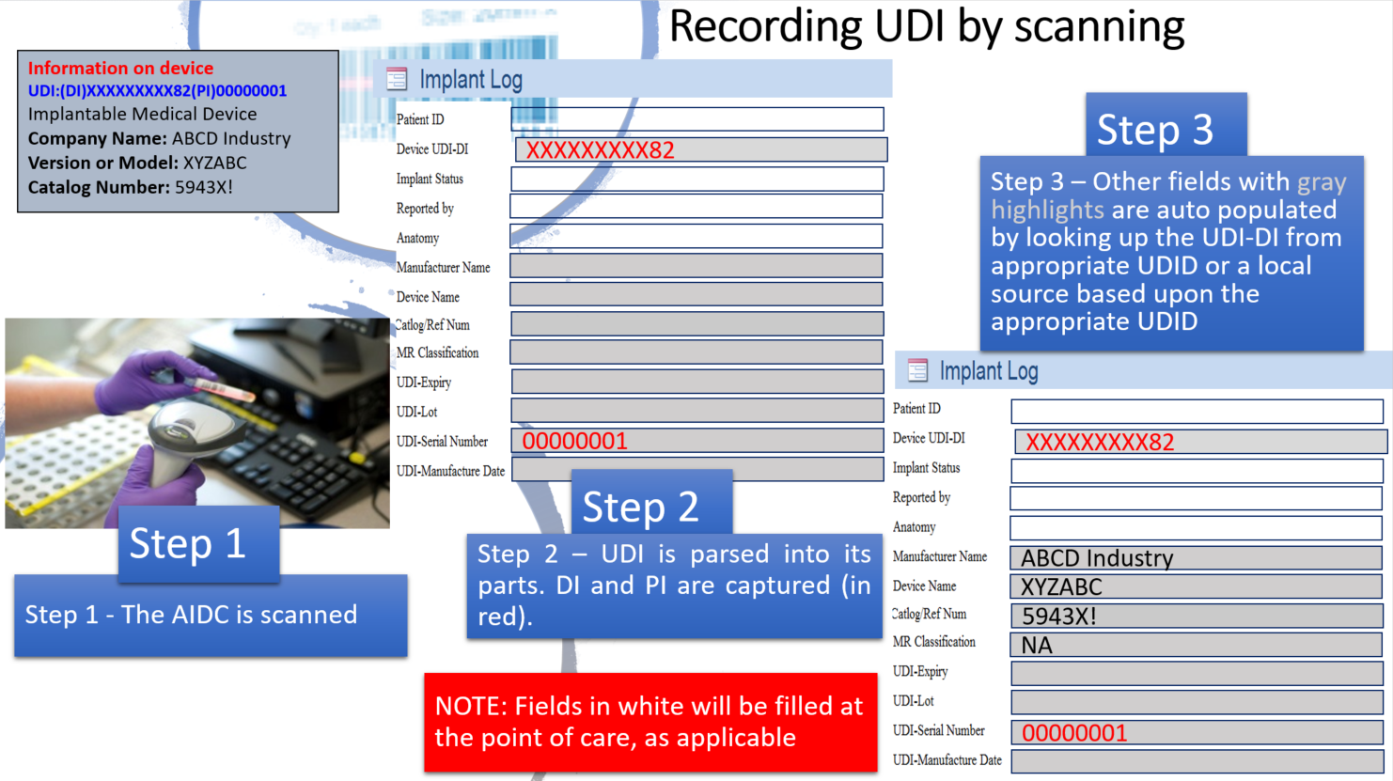
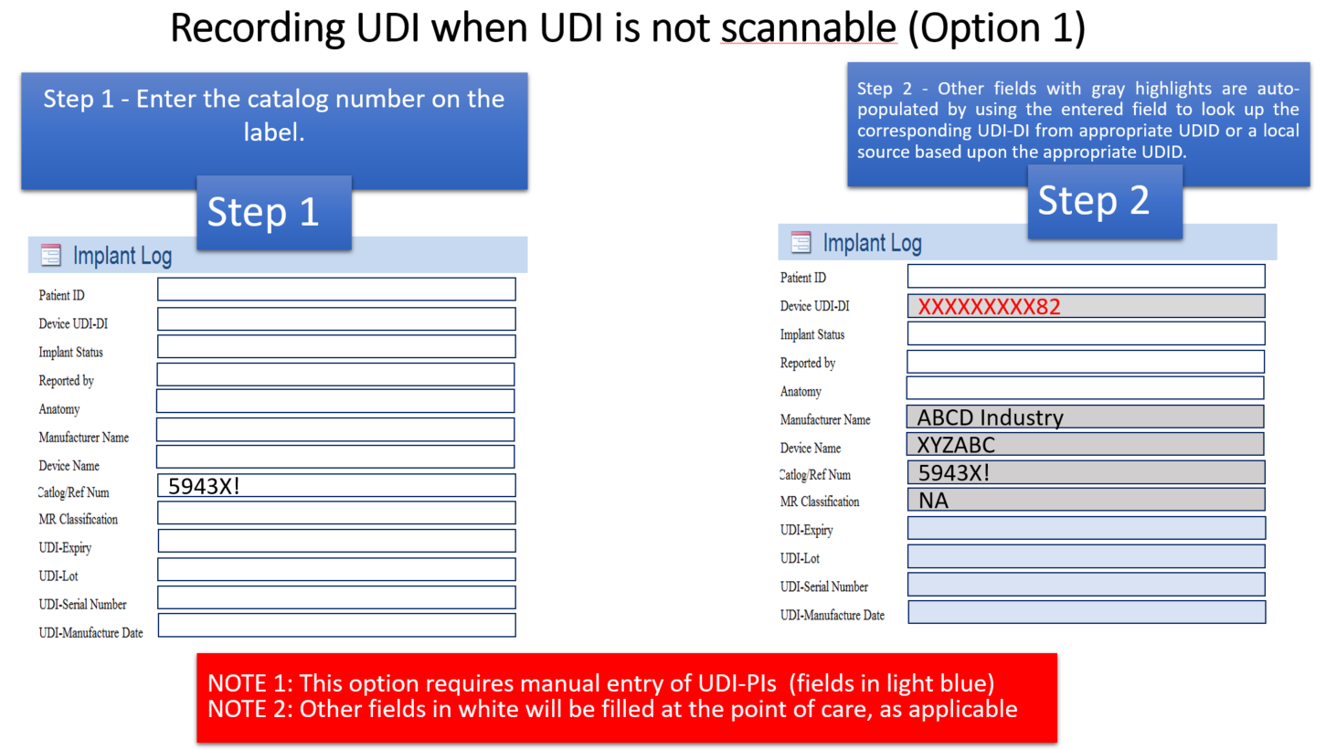
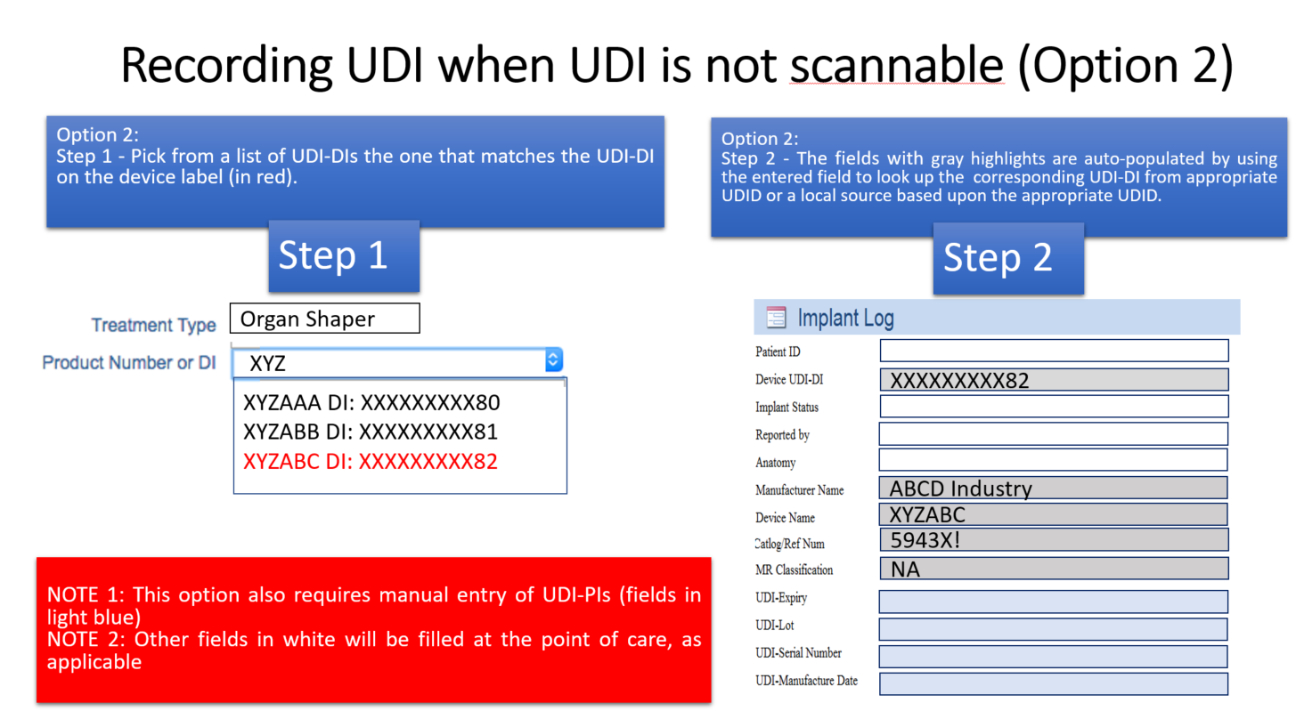

Use Case 2 – Adverse Event Reporting: US FDA Medical Product Safety Network (MedSun)
The MedSun program provides a web interface for member hospitals to report adverse events. The following lists the high level programming steps used to complete the structured form.
- Record and parse the UDI
  - Scan or manually record UDI found on label of device
  - Use software to parse the UDI into UDI-DI + UDI-PIs, and use the UDI-DI as a key to pull data from AccessGUDID record (the publicly available version of U.S. FDA UDID) and automatically populate the corresponding MedSun report.
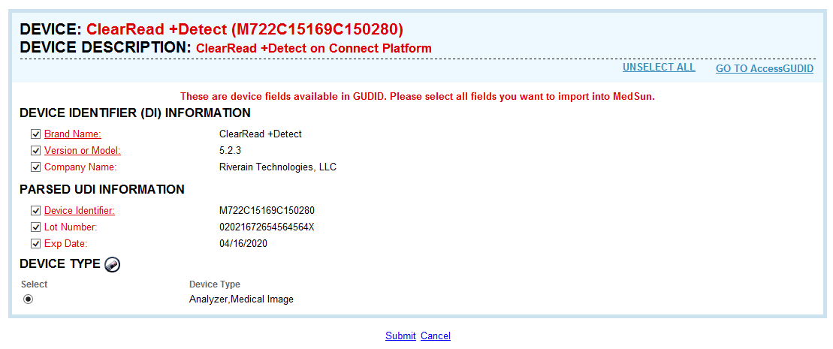
NOTE: MedSun does not display all elements available in an AccessGUDID record. MedSun only extracts the elements from AccessGUDID that are captured in MedSun.

Use Case 3 –Medical Device Registry: Society for Vascular Surgery Vascular Quality Initiative (VQI)
VQI offers three ways to enter stents/stent graft data:
- Product number or Catalog Number
- Manufacturer
- UDI-DI
VQI uses the UDI-DI as a means to identify products at the model/company level. A user can enter the initial letters of a product number or catalog number and see the relationship between the product number or catalog number and the UDI-DI as listed below.
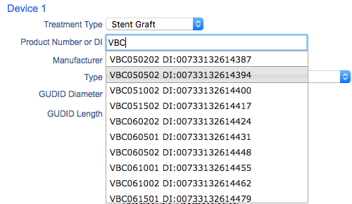
The VQI auto-populates data from AccessGUDID into appropriate fields (manufacturer, type, size) by using the UDI-DI to return data from AccessGUDID.

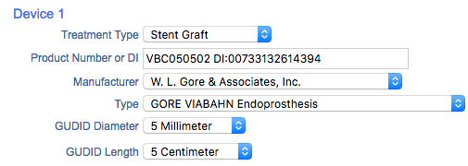
VQI also offers options for selecting from a list of available devices based upon data in AccessGUDID. VQI’s use case demonstrates that there is value to linking the UDI-DI to existing product numbers or catalog numbers during the current transition period.

IMDRF/RPS WG/N19 FINAL:2016, p. 9
Example of a parser that pulls data from a UDID is available at: https://accessgudid.nlm.nih.gov/resources/developers/device_lookup_api
US FDA MedSun website. https://www.fda.gov/MedicalDevices/Safety/MedSunMedicalProductSafetyNetwork/ Last accessed 10/02/2019.
US National Library of Medicine AccessGUDID website. https://accessgudid.nlm.nih.gov/. Last accessed 15/02/2019.
Society of Vascular Surgery Vascular Quality Initiative Website. https://www.vqi.org/. Last accessed 14/02/2019.

