IMDRF/UDI WG/N53 FINAL:2019
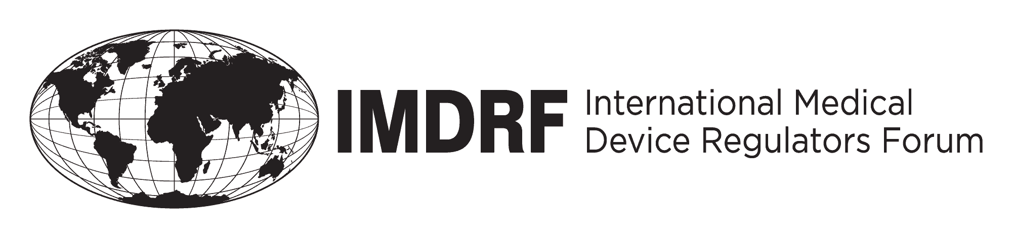

FINAL DOCUMENT

International Medical Device Regulators Forum

Title: Use of UDI Data Elements across different IMDRF Jurisdictions
Authoring
Group: IMDRF UDI WG

Date: 21 March 2019

Elena M. Astapenko, IMDRF Chair

This document was produced by the International Medical Device Regulators Forum. There are no restrictions on the reproduction or use of this document; however, incorporation of this document, in part or in whole, into another document, or its translation into languages other than English, does not convey or represent an endorsement of any kind by the International Medical Device Regulators Forum.

Copyright © 2019 by the International Medical Device Regulators Forum

Table of Contents
1.0 Introduction 4
2.0 Scope 4
3.0 Definitions 4
4.0 Use of UDI Data Elements across different IMDRF Jurisdictions 5
5.0 Update of the document 5

Preface
The document herein was produced by the International Medical Device Regulators Forum (IMDRF), a voluntary group of medical device regulators from around the world. The document has been subject to consultation throughout its development.
There are no restrictions on the reproduction, distribution or use of this document; however, incorporation of this document, in part or in whole, into any other document, or its translation into languages other than English, does not convey or represent an endorsement of any kind by the International Medical Device Regulators Forum.

Introduction
The IMDRF UDI Guidance (IMDRF/WG UDI/N7Final:2013) provides a framework for the regulatory authorities that intend to develop their UDI Systems in a globally harmonized approach.
Since 2013, many jurisdictions worldwide have taken important steps forward in implementation of National UDI systems. IMDRF has recognized the need to supplement the IMDRF UDI Guidance (IMDRF/WG UDI/N7Final:2013) which was developed as a high-level conceptual framework, by providing principles for globally harmonized application of UDI system and tools for operators to identify how common IMDRF principles are translated into real-world terms.
Considerations related to submission of UDI core data elements to UDI databases is acknowledged as one key concern.

Scope
This information document, to be read in conjunction with the IMDRF UDI Application Guide (IMDRF/UDI WG/N48Final:2018) is intended to provide a UDI data elements dictionary containing descriptions of the data elements as collected in National UDI databases (UDID) across jurisdictions.
The objective of this information document is in particular to identify how common UDID data elements listed in Section 9.2 of the IMDRF UDI Guidance (IMDRF/WG UDI/N7Final:2013) are collected by the different jurisdictions and whether and how additional jurisdiction-specific UDI data elements are collected.
A data dictionary should be easily accessible to users and managers of a data system. Just as a typical dictionary helps convey the meaning of words, a data dictionary translates data elements into real-world terms.
It helps users submit data to the database.

Definitions
See Section 3.0 of the IMDRF UDI Application Guide (UDI WG(PD1)/N48).

Use of UDI Data Elements across different IMDRF Jurisdictions
This document contains one Annex in an Excel form.
This annex includes information from the jurisdictions that have defined the data fields in their respective UDID systems.
The file contains three sheets:
- Notes – explains the contents of the different sheets and includes legend for the Compare summarization sheet
- IMDRF -2013 CDE – data elements listed in the IMDRF UDI Guidance (IMDRF/UDI WG/N7Final:2013)
- Comparison-Data Elements - side-by-side view of data element names and database requirements by the IMDRF UDI Guidance (IMDRF/UDI WG/N7Final:2013) and the participating jurisdictions.

Update of the document
Upon submission of any future contribution from IMDRF jurisdictions, the IMDRF Management Committee will consider processing and publishing updated versions of the Annex to this document.

