IMDRF/Standards WG/N51 FINAL:2018

Final Document

Title: Optimizing Standards for Regulatory Use

Authoring Group: IMDRF Standards Working Group

Date: 5 November 2018

Yuan Lin, IMDRF Chair

This document was produced by the International Medical Device Regulators Forum. There are no restrictions on the reproduction or use of this document; however, incorporation of this document, in part or in whole, into another document, or its translation into languages other than English, does not convey or represent an endorsement of any kind by the International Medical Device Regulators Forum.

Copyright © 2018 by the International Medical Device Regulators Forum
Table of Contents
1.0 Introduction 1
2.0 Scope 3
3.0 Definitions 3
4.0 General 4
5.0 Recommendations for Standards Development 6
6.0 Enhancing Stakeholder Participation in Standards Development 11
7.0 IMDRF and Standards Development 14
Appendix A: Challenges in Standards for Regulatory Purposes 16
Appendix B: How to Contact a National Body/Committee of a Country 18
Appendix C: References 21

Preface

The document herein was produced by the International Medical Device Regulators Forum (IMDRF), a voluntary group of medical device regulators from around the world. The document has been subject to consultation throughout its development.

There are no restrictions on the reproduction, distribution or use of this document; however, incorporation of this document, in part or in whole, into any other document, or its translation into languages other than English, does not convey or represent an endorsement of any kind by the International Medical Device Regulators Forum.

Introduction

Background
Standards play a significant role in the design, production, post-production and regulation of medical devices throughout their lifecycle. Important tools for conformity assessment, standards facilitate and support innovation and help ensure that devices are safe and perform as intended. Standards offer a means to streamline and harmonize regulatory processes around the world, especially as medical devices grow in complexity and international markets expand. Standards can be particularly valuable as they ‘… generally reflect the best experience of industry, researchers, consumers and regulators worldwide, and cover common needs in a variety of countries….’

As standards have grown in prominence in recent decades, evidence of their utility compels industry, Standards Developing Organizations (SDOs), Regulatory Authorities (RAs), academia, clinicians, public health experts and patients to dedicate resources to the development and promulgation of standards. However, standards are frequently written in ways that diminish their utility in regulatory processes. For example, some standards do not sufficiently contemplate conformity assessment testing needs. Other standards are too flexible or unclear in expectations, or do not meet a specific need, either for the market or regulators. These and other challenges highlight the importance of considering how medical devices are regulated when building a standard, so that a firm’s declaration of conformity with it will augment reviewers’ confidence and streamline the approval process. See Appendix A for more information.

In preparing this guidance, IMDRF learned that while all its member regions use standards for regulatory purposes, they differ in how they apply and/or recognize them. In addition, IMDRF’s research found that RAs’ active participation in the standards development processes of two international SDOs, the International Organization for Standardization (ISO), the International Electrotechnical Commission (IEC) as well as their corresponding national/mirror committees is uneven, and resource constraints, particularly time and people, hinder a robust and effective RA representation.

IMDRF’s conclusions – that standards can be improved by increasing and enhancing RA influence in standards developing processes and through better cooperation and coordination within the IMDRF network – led to the creation of this guidance. It offers clear recommendations to RAs, SDOs and other stakeholders for improving standards for use in medical device regulatory activities.

Role of standards in regulatory processes
Although regulatory processes among IMDRF regions differ, RAs share the common objectives to ensure medical device safety and performance and to protect public health. International consensus standards are based upon science, technology and experience and generally reflect the best experience of industry, researchers, consumers, regulators and other experts worldwide. IMDRF members affirm their collective belief that reliance upon consensus standards is a key element of a robust regulatory framework. Appropriate use of standards will promote efficiencies and innovation while facilitating objective assessment of device safety and performance.

IMDRF encourages the use of appropriate consensus standards in regulatory regimes and recommends that all RAs assess standards and publish a list of recognized or approved standards (for the purposes of this guidance, the term ‘recognition’ implies any official activity by regulators to evaluate the suitability of standards for their use in regulating medical devices). Most IMDRF regions have developed such programs though the procedures themselves may differ. IMDRF RAs note that they have more in common than their differences, setting the stage for future harmonization.

Consensus standards
Consensus standards contribute to regulatory quality because consensus-based SDOs must demonstrate adherence to the principles of transparency, openness to participation by interested stakeholders, balance of representation, and due process, among other principles. The rigor conferred by the consensus process ensures that many interests are considered and that no single party wields disproportionate influence. Note: In this guidance, we often refer to ‘standards’ without additional modifiers indicating whether it is a consensus or international consensus standard. IMDRF prefers international consensus standards; however, regional, national and consortia standards may be equally useful, especially in emerging technologies in which these SDOs may be able to react quickly to changes in the state of the art.

Benefits of optimizing standards for regulatory use
Standards offer important technical tools to assess medical devices. Standards optimized for regulatory use will lead to greater confidence in their utility among RAs and in conformity assessment. Optimized standards will (1) streamline the device review process, (2) improve the efficiency of regulations and (3) establish productive dialogue among RAs, manufacturers, conformity assessment organizations (including accreditation and testing professionals), clinicians and the public.

With wider acceptance of standards among regulators comes harmonization, which supports IMDRF’s mission: ‘…to strategically accelerate international medical device regulatory convergence to promote an efficient and effective regulatory model for medical devices that is responsive to emerging challenges in the sector while protecting and maximizing public health and safety.’

Adoption of the recommendations in this guidance will lead to important benefits for all stakeholders. For manufacturers, harmonization will help speed products to market and promote international trade. RAs will value the advances in regulatory science and practices. Ultimately, patients will benefit from expanded access to life-saving and life-enhancing treatments.

Scope
This IMDRF guidance is directed primarily at RAs, SDOs and those who participate directly in the standards development process, though its usefulness extends to all individuals interested in the application of standards to support regulatory frameworks. The guidance serves as an educational tool and resource by proposing improvements in the standards writing process and best practices for effective RA participation in standards development.

This document does not establish competencies or training requirements for experts/liaisons appointed to standards development activities nor does it offer direction on how regulators should implement the use of standards, though it is anticipated that RAs’ use of standards will be enhanced when standards are written with greater attention to regulatory utility. This guidance applies to all medical devices, including in vitro diagnostic devices.

Definitions

Consensus: general agreement, characterized by the absence of sustained opposition to substantial issues by any important part of the concerned interests and by a process that involves seeking to take into account the views of all parties concerned and to reconcile any conflicting arguments.
Note 1 to entry: Consensus need not imply unanimity (ISO/IEC Guide 2:2004, 1.7)

Performance: The ability of a medical device to achieve its intended purpose as stated by the manufacturer. Performance may include both clinical and technical aspects. (Essential Principles of Safety and Performance of Medical Devices and IVD Medical Devices IMDRF GRRP WG/N47 FINAL:2018 forthcoming)

Regulatory Authority (RA): A government body or other entity that exercises a legal right to control the use or sale of medical devices within its jurisdiction, and that may take enforcement action to ensure that medical products marketed within its jurisdiction comply with legal requirements. (GHTF/SG1/N078:2012)

State of the Art: Developed stage of technical capability at a given time as regards products, processes and services, based on the relevant consolidated findings of science, technology and experience. (ISO/IEC Guide 2:2004)

NOTE 1: The state of the art embodies what is currently and generally accepted as good practice in technology and medicine. The state of the art does not necessarily imply the most technologically advanced solution. The state of the art described here is sometimes referred to as the “generally acknowledged state of the art.” (Modified from ISO/IEC Guide 2:2004)

General
Optimized standards help facilitate the assessment of medical devices. They provide state of the art requirements for safety and performance and represent the consensus of a variety of experts and interested entities; a commitment to their use in regulatory processes promotes global harmonization. RAs and other stakeholders should support and contribute to standards development to foster the publication of standards that are useful in the regulation of medical devices.
Outlined below are three key expectations for the development and promulgation of optimized standards: a commitment to IMDRF’s Essential Principles of Safety and Performance of Medical Devices and IVD Medical Devices, an emphasis on performance over design stipulations in writing standards, and the importance of a consensus approach. (Note: While reference is made to standards addressing the IMDRF EPs, standards optimized for regulatory purposes may also be used to achieve alignment with other IMDRF/GHTF documents).

IMDRF Essential Principles of Safety and Performance of Medical Devices and IVD Medical Devices (IMDRF EPs)
IMDRF’s Essential Principles identify the high-level criteria that, when met, indicate that a medical device is safe and performs as intended, provides benefit to the patient, and should not compromise the clinical condition or the safety of patients, providers or other persons. Standards that are written with regulatory needs in mind should address one or more of the IMDRF EPs and reflect:
- a close relationship of the scope of the standard to one or more of the IMDRF EPs
- the extent to which the requirements contained in the standard can objectively meet the expectations of the relevant IMDRF EP(s)
- the existence of test methods/procedures for determining compliance with each of the requirements in the standard, and the definition of or means to identify clear acceptance criteria

Performance versus design stipulations
While there are occasions and products that clearly reflect a need to specify design requirements (for example, interoperability and/or security standards) it is preferable to express a standard’s requirements with references to performance rather than to specific device features. As noted in the ISO/IEC Directives Part 2, which describes how to develop a standard, this approach fosters innovation and healthy marketplace dynamics.
An example from the Directives illustrates this principle:
‘Different approaches are possible in the specification of requirements concerning a table:
Design requirements: The table shall have four wooden legs.
Performance requirements: The table shall be constructed such that [the table top remains level and at its original height] when subjected to … [stability and strength criteria].’

Attributes of optimized international standards
International, regional, national, consortia and industry standards for regulatory purposes should demonstrate the following characteristics:

- Consensus: standards should be written under conditions that promote accessibility, transparency, broad representation and consideration of interests through consultations.
- Fairness: the needs of all stakeholders, including regulators, are considered in standards development.
- Compatibility: standards are compatible with the IMDRF Essential Principles.
- State of the art: standards represent the state of art in a technological field.
- Efficiency: they should also promote economic benefits, e.g., reducing redundant reporting requirements, streamlining regulatory activities and harmonizing expectations across different countries and regions.
- Verifiability: requirements include verifiable, objective measurements.
- Reproducibility: testing methods in standards yield consistent results across different test facilities.
- Consistency: terms and symbols across standards are derived from international standards whenever possible.
- Clarity: standards are clear, unambiguous and easily understood.
- Non-duplication: standards should not duplicate or conflict with existing standards.
- Accessibility: standards and associated documents should be reasonably available to relevant stakeholders.

The remaining sections of this guidance outline recommendations for standards development and participation that are based upon these general principles, and which will foster the development of standards that are optimized for regulatory use.

Recommendations for Standards Development
This section offers specific suggestions for improving standards for regulatory use and for achieving harmonization.

Optimizing standards content
Standards must contain objective and specific requirements that clearly indicate how conformity can be achieved and conveyed. Adherence to the following will improve standards’ content and suitability for regulatory purposes:

- The standard should clearly identify to a stakeholder considering its use whether and which IMDRF EP(s) are addressed.

- Where possible, standards should include terms and definitions that are identical to or aligned with existing terms and definitions established and accepted in other standards (see ISO/IEC Directives Part 2).

- Standards should have a rationale explaining the basis for the requirements in the standard that may assist in interpreting the meaning and/or purpose of the standard. The rationale should identify and explain test methods and/or other means of demonstrating compliance. In addition, the rationale should explain how conformity to the standard achieves its goal of satisfying the associated IMDRF EP(s).

- Scope and residual risk: the standard’s scope should clearly identify when a reasonably foreseeable risk, hazard or hazardous situation is determined to be out of the standard’s scope.

- When a standard identifies a hazard or a hazardous situation without giving a specific requirement for its mitigation, the standard should provide direction on how to address the resulting risk as appropriate. Standards for specific products should include specific requirements for mitigation of a hazard or hazardous situation.

- Standards requirements should be associated with clear acceptance criteria, quantitative where applicable, including instances in which clinical performance is a normative requirement. Where such criteria are absent, other ways to demonstrate conformity should be indicated.

- Acceptance criteria should be based on generally accepted science and technology, and where this is absent, be validated as relevant for meeting safety and performance requirements. A rationale section can provide information on the validation methods used.

- Where provisions permit not meeting an acceptance criterion or requirement while still allowing a claim of conformity, justification should be provided as to why the acceptance criteria are not mandatory (see ISO/IEC17050-2:2004 – Supplier’s Declaration of Conformity - Part 2 Supplemental Information).

- Where standards require test methods, these should be described in sufficient detail to ensure that the test can be successfully conducted and consistent results obtained. This should be verified prior to the publication of the standard. When technical requirements are stipulated that are associated with new or unfamiliar test methods, those methods should also be verified.

- Whenever alternative test methods are included in a standard and preferences for different alternatives provided, the reasons for the preferences should be explained.

- Standards should contain, as an annex, a table that cross references, or maps, the standard’s clauses to the applicable IMDRF EP(s).

- When a standard is revised, the published version should highlight the changes from the previous version (e.g., show a red-line version of the standard or a table of changes).

Best practices for standard development procedures
Standards should be developed using consensus principles to confer credibility to the future published standard and enhance the probability of its use.

At every stage of the standards development process, careful thought should be given to how a standard can be used by RAs. In the preliminary and proposal stages, the effect on regulatory practices and industry use should be evaluated. The justification for the need for the standard should clearly identify the purpose in its scope and specify how it will achieve that purpose, e.g., meeting an EP, addressing new technologies, or mitigating a public health concern or a known deficiency from post market reports.

When crafting the business plan, standards developers should carefully and comprehensively study objective market, regulatory and/or safety needs. A robust analysis of need during the business plan stage will preclude the drafting of standards that are unnecessary or of little regulatory use. The business plan should also include an effective impact assessment that explicitly considers regulatory usefulness in new work items.

Before drafting begins, standards writers should investigate whether existing standards already address the issue under consideration. In cases where SDOs need to develop local standards due to local requirements, it is preferable to consider the use of an international standard via its adoption, modification and/or deviation prior to developing a unique national standard. Avoiding duplication of and conflicts between existing standards and new proposals – at national, regional and international SDO levels - will save time and resources.

SDOs and National Bodies (the country level member entities of some SDOs, known as National Committees and Member Bodies in IEC and ISO respectively, responsible for developing their nations’ positions on international standards; see section 6.1 for more detail) should seek and document representativeness of committees supporting the stakeholder categories affected by the proposed deliverable(s) as specified in New Work Item Proposals and/or revision plans.

National Bodies and standards writing committees should build regulatory utility into their standards. To encourage rigor in the standards writing process, they should define their expectations for achieving consensus and transparency and clearly emphasize the importance of broad participation by all relevant stakeholders. In order to track their success, these groups should routinely audit their compliance with National Body and SDO policies and publish their results.

Once drafting is underway, working groups solicit and deliberate stakeholders’ comments to the draft standard. At this stage, the RA comments (both through their National Bodies and from IMDRF) can be particularly helpful, as they offer insights into the global regulatory usefulness of the standard. In the enquiry stage, it is useful to incorporate additional comment information on the comment form: in addition to general, technical and editorial categories, the comment form should also include two additional comment categories: regulatory and clinical. The awareness of a comment’s regulatory or clinical origins will add valuable perspective to the standards development process.

Because some standards address safety and performance of medical devices that have an impact on broader public health issues, IMDRF encourages SDOs to make information about these standards used for regulatory purposes more accessible to affected stakeholders throughout the development process, thereby assuring adequate input from the larger medical and public health communities, including RAs. IMDRF strongly recommends that SDOs urge National Bodies to widely publicize opportunities to provide input. RAs should also consider mechanisms to alert important stakeholders when these standards become available for comment.

SDO committees should emphasize the importance of post-market information during standards revisions to track and evaluate post-market performance of the applicable technology. IMDRF encourages SDOs to also flag standards associated with known risks and notify users of the identified concern.

Finally, in order to deepen awareness of and expertise in the regulatory fitness of standards and to drive participation in their work, SDOs should regularly organize and offer training on standards and standards development procedures to all interested entities. Equally importantly, SDOs should actively collaborate with IMDRF to train the technical committees and working groups on regulatory requirements of medical devices, and to encourage member countries to carry out similar training in their own agencies.

Use of standards in meeting IMDRF Essential Principles
The IMDRF EPs provide broad, high-level criteria for design, production, and postproduction (including post-market surveillance) throughout the life-cycle of all medical devices. They provide a framework for regulatory expectations and represent a consensus on fundamental design and manufacturing requirements that, when met, indicate that a medical device is safe and performs as intended and offers significant benefit. Standards that contain objective and clear requirements may be used to demonstrate conformance with some or all of the IMDRF EPs.

Standards that conform to the relevant EPs provide a greater level of detail and specificity than can be expressed in the EPs. Thus, when writing standards it is helpful to test the standard against the relevant EP(s). Mapping a standard to its EP(s) will direct standards developers’ efforts to adequately consider the regulatory ramifications of the standard and its applications, and ultimately build confidence among RAs that a standard is fit for use in conformity assessment. This approach has the added benefit of promoting harmonization among jurisdictions. Note: the use of specific standards depends on the requirements of the RAs having jurisdiction. In addition, some RAs may have additional requirements outside these EPs.

Figure 1 below uses examples to delineate how standards, when aligned with the relevant EPs, contribute to the assessment of a device’s performance. The first example is for technical performance and the second is for clinical performance.

Example of Essential Principle:
5.1.1 Medical devices and IVD medical devices should achieve the performance intended by their manufacturer…

Technical performance:
Conformity with standard(s) demonstrates the ability of a medical device under test to achieve technical goals that are needed to support its intended use.

Clinical performance:
Conformity with standard(s) demonstrates the ability of a medical device to provide clinical outcome(s) in its intended use as claimed by the manufacturer. (GHTF/SG5/N1R8:2007, modified)

Performance:
The ability of a medical device to achieve its intended purpose as stated by the manufacturer. Performance may include both clinical and technical aspects.
General Standards Example: IEC 60601-1/61010-1
Example of Essential Principle:
5.2.1Where appropriate and depending on jurisdictional requirements, a clinical evaluation may be required. A clinical evaluation should assess clinical data to establish that a favorable benefit-risk determination…
Example of Essential Principle:
6.2.1 Medical devices emitting ionizing radiation intended for medical imaging should be designed and manufactured in such a way as to achieve ……

Standards Example:
IEC 60601-1:2005 3rd Ed - Clause 10
Other examples of standards:
IEC 60601-series (General requirements for Basic Safety and Essential Performance
-1-x (collateral general requirement(s)
-2-x (product specific)

Note: Device standards that reference the general standard addressing one or more IMDRF EP(s) may provide additional requirements specific to the device under consideration.

General standard example:
ISO 14155:2011 Clinical investigation of medical devices for human subjects -- Good clinical practice.
Product specific example:
ISO 80601-2-61:2017 Medical electrical equipment - Part 2-61: Particular requirements for basic safety and essential performance of pulse oximeter equipment – Clause 201.12.1.101.2/Annex EE

Figure 1: Example of standards addressing Safety and Performance of the IMDRF Essential Principles

Enhancing Stakeholder Participation in Standards Development
Standards’ role in international commerce and their impact on competitiveness and other priorities confer a special significance to contributions from RAs. RA engagement promotes the development of standards that facilitate and shape innovation in ways that benefit global public health, as well as the medical device marketplace. When actively contributing to standards development, RAs interact with a wide range of stakeholders at the domestic and international levels and contribute substantively to technical and policy solutions with industry experts, international counterparts, other regulators and policymakers, and public health organizations.

RAs’ engagement is enhanced by organizational support from their respective agencies. IMDRF recommends that RAs establish a formal standards function, e.g., appointment of a designated standards executive and/or a department responsible for the RA’s standards activities.

International, regional and national level participation: joining the conversation
Standards development takes place at the international, regional and national levels. Internationally, consensus SDOs draft, publish and sell standards in the global market. While some SDOs establish membership and participation by individual experts (e.g., ASTM International and HL7), membership in IEC and ISO committees (including technical committees, subcommittees, working groups and maintenance teams) is by country only. ‘Participating’ member countries send a limited, prescribed number of delegates to meetings around the world in which standards are written, reviewed, revised or rescinded. They also conduct other committee tasks such as writing guidance, technical reports and business plans. This work is formal and governed by strict protocols and rules designed to maintain consensus status.

Countries, as the members of ISO and IEC, work on a national level to formulate their positions on the various SDO priorities. ISO and IEC member countries designate an organization to act as ‘Member Body’ (in ISO terminology) or “National Committee” (in IEC terminology); per the ISO/IEC Directives Part 1, this document uses the term ‘National Body’ to refer to them. The National Body is responsible for relevant activities of ISO and IEC within their respective countries, including audits, registration of international experts to participate in IEC/ISO working groups, review of new standard proposals, guidance and supervision of commenting and voting, and hosting ISO and IEC conferences.

The National Body manages various national or mirror committees (called Technical Advisory Groups, or TAGs in the US; this document will hereafter use the term ‘mirror committees’) whose work at the national level parallels that of ISO and IEC committees and working groups at the international level. Individuals in these groups also constitute the pool of nominees from which the National Body draws for official delegates to the ISO and IEC meetings.

The objectives of these national-level mirror committees are to develop consensus on the many issues about which ISO and IEC will write standards and reports, and their decisions will form the basis of their countries’ official positions. These groups are ordinarily accredited by the National Bodies; mirror committees also monitor the environment for needs and opportunities that the SDO should consider, and propose new work items to address those needs.

To increase utilization of standards for regulatory applications, RAs should participate in standards development at both the national and international levels. At the international level, RA engagement is welcomed in the various committees within IEC and ISO and regulators are strongly encouraged to serve as experts through their official country delegations.

Equally important is participation in the mirror committees. As noted above, the National Bodies develop consensus on their countries’ positions and votes; their nominating function to ISO and IEC delegations makes national level engagement even more important for RAs. This accessibility at the national level supports consensus principles and is an important feature that facilitates participation in standards development without requiring the membership and resources necessary for ISO and IEC membership.

Joining the ISO and IEC National Bodies and mirror committees is a key first step for RAs. It is not always clear how one joins a mirror committee. Most countries’ National Bodies welcome participation and direct their mirror committees to offer membership to all interested stakeholders, though they may be administered by private organizations who may charge dues or membership fees. RAs often have membership status through their agency or government and that membership may entitle them to join mirror committees. Understanding and identifying relevant committees may require investigation; Appendix B offers specific steps for identifying committees of interest and you should not hesitate to contact the many individuals listed on the SDOs’ websites for clarification. Note: IMDRF recommends that regulators and other stakeholders investigate participation in other SDOs besides ISO and IEC that are relevant to medical device regulation.

Recommendations for participation: submitting effective comments
Standards are written according to an established and orderly procedure, from the proposal stage through draft iterations and finally a vote and publication. RAs should enter the process as early in the standard’s life cycle as possible. If regulators contribute expertise early, at the New Work Item Proposal (NWIP) stage, particularly addressing the scope and justification, the opportunity to shape its direction and regulatory utility is maximized. Figure 2 below depicts the stages in the standards development process over time, from left to right. The further along the standard moves in the process, the less opportunity there is for substantive changes.

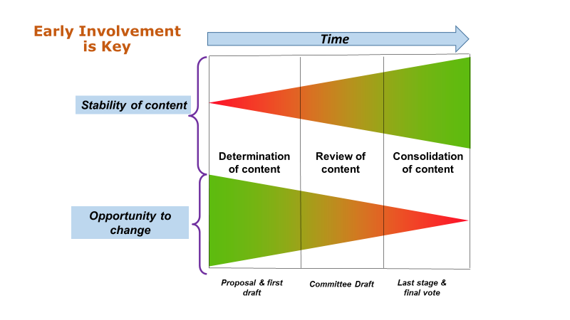
Figure 2: Stages of ISO standards development

On their Web sites, ISO and IEC publish comprehensive information about where each standard currently stands in the development process. Interested stakeholders may search by the Technical Committee or Sub-Committee working on a standard or the standard itself; the stages are coded for easy identification (see https://www.iso.org/files/live/sites/isoorg/files/developing_standards/docs/en/stage_codes.pdf) and http://www.iec.ch/standardsdev/resources/processes/stage_codes.htm).

Once engaged, participants need to clearly understand the standard’s substance and purpose, pay attention to others’ thoughts and carefully analyze any challenges or problems that the draft document presents. They should solicit input from their regulatory colleagues (both in their own country and among their peers, as well as other experts who may be interested in the topic), and consider implications that elements of the standard will have on regulatory activities, such as the review processes for conformity assessment, testing methods and audit requirements.

The next step is to articulate one’s position clearly and timely and in the format specified by the National Body. Protocols for submitting comments are clear and straightforward; they call for not only an explanation of the commenter’s suggested change(s), but also the submission of specific language that can replace the original text. Ideal comments are clear, concise and germane. For more information on how to provide effective comments, please see the ISO/IEC Directives Part 2 (http://www.iec.ch/members_experts/refdocs/iec/isoiecdir-2%7Bed7.0%7Den.pdf).

RAs should take advantage of every opportunity to submit comments. The entire standards development system is predicated upon stakeholder input and having RAs’ insights during the entire process means that regulatory use will be considered in time for it to make a difference.

RAs should not only join but should also seek leadership positions within SDO committees and national bodies. Serving in a leadership role is important for several reasons. First, having regulators in leadership positions will result in more useful standards for regulatory purposes. Second, those who hold an office will contribute substantively and demonstrate commitment to the overall good of the standards development process. Finally, it will benefit both the participants and their organizations professionally.

IMDRF and Standards Development
Representing medical device regulatory authorities from around the world, IMDRF enjoys a unique position and authority in the international community. As such, it capitalizes on its collective expertise and relationships with SDOs that share its goal of expanding the use of standards to streamline regulatory requirements. While IMDRF engagement with SDOs in no way diminishes the importance of individual regulators’ participation (e.g., in both their National Bodies and at the international SDO levels), agreements to collaborate with ISO and IEC provide mutual benefit to IMDRF, SDOs, and RAs. The more these entities interact, the greater the impact regulators will have on the standards development process.
In its role as partner to the SDOs and advocate for member RAs, IMDRF acts as a resource to both, and serves as a hub for communicating needs and priorities in both directions: from the SDOs to regulators and vice versa. In addition to facilitating communications, IMDRF offers oversight and assistance to RAs in their contributions to standards development, particularly in commenting support, both through their national bodies and through IMDRF.
For their part, through these interactions (including joint meetings and training sessions), SDOs boost RAs’ confidence in their standards by committing to consensus principles, particularly balanced participation in its working groups and transparency at all levels of the standards development process. Additionally, SDOs’ support for the IMDRF EPs and other priorities such as risk management and quality management programs fosters regulatory-ready standards and their ultimate adoption and promulgation.

IMDRF is the voice of its members, who strongly endorse the recommendations in this guidance. SDOs and RAs around the world, through collaboration and a collective commitment to the use of consensus standards, are advancing progress toward IMDRF’s key strategic goal of ‘…improving the suitability of standards for regulatory authorities and effective regulatory authority involvement at each stage in standards development.’ The ultimate outcome: global regulatory harmonization.

Appendixes

Appendix A: Challenges in Standards for Regulatory Purposes

(Excerpted from Improving the Quality of International Medical Device Standards for Regulatory Use, submitted to the IMDRF Management Committee, 2017)

IMDRF identified key shortcomings in the way standards are currently written. Problems with representation, decision-making and processes, and a lack of understanding in ISO and IEC about what RAs need are all important issues. Discussions with ISO and IEC leadership lead us to conclude that, while challenging, these problems can be resolved with appropriate intervention and collaboration among RAs and SDOs.

Note: it is acknowledged that various RAs may use standards differently. For some RAs, regulatory authorizations or approvals may be based entirely on compliance to consensus standards as a mandatory approach to obtaining authorization to market a medical device. For some RAs, standards may be an optional element that can be used to complement and augment other documentation, test reports, and objective evidence used to demonstrate safety and effectiveness. The approaches used by RAs might also differ based on the risk classification of the medical device.

Representation and Expertise of Standards Committees
- Poor participation by RAs, due to financial and human costs of engagement, precludes substance and language that are useful for regulatory purposes from appearing in final standards. If regulators are not present at the drafting and commenting stages at a minimum, the standards will not reflect requirements conducive to product review processes.

- A profusion of work items (and duplication across SDOs) stresses resources. Most regulatory authorities characterize themselves as understaffed; those who work on standards often do so on an extra-curricular basis and must carefully prioritize those standards most important to their areas of expertise. Frequently, RAs are unable to contribute manpower to all pertinent standards.

- Unbalanced representation in drafting and voting can result in some groups’ disproportionate voice in and impact on standards development. The ramifications of a standards committee having, for example, an industry-heavy composition can be significant if clinical, public health and/or safety experts are under-represented.

- ‘Turf battles’ among TCs and SCs sometimes stymie progress. It is sometimes unclear which TCs and SCs should have jurisdiction in a technical area, which can slow progress as ownership is worked out.

Transparent processes and decision-making
- Working document accessibility is often unpredictable, making analysis, commenting and future promulgation difficult. When regulators have easy and reliable access to the drafts, they are more likely to contribute substantively on behalf of the review process.

- Lack of transparency on authorship of proposals, comments and positions hinder an understanding of other positions and their origins. Knowing which individual or stakeholder submitted specific input can help regulators understand and effectively balance the overall direction of the standard.

- Adherence to deadlines is often poor; business plans need to clearly specify due dates, and TCs should demonstrate better accountability to timelines, especially for emergent and urgent standards. Missing deadlines and extending work items make it even more difficult for RAs to be able to contribute where they are most needed.

Usefulness for regulatory purposes
- Inadequate RA input into design of key standards often leads to out-of-scope substantive content. ‘Scope creep’ for example can result in standards that do more than is needed, reducing their utility and adoption.

- Insufficient attention is paid to evaluating need in developing NWIPs. IMDRF members note that standards teams should spend more time determining a market, safety or regulatory need before the standard is actually drafted (this may be aided by developing a set of design specifications for regulatory purposes). This will prevent unnecessary standards from being developed, while redirecting participants to pursue a more appropriate outcome, e.g., a technical report or other option.

- Impact assessments need outside review to assure a standard is ‘fit for purpose.’ For example, gaining insights from testing laboratories will ensure that conformance assessment is doable and reasonable.

- Mixed standards can be difficult to use in product reviews. Standards that combine, for example, product and process requirements present challenges for recognition programs and for the review process.

- Conformance considerations (e.g., validation) and clarity of expectations need to be built into standards. Since conformance assessment, testing and declarations are among standards’ most important functions it is important to always keep these practical, applied aspects of standards in mind when developing them.

- Content of standards can be too flexible. Technological changes encourage the allowance of more flexibility to accommodate the rapid rate of advances. That flexibility can render standards less useful as they may not adequately identify minimum requirements for quality, safety and/or effectiveness.

Appendix B: How to Contact a National Body/Committee of a Country
Source: Global Medical Technology Association

To participate productively in standards developed by national voting (e.g., ISO/IEC), it is important to know that your participation is authorized through your country’s National Body/Committee. This appendix provides information on how to reach your National Body/Committee.

For an IEC committee
Go to the IEC website link at this link: http://www.iec.ch/dyn/www/f?p=103:6:0##ref=menu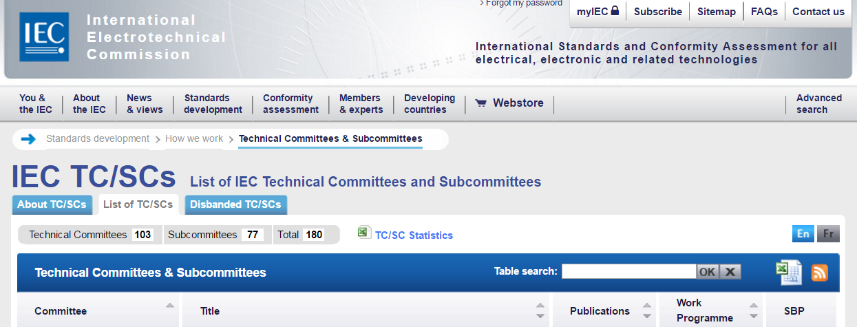

Scroll down and click on the TC or SC you want

Click on the tab marked Structure 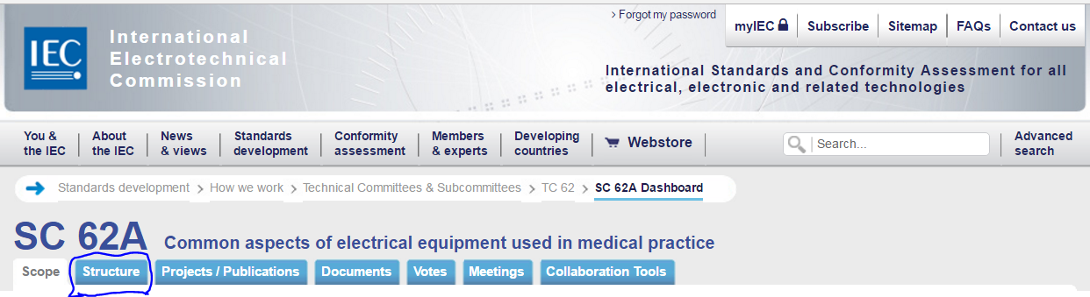

Click on the country whose National Committee information you seek:
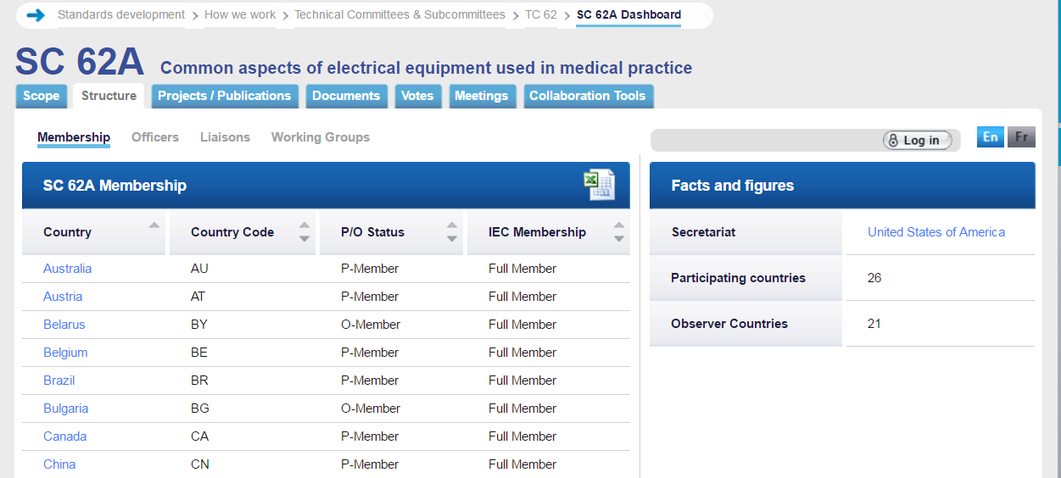

For example, if you selected Canada, the contact information will appear. There is a link (circled) to e-mail the National Committee.

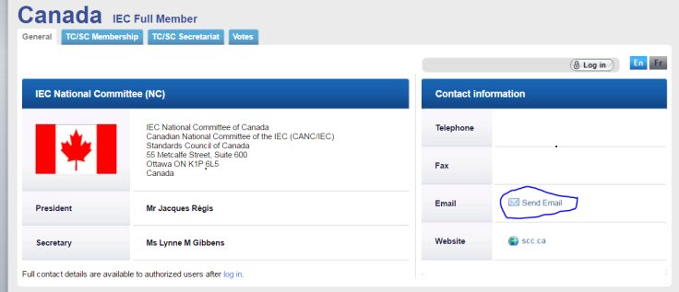

For an ISO committee
Go to the ISO website at this link: http://www.iso.org/iso/home/standards_development/list_of_iso_technical_committees.htm

At the bottom of the page is a list of Technical Committees (TCs).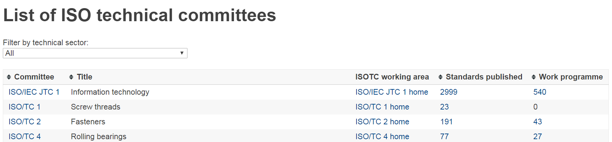

Scroll down and click on the TC you are interested in, for example TC 210

At the bottom of the page you will find information on how many countries participate in that TC. The number is a link. Click on it.
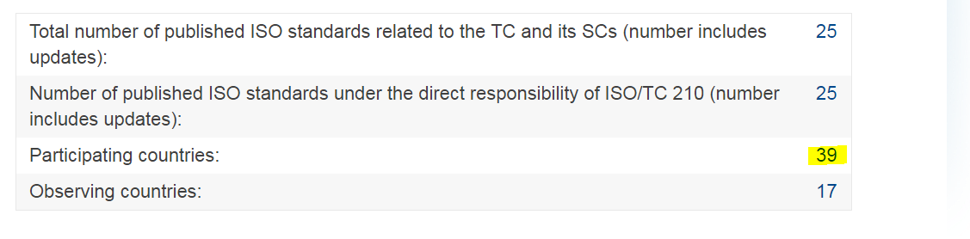
Scroll down and click on the country for which you desire National Committee information (in this example, Australia). The e-mail to contact will be available.

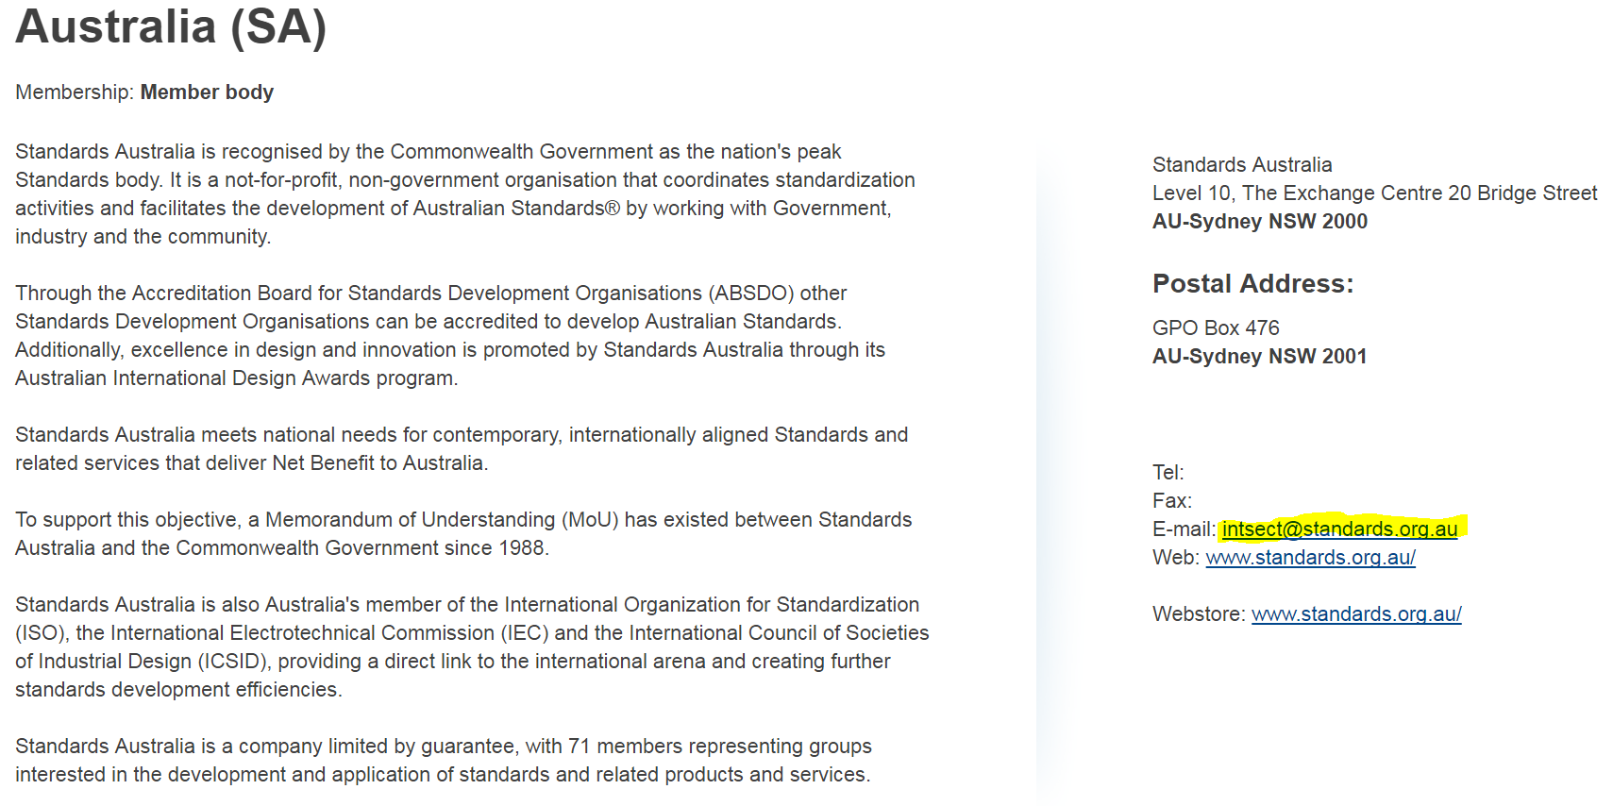

Appendix C: References

Asian Harmonization Working Group Playbook (see in particular Chapter 7) http://www.ahwp.info/sites/default/files/ahwp-files/4_Technical_Committee/AHWP%20Playbook%20for%20Implementation%20of%20MD%20Reg%20Framework.pdf

IMDRF Essential Principles of Safety and Performance of Medical Devices and IVD Medical Devices: 2018 (IMDRF GRRP WG/N47 forthcoming)
IMDRF Strategic Plan 2020:
http://www.imdrf.org/docs/imdrf/final/procedural/imdrf-proc-151002-strategic-plan-2020.pdf

International Electrotechnical Commission (IEC) http://www.iec.ch/about/activities/standards.htm?ref=home

International Organization for Standardization (ISO)
https://iso.ch/home.html

ISO Conformity Assessment tools to support public policy: the CASCO Toolbox, accessed at
https://www.iso.org/sites/cascoregulators/02_casco_toolbox.html

ISO/IEC Directives Parts 1 (Ed. 13, 2017) and 2 (Ed. 7, 2016)

ISO/IEC Guide 59, Code of good practice for standardization 1994

ISO/IEC Guide 63:2012 Guide to the development and inclusion of safety aspects in International
Standards for medical devices https://www.iso.org/standard/50729.html

ISO/IEC 17007:2009, Conformity assessment – Guidance for drafting normative documents suitable for
use for conformity assessment

ISO/IEC 17050-1:2004 Conformity Assessment – Supplier’s Declaration of Conformity – Part 1: General
Requirements

ISO/IEC 17050-2:2004 Conformity Assessment – Supplier’s Declaration of Conformity – Part 2:
Supplemental Information

ISO 14971:2007 Medical devices – Application of risk management to medical devices

Society for Standards Professionals https://www.ses-standards.org/page/A2?

World Health Organization WHO Global Model Regulatory Framework for Medical Devices including in
vitro diagnostic medical devices 2017

World Trade Organization Agreement on Technical Barriers to Trade 1994, accessed at
https://www.wto.org/english/docs_e/legal_e/17-tbt_e.htm

http://www.iec.ch/about/activities/standards.htm?ref=home, accessed 18 June 2018
For more information about consensus standards, see ASNI Essential Requirements at https://share.ansi.org/Shared%20Documents/Standards%20Activities/American%20National%20Standards/Procedures%2C%20Guides%2C%20and%20Forms/ANSI-Essential-Requirements-2018.pdf and ISO/IEC Guide 2:2004 Standardization and related activities – General vocabulary accessed at https://www.iso.org/standard/39976.html 28 June 2018.
IMDRF Strategic Plan 2020, accessed at http://imdrf.org/docs/imdrf/final/procedural/imdrf-proc-151002-strategic-plan-2020.pdf
IMDRF GRRP WG/N47 forthcoming at http://www.imdrf.org/documents/documents.asp
See ISO/IEC Directives Part 2, accessed at http://www.iec.ch/members_experts/refdocs/iec/isoiecdir-2%7Bed7.0%7Den.pdf
See Annex 3 of the World Trade Organization’s Agreement on Technical Barriers to Trade, accessed at https://www.wto.org/english/docs_e/legal_e/17-tbt_e.htm and the World Health Organization’s Medical Device Regulations: Global Overview and Guiding Principles, accessed at http://www.who.int/medical_devices/publications/en/MD_Regulations.pdf
IMDRF Strategic Plan 2020, accessed at http://imdrf.org/docs/imdrf/final/procedural/imdrf-proc-151002-strategic-plan-2020.pdf

